CMAST II

1. **Provide an abbreviated description of the unit including evidence of on-going need.**

Grambling State University (GSU) is requesting continued approval of the *Center for Mathematical Achievement in Science and Technology* (CMAST). The Center was initially approved in October 2006 for a five-year period. The approval of the center was extended through February 2011. CMAST provides the means for Grambling State University to engage in the systematic examination and improvement of instruction in mathematics, science, and engineering technology; thus addressing the retention of students. The Center promotes activities that focus on curriculum reform, undergraduate research, placement of students, K-12 outreach, and faculty professional development. The Director of the Center works directly with **STEM** faculty in the implementation of activities. During AY 2010-2011 the Center received $374,581 in support from the National Science Foundation. In September 2011 the National Science Foundation awarded the Center an additional five years (2011 – 2015) of financial support. The awarded amount is $1,748,315 and will be used to continue activities designed to improve student success and retention in **STEM** programs.

In 2009 GSU ranked 9th in the nation in awarding degrees to African Americans in computer & information sciences and ranked 14th in awarding degrees to African Americans in the physical sciences (Diverse Issues in Higher Education, 2009). Grambling State University was cited as being among the top twenty-five HBCUs in the awarding of chemistry degrees during the 1996-2001 time period. GSU’s ranking was 15th, having awarded forty degrees to chemistry majors (NSF Webcaspar). The success that GSU has had in graduating students in **STEM** areas and placement in STEM graduate programs is a direct result of curriculum reform, mentoring, tutorial, and research programs that are made available to students.

The retention of STEM majors from the freshman to sophomore year at Grambling State University remains a challenge and supports the continued need for the Center. A five-year review of data shows that the average retention rate of STEM majors is 42.6% (Table I).

**Table I. Five Year retention rate in STEM**

|  |  |  |  |  |  |  |  |  |  |  |  |  |  |  |  |  |
| --- | --- | --- | --- | --- | --- | --- | --- | --- | --- | --- | --- | --- | --- | --- | --- | --- |
| **5 Year Retention Rate for Science & Engineering Technology** | | | | | | | | | | | | | | | | |
| **1st Time Freshmen returning for soph. year by STEM major** | **06/07**  **# of stud.** | **Return**  **07/08** | **%** | **07/08**  **# of stud.** | **Return**  **08/09** | **%** | **08/09**  **# of stud.** | **Return**  **09/10** | **%** | **09/10**  **# of stud.** | **Return**  **10/11** | **%** | **10/11**  **#of stud.** | **Return**  **11/12** | **%** | **AVG** |
| BIOL | 45 | 19 | 42 | 71 | 19 | 27 | 80 | 24 | 30 | 84 | 45 | 54 | 49 | 33 | 67 | 44.0 |
| CHEM | 14 | 5 | 36 | 7 | 3 | 43 | 12 | 3 | 25 | 13 | 7 | 54 | 9 | 7 | 78 | 47.2 |
| COMP SCI | 26 | 7 | 27 | 37 | 5 | 14 | 43 | 6 | 14 | 51 | 22 | 43 | 21 | 16 | 76 | 34.8 |
| ENG TECH | 56 | 12 | 21 | 42 | 8 | 19 | 64 | 9 | 14 | 55 | 30 | 55 | 30 | 16 | 53 | 32.4 |
| PHYS | 1 | 1 | 100 | 2 | 2 | 100 | 16 | 1 | 6 | 18 | 6 | 33 | 3 | 1 | 33 | 54.4 |

The Center for Mathematical Achievement in Science & Technology’s ultimate goal is to increase the success of students enrolled in **STEM** courses and increase the retention/graduation rates of **STEM** majors. These success factors are aligned with the intent of the GRAD Act.

**Part II – Activities**

1. **List on-going and proposed activities of the unit, including significant accomplishments to-date.**

CMAST contributes to the university’s ability to significantly impact the success of students.

Upon establishing the Center in 2005, CMAST’s primary goal was to decrease the failure rate of students in introductory mathematics courses. Over the past six years the Center has directed activities that focused on reforming how mathematics is taught at Grambling State University. The direct result of the implementation of CMAST was a significant increase in the success of students in introductory mathematics courses. This data is summarized in the graph that follows. Fall 2004 represents the baseline year, prior to CMAST being established. Four introductory level mathematics classes were targeted, Pre-calculus I, Pre-calculus II, Calculus I, and Calculus II. Pre-calculus I and Pre-calculus II are part of the general education course requirement. Calculus I and calculus II are the first two mathematics courses required of mathematics based **STEM** majors. The success rate of students enrolled in these mathematics courses increased significantly. For example, the success of students enrolled in Pre-calculus I increased from 15.7% of students in 2004 to 60.2% in 2011. The success rate of students enrolled in Calculus I increased from 21% to 60.4%.

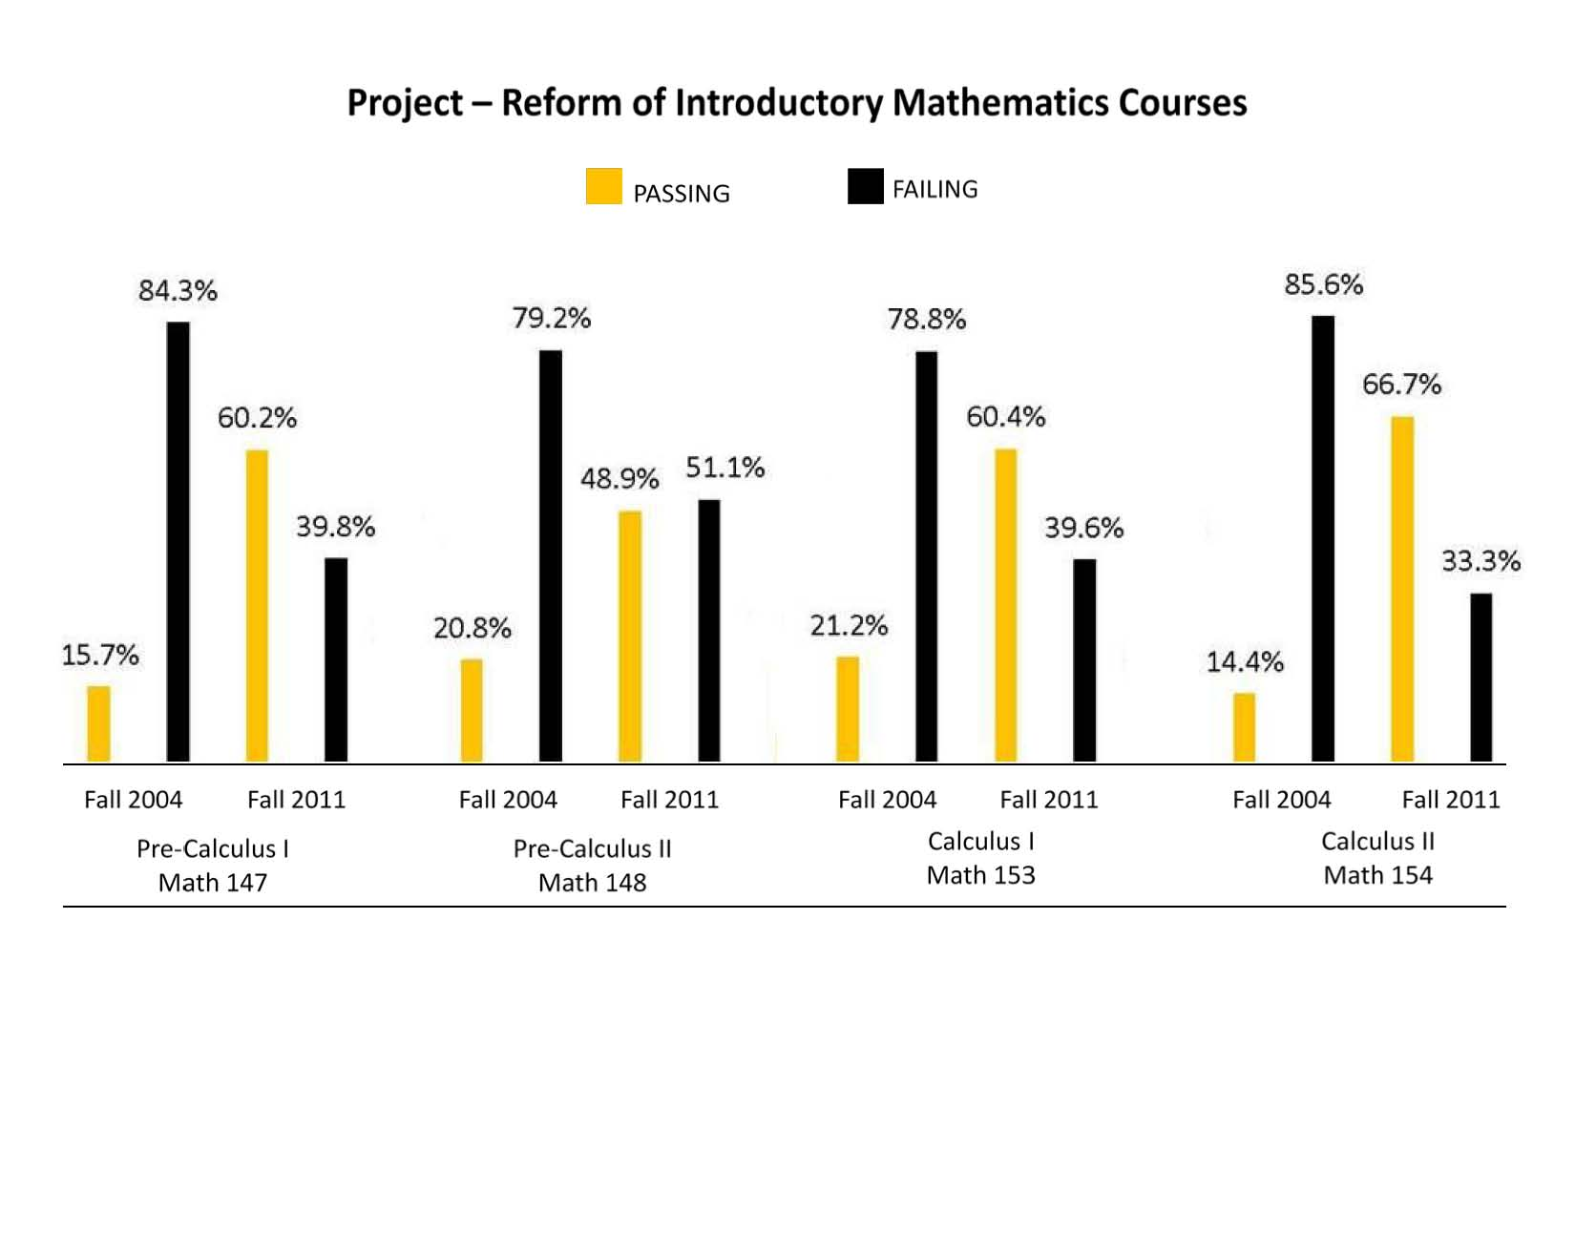

Calculus II

Calculus I

Pre-Calculus I

Pre-Calculus II

This success can be attributed to several changes in the way mathematics is being taught at the university . They include the addition of a problem session to introductory mathematics courses, development of mathematics modules that targeted problems that demonstrated the relevance of mathematics, and a more concentrated effort to place students in the appropriate mathematics course.

**CMAST II**

Phase 2 of the CMAST program proposes to expand upon the successes of the first cycle of funding in ways that will transform the educational experience in entry level areas of science and engineering technology at GSU, thereby increasing the retention of STEM majors.

The retention of STEM majors can be tied to student success in introductory STEM courses. A review of the data shows that the performance of students in specific STEM courses is impacting the academic success of students and in many cases retention in the degree program. Over a four year period 73% of freshmen Engineering Technology majors have changed their majors. During this period 76% of computer science majors were not retained from the freshman to sophomore year. The retention rate for freshman chemistry majors is 39.5% and 38.3% for biology majors. Forty percent of physics majors do not persist with the major. These data support the development of a systematic approach to increasing graduates in STEM areas that include biology, chemistry, engineering technology, physics, and computer science.

We plan to use the positive approaches realized during the first cycle of funding with the successful restructuring of mathematics courses to impact the retention of STEM majors by now concentrating on the restructuring of introductory science and engineering technology courses. A total of eight (8) courses have been identified; two in each of the following disciplines: chemistry, engineering technology, computer science, and physics. Introductory Biology courses have been excluded due to the fact that the success rate of freshmen students in introductory biology courses over a four year period is 77%. Additionally, these courses were recently restructured as a result of funding received from the Louisiana Board of Regents.

**Reforming Introductory Science & Engineering Technology Courses-Proposed Activity**

***Engineering Technology***

Engineering technology education involves the integration of the theory and principles of engineering with practical hands-on laboratory experience to produce graduates that are occupationally ready. Its primary focus is on the applied aspects of science and engineering. The Department of Engineering Technology at GSU currently enrolls ~180 students in its ABET-accredited programs, drafting and design engineering technology concentration and electronics engineering technology concentration. About forty percent of these students are freshmen. Only 38% of freshmen engineering technology majors who enroll in the introductory engineering technology course keep engineering technology as a major after having completed these courses. One reason for this high attrition rate is a lack of motivation of the current generation of students to learn the fundamentals of mathematics, physics and engineering prior to getting experience in using applications. Freshmen students want to get hands-on experience immediately. They want to see why they need to learn “all that stuff.” Many of the students who drop out of the program do so, not because of inability to do the necessary work, but because they cannot see where what they are being taught in the course will lead; they cannot see “engineering technology” in their introductory level courses. This is a result of the introductory engineering technology courses having no associated laboratory experience.

The Engineering Technology Department will restructure introductory courses to keep the student engaged. The new initiative implements a problem-based-learning strategy in its introductory level course. The strategy involves the use of simple real-world problems to introduce new topics and concepts to students.

During the fall 2009 semester, the Engineering Technology Department used a section of Engineering Graphics (ETC 103) to pilot this idea. Fifty-nine percent of students enrolled in the course during spring 2009 received a grade of C or higher. The pilot section taught during the fall 2009 semester had eighty-seven percent of students enrolled in the class earning a grade of C or higher. Fewer absentees were also observed.

***Computer Science***

Over the last four years the retention of computer science majors from the freshman to sophomore year has decreased significantly. This can be directly correlated to the success of students in the freshman level computer science courses that computer science majors are required to complete. These courses introduce the student to the java programming language. During the 2008/2009 academic year ~52% of the students who enrolled in CS 110 earned a grade of D, F, or withdrew from the class. Forty-two percent of those students who enrolled in CS 120 (the second sequence of CS 110) did not receive a grade of C or higher. This high failure rate is believed to be primarily due to the inability of most students to grasp the programming logic in a lecture setting.

The computer science faculty will reform CS 110 and CS 120 by infusing problem-based/hands-on programming exercises into the course structure. Computer Science faculty are developing modules to facilitate these exercises. During the Fall 2011 academic semester 78% of students who were enrolled in CS 110 earned a grade of “C” or higher. Mini- modules being developed were used as homework activities to assist students with learning algorithms and programming techniques in JAVA. Additionally, the computer science faculty member met with the class an additional hour each week.

***Chemistry and Physics***

A goal of science and mathematics education at GSU has been to enable students majoring in science, engineering technology and mathematics to become achievers in their respective fields of study as well as to become independent learners. Pedagogy implemented by **STEM** faculty is grounded in a shared inquiry paradigm. Chemistry and physics faculty will use Process Oriented Guided Inquiry Learning (POGIL) strategies in introductory courses to increase student success. POGIL is a student-centered teaching model; students work in small groups with individual roles to ensure that all students are fully engaged in the learning process. POGIL activities focus on core concepts and encourage a deep understanding of the course material while developing higher-order thinking skills. POGIL develops skills such as critical thinking, problem solving, and communication through group assigned projects and managed activities.

During the fall 2008 and fall 2009 semesters, the Chemistry Department piloted a hybrid POGIL format of instruction for a section of general chemistry. Students who were enrolled in the Hybrid POGIL facilitated general chemistry course were more successful.

**Physics Concentration (B.S. in Mathematics and Physics degree program)**

Over a four year period the number of first time freshmen majoring in physics has increased. The retention of these majors has been a challenge. During Fall 2009, 18 freshmen students indicated physics as a major. Only six of these students remained with the major by Fall 2010. A review of student performance in introductory physics courses, over a five-year period, shows that 79.4% earned a grade of C or better in the class.

**Table II. Percentage of Students to earn a grade of C” or higher over a five year period**

|  |  |  |  |  |  |  |
| --- | --- | --- | --- | --- | --- | --- |
| Physics Course | AY 2005-2006 | AY 2006-2007 | AY 2007-2008 | AY 2008-2009 | AY 2009-2010 | AY 2010/2011 |
| Physics 153 | 80 (25) | 80 (15) | 77 (35) | 68 (28) | 85 (14) | 62 (26) |
| Physics 154 | 81(22) | 87 (17) | 80 (20) | 73 (11) | 83 (12) | 88 (16) |

The retention of physics majors cannot be linked to performance in the introductory physics course. Students who have changed their major have indicated that a lack of a connection with the department has contributed to the change. These students felt isolated in the major. In an effort to address this issue, we are proposing to infuse research into the curriculum beginning the freshman year.

Data show that students who are engaged in research are retained in the major and graduate. The physics faculty will develop mini-research projects that can be infused into the freshman year. The project will be facilitated by physics faculty and upper level physics majors. The upper level physics major will not only facilitate the research project but will also provide mentoring to these students. The research and mentorship will assist the freshman student in establishing a connection to the major. The first sequence course, PHYS 153, will focus primarily on using the literature. The students will be required to complete literature searches and engage in discussions regarding the articles. The students will meet with upper level (junior or senior status) physics majors at least three hours a week. In the second sequence course, PHYS 154, the student will work on a mini project. The students will present the work at the university sponsored Phillip Young Undergraduate Research Symposium held each spring semester.

**Learning Community**

Research has shown that student retention is affected by factors that include:

* the expectations the institution has for its students
* the effectiveness of advising
* the support (academic & social) available
* the involvement of the student in campus activities, and the learning of the student

Learning communities have proven to be successful in addressing each of these factors. Learning communities make an attempt to eliminate isolated learning and create learning experiences that engage and empower the student. This is done by requiring students to take common courses and engage in common activities. These courses/activities have a common theme, a theme that gives connection. The students also develop a connection to each other since they are a part of a series of common experiences.

Learning communities promote group learning. Students participating in learning communities realize they learn from each other and can enhance performance by organizing collaborative groups. According to Vincent Tinto (2003), learning communities help to address the retention of students. In his study, Tinto examined three institutions that had learning communities: University of Washington, LaGuardia Community College and Seattle Central Community College. He found that students who participated in learning communities were retained at a higher rate than those students who did not participate in learning communities. The Seattle Central Community College Learning Community Students had a retention rate that was ~25% higher than the non-learning community students. Additionally the study found that the Learning Community students spent more time outside of the classroom engaged in learning activities with one another. At the end of the learning community experience students rated their intellectual gains higher.

Grambling State University will use learning communities to increase the retention of STEM students from the freshman to the sophomore year. The GSU STEM First Year Learning Community will focus on providing Freshman STEM Students with competencies that will support academic success. We expect that at the end of the freshman year STEM students will:

* + Engage in Quantitative Reasoning
  + Have confidence in their ability to grasp the concepts that are covered in any course
  + Communicate effectively (written & verbal)
  + Seek collaborative learning experiences
  + Identify and employ appropriate study skills for specific courses
  + Clearly articulate career options that are available for their major and the path that should be taken to achieve each, and
  + Manage time such that goals can be reached.

To ensure that the competencies are met, the STEM First Year Learning Community will focus on common classes, social activities, and enrichment activities.

During the fall 2009 semester Grambling piloted a learning community for incoming freshmen STEM majors. These students (20 students) were placed in a common freshman composition class, a common mathematics course (dependent upon the major), and a common chemistry course. The instructors of these courses offered evening study sessions twice a week, in which students worked in groups on specific problems. The students in the learning community attended art shows, and theatre productions that were featured on campus. The art and theatre faculty gave a pre-show briefing that provided information on the type of art/play and information regarding the artist/author. The Learning Community Students also attended a home football game as a group. Ninety-one percent of the students who participated in this pilot learning community were successful in the mathematics courses (100% in precalculus & 100% in calculus I). The success of the students in the English composition course was 83%. The students were not as successful in the General Chemistry course. Only sixty percent earned a grade of C or higher. This was probably due to the fact that the chemistry professor did not offer evening tutorials that were offered for the mathematics and freshman composition courses.

The learning community that will be implemented in CMAST II will have a similar structure as the pilot program, with ***academic coaching for success*** added. The faculty teaching the common courses will be carefully selected to ensure that the faculty is committed to the project. Additionally, upper level STEM students will be utilized to facilitate evening group study sessions. These upperclassmen will also serve as peer mentors. The Director of CMAST in collaboration with our Developmental Education graduate program will identify “academic coaches” to work with students. This is similar to the model used in athletics. Athletes have a coach to work with them to enhance a specific skill. STEM students will have a coach assigned to address specific needs that will support success in the academic program. The coach may work with a student in developing good note-taking skills or time management skills. Additionally, the coach may just listen when a student needs to talk about personal issues. The academic coach will be concerned with the total person.

We expect to have two learning communities, with thirty students each. One learning community will be reserved for biology majors. This is being done in an effort to address the retention rate of freshman biology majors to the second year. We will make an effort to identify biology majors for participation in this program who are at risk of dropping out of the program. Factors such as high school grade point average, ACT score, and family responsibilities will be used to identify these students.

**Scholars Program**

The Scholars Program includes activities that focus on enhancing the preparedness of **STEM** students for graduate study and ultimately their placement into graduate programs. These activities include a rising sophomore summer research academy, undergraduate research mentorship program, and GRE preparation. The Rising Sophomore summer research academy provides students with hands-on experience in the development of research techniques specific to the discipline. Students work on an abbreviated research project under the guidance of **STEM** faculty. This academy will be expanded from two weeks to three weeks in length. One hundred - two students have participated in the rising sophomore academy.

The Undergraduate Research Mentorship program pairs students with faculty researchers and involves the student in the faculty’s research program on the campus of Gambling State University. Additionally, students are assisted in securing summer external research experiences. The percent of **STEM** students engaged in research has nearly doubled since the Center was established.

|  |  |  |  |  |  |  |  |
| --- | --- | --- | --- | --- | --- | --- | --- |
| **Research Experience** | 04/05 | 05/06 | 06/07 | 07/08 | 08/09 | 09/10 | 10/11 |
| **External and On Campus** | 56 | 53 | 72 | 106 | 91 | 99 | 88 |

English faculty facilitates GRE preparation workshops that focus on the verbal and writing component of the graduate record examination. One hundred fifty students have taken advantage of this training. The placement of **STEM** graduates into graduate programs also increased.

|  |  |  |
| --- | --- | --- |
| **Discipline of Graduate** | **% of graduates enrolling in graduate programs during 1999-2004 time period** | **% of graduates enrolling in graduate programs during 2005-2011 time period** |
| ***Biology*** | 2 | 18 |
| ***Chemistry*** | 36 | 51 |
| ***Mathematics*** | 0 | 40 |
| ***Computer Science*** | 3 | 21 |
| ***Engineering Tech*** | 1 | 9 |
| ***Physics*** | 38 | 44 |

**K-12 Outreach**

Grambling State University since 1989 sponsors a high school student enrichment program during the summer. This program is called the High Ability Program. The program invites high school students who have completed their junior year and have a minimum grade point average of 3.0, on campus for four and a half weeks. These students enroll in college level courses, specifically mathematics, and English. Other enrichment activities are provided. The High Ability Program is a successful program in that ~50% of the students who participate upon graduation from high school enroll at Grambling State University. These former High Ability Participants are quite successful as Grambling state University students. The retention rate for the participants who enrolled at the University as a first-time freshman during the fall 2008 semester is 60%.

During the 1990’s, a **STEM** program funded by the Office of Naval Research (ONR) teamed with the High Ability program to support high school participants in this program who had a **STEM** interest. The High Ability Students completed an introductory physical science course that required the students to complete a research project. These students gave a poster presentation of the results of the research. This partnership was successful in serving as a feeder program to **STEM** majors of academically prepared students.

CMAST will partner will the High Ability Program in an effort to recruit students who are prepared for success in **STEM** areas. These students will engage in a science learning activity that is designed to increase scientific reasoning and communication skills.

This partnership was piloted during the summer of 2010. Forty-four (44) high school students participated in the program. These students enrolled in six credit hours (mathematics and English) and also completed a science project. During summer 2011 eighteen (18) high school students participated in the program.

**Faculty Development**

The University has a Professional Development Program funded by Title III through which promotes the growth and development of faculty. Developmental activities offered to faculty include workshops in computer literacy and integrating technology into instruction. Workshops, seminars and other professional development activities enables STEM faculty to provide better training to students. Under the Professional Development Program, faculty members *without terminal degrees* can receive financial support in pursuit of an advanced degree in the appropriate field. This program also provides travel funds for conference and workshop attendance.

The CMAST II program will provide workshops for faculty that will assist in the implementation of teaching strategies that promote problem based learning and inquiry teaching strategies. These workshops will focus on the development of innovative teaching strategies that will be more effective, than the traditional lecture mode of instruction, with our student body. This in turn is expected to increase student performance in STEM courses. Additionally travel support will be provided for faculty to attend conferences and workshops.