Faculty Information
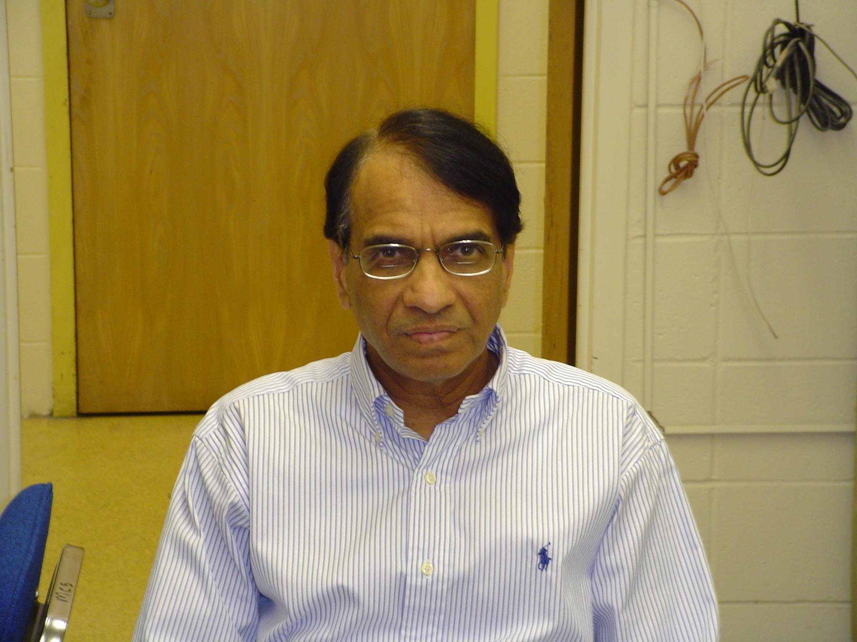
Name: Dr. Parashu R. Sharma

Brief Biography: Dr. Sharma has been serving Grambling State University in the Department of Mathematics and Computer Science since August 1985 in various capacities and is currently a professor in the Department of Mathematics & Computer Science. He received his Ph. D. (1977), Master’s (1972), and Bachelor’s (1969) degrees in Chemical Engineering. He retrained himself in the area of Computer Science by attending various courses, workshops, seminars, and self-study. Before joining GSU faculty, Dr. Sharma taught at Birla Institute of Technology and Science located at Pilani, India and at the University of Roorkee, Roorkee, India. He also worked as a senior research fellow at the Institute of Technical Thermodynamics and Refrigeration at the University of Karlsruhe, Karlsruhe, Germany. Dr. Sharma has a diversified teaching and research experience in the fields of engineering, mathematics, and computer science. He is in the unique position to blend his knowledge from these multidisciplinary fields and engage his students in diversified educational and research activities.

Dr. Sharma has worked on a variety of research projects in India, Germany, and United States. Dr. Sharma is actively engaged in proposal writing. Since 1990 he has authored and co-authored many grant proposals and thirteen (13) proposals have been funded. Dr. Sharma is the author of many research papers published in national & international journals, and conference proceedings. He diligently works for improving the educational standards and quality at Grambling State University. Dr. Sharma closely works with several industries to provide summer internships and co-op for the departmental students.

Research Interest and Specialization:
- Computational Sciences and Engineering
- Nucleate Pool Boiling Heat Transfer

Funded Grants (PI or CO-PI): 13 funded Grant proposals, since 1990, from various Federal, state, and private agencies. Federal agencies include the Army Research Office, Department of Defense, Office of Naval Research, National Science Foundation, and National Institute of General Medical Sciences.

Participating Grants (working in a funded grant):

- Path to Graduate Level Degrees for Low-income Talented Students funded by National Science Foundation
- A Partnership for Undergraduate Student Training in Academic Research (U*STAR) Program funded by National Institute of General Medical Sciences
- Partnership for Minority Access to Baccalaureate Degree (Bridges to the future program) funded by National Institute of General Medical Sciences.
- Caterpillar Excellence Fund funded by Caterpillar, Inc.

Teaching Load Spring 2004: 6 Semester Hours;
  - Numerical Methods
  - Differential Equations

Conference Hours:
- 10:00-11:00 Daily
- by Appointment

Contact Information:

Telephone: (318) 274-6138 or (318) 274-2232
FAX #: (318) 274-6388
E-mail: sharmapr@gram.edu

