Faculty Information

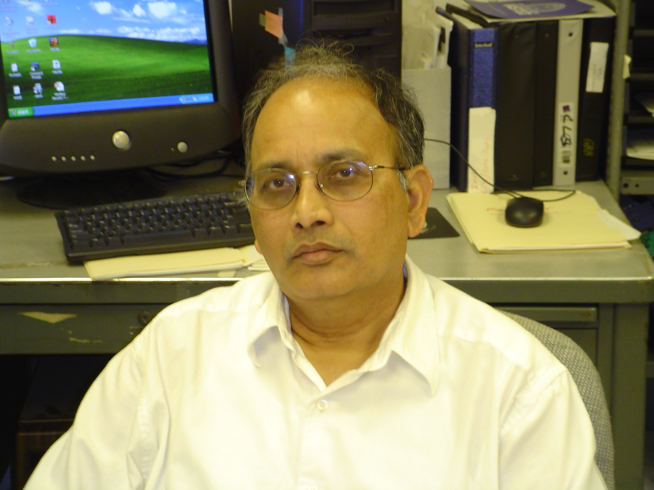
Name:
Dr. Yenumula B Reddy

Brief Biography of yourself:
Dr. Y. B. Reddy is a Professor of Computer Science at Grambling State University (GSU). He has been with GSU since 1986. Dr. Reddy received his Ph.D. in Computer Science from the Indian Institute of Technology, Delhi, India. He has approximately twenty five years of experience in research on large-scale software systems. His research contributions span a number of areas including intrusion detection, data mining, neural networks, intelligent systems, information systems, information filtering, and genetic algorithms. He has published many technical papers on relevance filtering, intelligent systems, and information filtering. Dr. Reddy is the Principal Investigator of the research grants "Data Fusion using Neural Networks Approach" funded by McDonald Douglas Technologies Incorporated, and "Embedded Systems - Neural network approach" funded by General Dynamics. He is also principal investigator of the infra-structure grants funded by National Science Foundation and Louisiana Education and Quality Scientific Foundation. He is Co-Principal Investigator of many other group research grants funded by Army Research Office, Army Research Labs, and Office of Naval Research. Dr. Reddy is member of IEEE, ACM, and Louisiana Academy of Sciences. He is international program committee member of CSMA 2002, IconIT2001, IASTED- ASM 2000-Cont, IASTED- MSO 2000-Cont, and Technical committee member of IASTED-ASM and MSO. DR Reddy is also Executive Committee member of Louisiana Academy of Sciences and Computer Science Session Chair of LAS conferences since 2004-Cont.

Research Interest and Specialization:
- Wireless Communications, Intrusion Detection, Data Mining, Intelligent Agents, Information Filtering
- Genetic Algorithms and Neural Network Applications

Courses taught and Times given:
CS 310 10AM M W F Software Engineering
CS 400 3 PM M Computer Science Seminar II
CS 424 9:30 AM T H Adv Prog. Techniques
CS 428 3:30 PM T H Computer Graphics (Jogl)

Conference Hours:
M W F 9AM – 9:50 AM & 11 AM – 11:50 AM
T H 1:30PM – 3:20PM

Contact Information:
Office Number: (318) 274 - 2421
Fax Number: (318) 274 - 4996
Email address: ybreddy@gram.edu

