Faculty Information
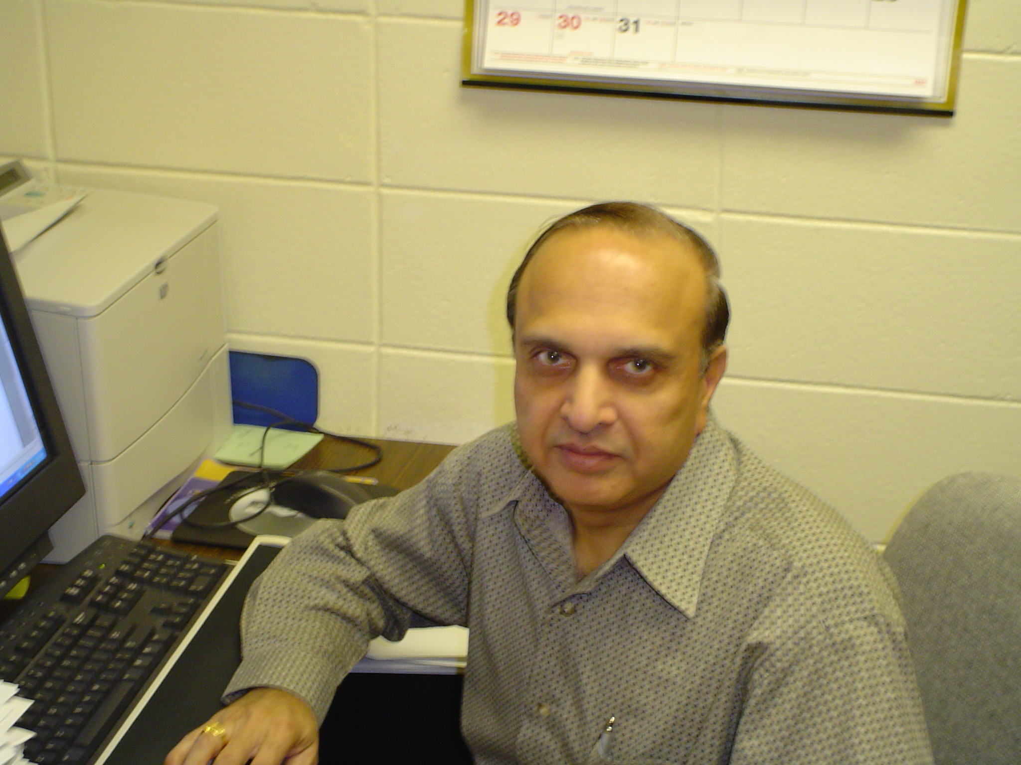
Name:
Dr. Arun K. Agarwal, Ph. D.

Brief Biography:
Dr. Arun K. Agarwal is a Professor of Computer Science at Grambling State University. He has been in this Department since 1969. Dr. Agarwal received his Ph. D. in Mathematics from Lucknow University, Lucknow, India. He served as a Postdoctoral fellow at Department of Mathematics, West Virginia University, Morgantown, WV during 1968-69. He along with some other faculty members in the department retrained himself in the field of Computer Science during 1970’s and early 1980’s. He has earned required graduate credit hours in Computer Science from various Universities. He has published twenty-two research papers in various International refereed journals. He has worked as a Member of Technical Staff with AT&T in Holmdel, NJ and Columbus, OH during summers of 1982-1984, where he has unpublished Internal publications to his credit. His research interest includes Entire Functions, Special Functions, Computer Assisted Instruction, and Database Systems. He has attended and participated in numerous Workshops and Seminars in Computer Science, Mathematics, and Statistics. He has been a Reviewer for two international periodicals, Mathematical Reviews (U.S.A.), and Zentralblatt Math. (Germany) since more than 30 years. He has received grants from National Science Foundation and worked with other faculty members in various different grants from different Federal Agencies. He teaches different courses in Computer Science, Mathematics, and Statistics in the Department.

Research Interest and Specialization:
Entire Functions of one and several complex variables, Special Functions, Computer Assisted Instruction, and Database Systems.

Participating Grants (working in a funded grant):
I am working with Dr. M. Himaya in his grant funded by National Institute of Health.

Teaching Load Spring 2004:
CS 107 9:30 AM T R Computers and Society
MATH 201 1 PM M W F Calculus III
STAT 274 2 PM T R Probability and Statistics II

Conference Hours:
Monday, Wednesday, and Friday 10 AM – 11:50 AM and 2 PM – 2:50 PM
Tuesday 10 AM – 11:50 AM

Contact Information:
Office Number: (318) 274-6178
Fax Number: (318) 274-6388
Email Address: agarwal@gram.edu

