Faculty Information:

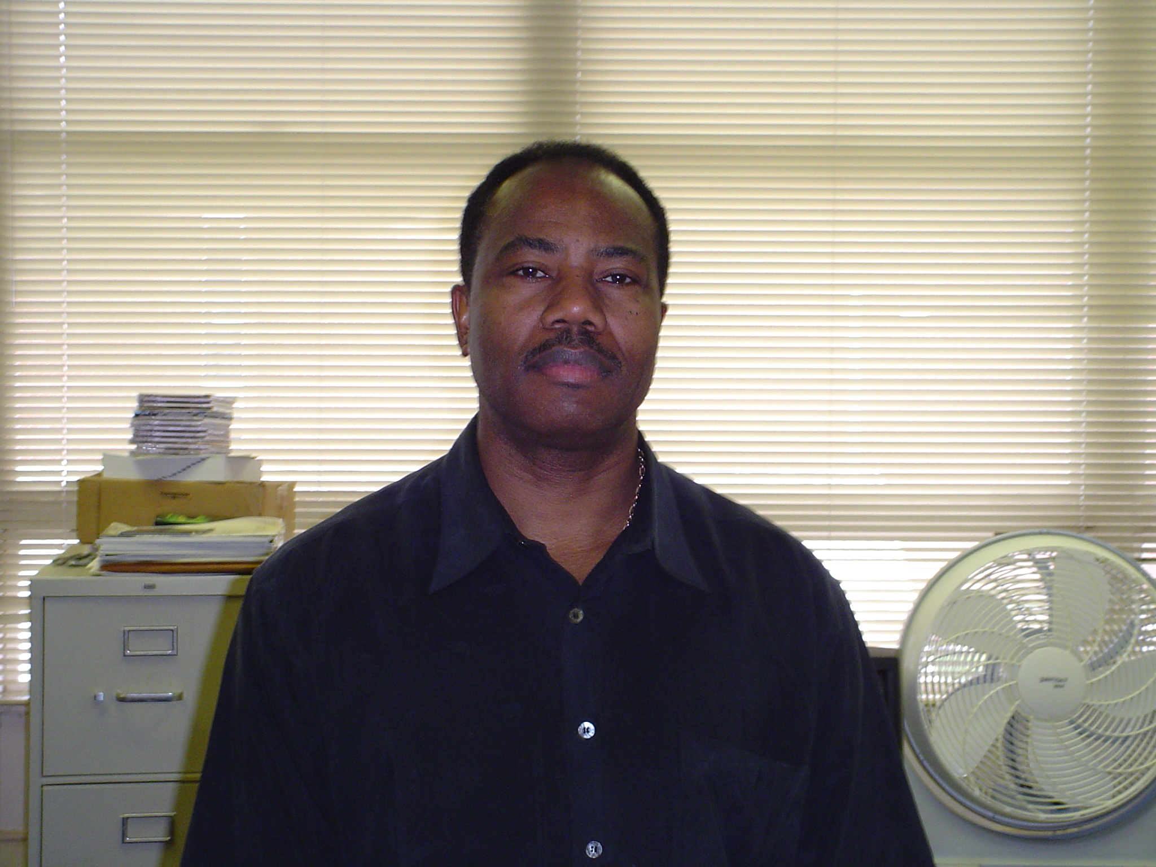
Dr. Avaine Strong is an Assistant Professor and Acting Head of the Department of Mathematics and Computer Science at Grambling State University. He arrived spring 2001, after receiving his Ph.D. in Physics from Howard University. Dr. Strong has Masters in Mathematics, Physics and Electric Engineering/Computer Engineering from Northwestern Louisiana State University. Eleven years of teaching at the college level. As well as a variety of other positions held in the military, Federal government, academia and industry. These positions are an Army officer, systems analyst, mathematician, and scientist. All of which extended over of some seventeen years of experience in battle management and scientific research. Emphasis was placed on extensive utilization of mathematical modeling, Physics and Engineering.

Locations:

Staff Member John Hopkins University Applied Physics Laboratory (APL),
Laurel, Maryland

Assistant Professor of Mathematics and Physics Voorhees College, Denmark,
South Carolina

Chairman, Div. Of Engineering, Industrial and Related Technology Denmark
Technical College, Denmark, South Carolina

General Engineer, USA MICOM Redstone Arsenal, Alabama

Senior System Analyst, SRS Technologies Division, Fort Walton Beach,
Florida & Huntsville, Alabama

Computer Scientist, Mathematician & Physicist, Air Force Weapons
LaboratoryKirkland AFB, Albuquerque, New Mexico

Research Interests and Publications:

On The Deployment And Station Keeping Dynamics Of N - Body Orbiting Satellite Constellations, Ph.D. Dissertation, Department of Physics and Astronomy, Howard University, December 2000.

The Implementation of Maintaining Constant distance Between Satellites in Coplanar elliptic Orbits, the Journal of the Astronautical Sciences, Vol. 50, no. 1, Jan – March 2002, 53 – 69.

Techniques for Deploying Elliptically Orbiting Constellations in Along – Track
Formation, the Acta Astronautica Journal, 2005

Teaching Load Spring 2004:

MATH 335 OPERATIONS RESEARCH 11:00 - 11:50 MWF CH 281

MATH 418 VECTOR ANALYSIS 12:30 - 01:50 TR CH 282

MATH 321 INTRO TO MODERN ALG 02:00 - 02:50 MWF CH 280

Conference Hours: 9:00 – 11:00 MTWRF

Contact Information

Office Number: (318) 274 – 6177
Fax number: (318) 274 – 6388
Email address: stronga@gram.edu

