The GSU LA GEAR UP Experience

CSI: Grambling 2008
(College Success Investigators)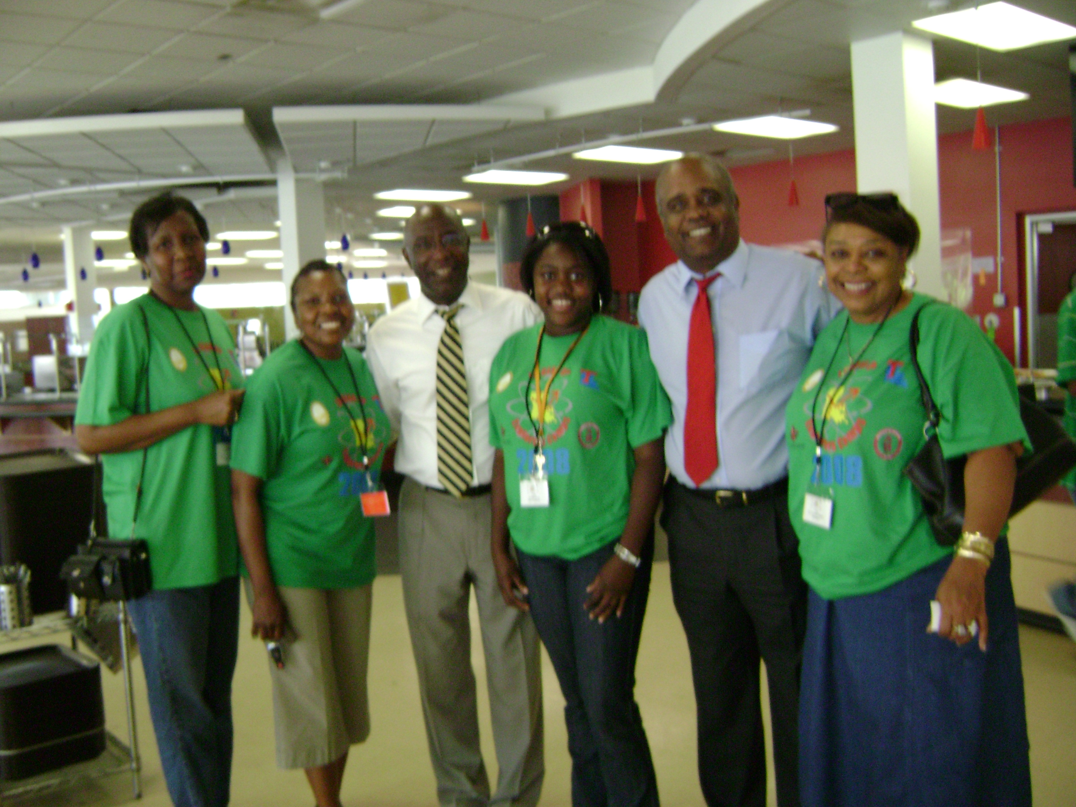

What is LA GEAR UP?

First, in 2002 the U.S. Department of Education awarded a 12.5 million dollar GEAR UP (Gaining Early Awareness and Readiness for Undergraduate Programs) grant to the State of Louisiana. In 2003 LA GEAR UP introduced Summer Learning Camps. These camps were designed to help students develop and enhance academic and leadership skills needed to help promote success as they complete their post secondary education. Specifically, this initiative focused on the following: 1)Provide stimulating experiences in Math, Science, Technology, and/or English/Language Arts,; 2) Expand career goals and aspirations; 3) Provide information about college that include early planning and financial support services; and 4) combine learning with fun.

As a result of these initiatives, funds became available to implement Summer Learning Camps at universities across the state for middle and high school students. Therefore, Dr. Loretta Walton Jaggers and Dr. Nanthalia McJamerson (Professors of Education in the Department of Curriculum and Instruction at Grambling State University), submitted a proposal to the Louisiana Board of Regents (LA SIP/LA GEAR UP) in 2005 to fund a one week LA GEAR UP Summer Learning Camp at $37,000.00. The grant was awarded and the project was a success based on the results of the numerous project evaluations. Afterwards, Dr. Jaggers and Dr. McJamerson continued to submit proposals and received the following grants for Summer Learning Camps at Grambling State University:

- 2006-86,873.00(2 one week camps)
- 2007-104,520.00(2 one week camps)
- 2008-104,342.85 (2 one week camps)

The GSU Summer Learning Camp

Introduction

The Grambling State University LA GEAR UP Project was designed to focus on the theme, CSI: Grambling (College Success Investigators). Using CSI (Crime Scene Investigation) projects, campers work collaboratively with their peers and content area specialists to strengthen basic Math, Science, and Reading/Literacy skills. The camp activities were also designed to focus on leadership preparation, Math and Science tutorials and study skills, test-taking strategies, preparation for college life, and career opportunities in Math and Science, and Reading/Literacy skills. GSU collaborated with community agencies/organizations, Louisiana Tech University and ULM University and other LA GEAR universities to plan and implement project activities.

The Academic Component
The Explorations/Classes were held on Monday through Thursday
from 8:00 through 11:45. There were diverse creative instructional strategies resources, activities and several breaks during the instructional process. The activities included role play exercises, critical thinking, writing, and technology infusion activities. The highly creative interactive activities throughout the four explorations were connected to the field trip on Friday. Opportunities were provided for participants to enhance their self-esteem through the use of positive reinforcement.

The summary activities follow for each of the four Explorations:

- Sherlock Bones: Identification of Skeletal Remains -The lab activities involved the utilization of actual techniques used in forensics to identify and access skeletal indicators. The students had an opportunity to complete activities at different Science Stations as they applied concepts presented in the instructional process.
- Theta Technology Crime Scene II –The activities provided opportunities for students to utilize the materials in the kit to match fiber, fingerprints, analyze blood samples, and use chromatography to help solve the case that is presented in the scenario. Students completed tasks in forensic teams at Science Stations to solve their individual cases and report the using data summaries.
- Terror from Paradise- This Exploration was designed to provide creative interactive activities and diverse resources that focused on solving a case involving terrorists transporting biological weapons to the United States. The students were assigned to an FBI Chemistry team that will collect samples and test for the presence of biological weapons. The teams will write summaries about the process used to determine the presence of the biological weapons.
- Mystery of the Bloody Stain- Activities were designed to focus on strategies for performing ABO and Rh typing to determine how blood can be used in solving crimes. The activities involved opportunities for the students work in pairs to solve crimes using blood groups and blood typing.

The 2008 Grambling LA GEAR UP Project was designed to provide opportunities for middle and high school students to participate in diverse academic, enrichment and recreational activities while enhancing their self-esteem. There were 57 campers in attendance during week I (June 22-28, 2008), and 69 campers in attendance during week II July 6-12, 2008). Specifically, the key academic and enrichment activities included Explorations/classes that focused on forensic investigations while developing and enhancing basic Math, Science, and Reading/Literacy skills. Based on Boreal Laboratory Kits, the four explorations/classes follow: (1) Sherlock Bones: Identification of Skeletal Remains; (2) Theta Technologies Crime Scene II; (3) Terror from Paradise; and (4) Mystery of the Blood Stain. The campers participated in Pathfinder/Financial Assistance Workshop activities that were presented by the State LA GEAR staff, and representatives from the GSU Admissions and Financial Aid Offices. The campers were also exposed to diverse Math and Science careers through participation in the Explorer’s Club activities. The culminating activity on Friday included a field trip to the Crime Lab in Monroe, Louisiana, and the Natural Science Museum at ULM. (one of our LA GEAR UP partners). The recreational activities included basketball, volleyball, table games at the Grambling High School gym. The week I campers had an opportunity to have a Pizza Party at Pizza Inn in Ruston, Louisiana. During week II the campers participated in a swimming pool party at Louisiana Tech (one of our LA GEAR UP partners). After the pool party they journeyed back to GSU for a Pizza Party in Adams Hall.
On Friday evening after the campers returned from the field trip to Monroe, Louisiana, they participated in the traditional graduation ceremony and dinner/dance. This grand celebration serves to culminate the week’s activities for the campers. During the 2008 celebration for week I and week II, Dr. Sean Warner, Dean of the College of Education, and Dr. Doris Williams Smith, Head of the Department of Curriculum and Instruction, provided parting “words of wisdom”. Since the La GEAR UP experience is a major recruitment effort for Grambling State University, each camper received gift bags that included Grambling t-shirts, key chains, pens, folders, and a yearbook. The campers were thrilled. The Grambling bag of “goodies” were donated by our community supporters and special LA GEAR UP donors. These special donors (who were recognized at the affair), included Dr. Helen Richards Smith, Mrs. Mary Hobdy, and Dr. Jimmy McJamerson. Some of the other persons who donated items for the Grambling bag of goodies” included Mrs. Hazel Johnson Jones, Mrs. Jean G. Brown, Mrs. Shirley Henderson, Mr. Glenn Lewis, Mrs. Rosalind Lewis, Mrs. Anna Moss, and the Grambling State University Police Department.

Collaborations and Supporters
We utilized numerous opportunities to collaborate with various GSU departments, the community, other LA GEAR UP universities, and the LA GEAR UP state administrators. Specifically, Dr. Kerry Davidson, State Project LASIP/LA GEAR UP Director, Mrs.. Diana Frank, and Mrs. Renee Carter provided enormous support in helping to plan, organize and implement the Summer Learning Camps throughout the years. We also had a variety of “in kind supporters” that included President Horace Judson, Dr. Robert Dixon, Dr. Sean Warner, Dr. Doris Williams Smith, other GSU administrators, faculty, staff, and students. Specifically, some of the supporters included Aramark, Barnes and Noble Bookstore, Information Technology Center, KGRM, the Gramblinte, the GSU grants office, and the GSU fiscal offices. There were numerous opportunities for collaboration between Grambling State University’s LA GEAR UP staff, other LA GEAR UP universities throughout the state, and the LA GEAR UP state administrators. Specifically, Mr. Glenn Beer, the State LA GEAR Coordinator, arranged the special pool party activity at La Tech and one of the pizza parties at Pizza Inn in Ruston during the 2008 camp.

Evaluations
The Louisiana GEAR UP office surveys camp participants to determine the quality of their experience. Qualitative data generated from this survey instrument reflect how the camp participants felt about the overall LA GEAR UP program as well as the impact the program had on them. The cluster of responses of four of the questions represents to a large extent how they perceive the LA GEAR UP program. Those perceptions provide an additional indication that the goals of the CSI: Grambling Summer Learning Camps were achieved.
- Best things about the LA GEAR UP
The best things about the LA GEAR UP Summer Camps as perceived by the students cover their future expectations and their interpersonal relationships. The following comments represent the above mentioned category:
- Get a feel of college life
- Staying on a college campus and taking college courses
- Experiencing college life
- Communication with camp counselors and staff
- Meeting new friends
- Teachers can really teach
- Thoughts about Attending College
Another important question the students answer pertained to their thoughts about attending college after spending a week on a college campus and experiencing life as college students. The LA GEARUP program was designed to influence students to seek a college education. The following positive comments were in support of this effort:
- I will go to college no matter what. My thoughts are the same.
- I really want to come to college now. My thoughts have changed.
- I am going to attend college for sure.
- I am going to love attending college. I will love college life.
- College is going to be great.
- I am still a little intimidated about attending college, but not as much. No, my thoughts have not changed. I still want to major in business.
- Leadership Training
Additionally, another significant aspect of the LAGEAR UP program was to enhance and cultivate the leadership ability of cam participants. To check this aspect of the program, question seven asked the students, “After attending leadership training, how would they make a difference in your school and your community?” Based on the following comments, the program was successful in meeting this goal:
- Be more active in the community
- I have learned to be a better leader by listening to other people. I will be more cooperative with classmates.
- I will step up my attendance and attitude and become a better role model for the younger ones.
- Since I have gained more leadership qualities, I would tell my friends and others about how things should be done.
- Help others to realize that you have to follow before you can lead.
- I will practice the leadership skills that I have learned here at camp. I will help the community by volunteering.
- To graduate and be a role model for family and friends.
- Most Important Aspects of the Program
Furthermore, the most important aspect of the LA GEAR UP program was to enhance the academic achievement or camp participants. To address this goal of the program, question two asked the students to indicate some specific things they learned during summer camp. The following responses given revealed that the students’ growth was not only academic but social as well.
- Learned more about forensic science, especially DNA.
- Learned how to identify the bones of a male and a female and how to determine their race.
- Stay focused and be on time because you might miss something.
- How to tell a person’s blood type and how to test blood samples.
- Learned more about the physical attributes of people.
- You have to put work into everything you do.
- How to become a leader.
The 2008 LA GEAR UP Staff

Dr. Loretta Walton Jaggers -Director
Dr. Nanthalia McJamerson Co-Director and Leadership Coordinator
Dr. Ronnie Davis-Assessemnt Coordinator
Dr. Elaine Foster-Tutor/Counselor Coordinator
Mrs. Shirley Hendon-Administrative Assistant
Mr. Sheddrick Bradford-Multi-Media Coordinator
Dr. Danny Hubbard-Coordinator, Forensic Experts
Dr. Waneene Dorsey, Forensic Expert
Ms. Nyoka Freeman, Forensic Expert
Ms. Patricia Schneider, Forensic Expert
Mrs. Marian Young, Dorm Mom
Mrs. Herbert Lyons, Dorm Dad

Camp Counselors (Week I and Week II)
Marian Barnes
Willie Butler
Jovan Johnson
Latiia Joseph
Emma Jules
Alice Leonce
LaTeryl Mason
Clarita Monrose
Joshua Ogunyemi
Frank Smith
Martez Stevens
Aisha Trim
Tenisha Willis

Official LA GEAR UP Partners and Volunteers
Mr. Bruce Morgan, GSU Web Master
Demetria Jaggers
Denesha Jaggers
Kiana Carr
Brian Wyms
Sherlonda Williams

