

DEPARTMENT OF KINESIOLOGY, SPORT & LEISURE STUDIES

LEISURE STUDIES PROGRAM SELF-STUDY REPORT

Prepared for the

Council on Accreditation of Parks, Recreation, Tourism and Related Professions

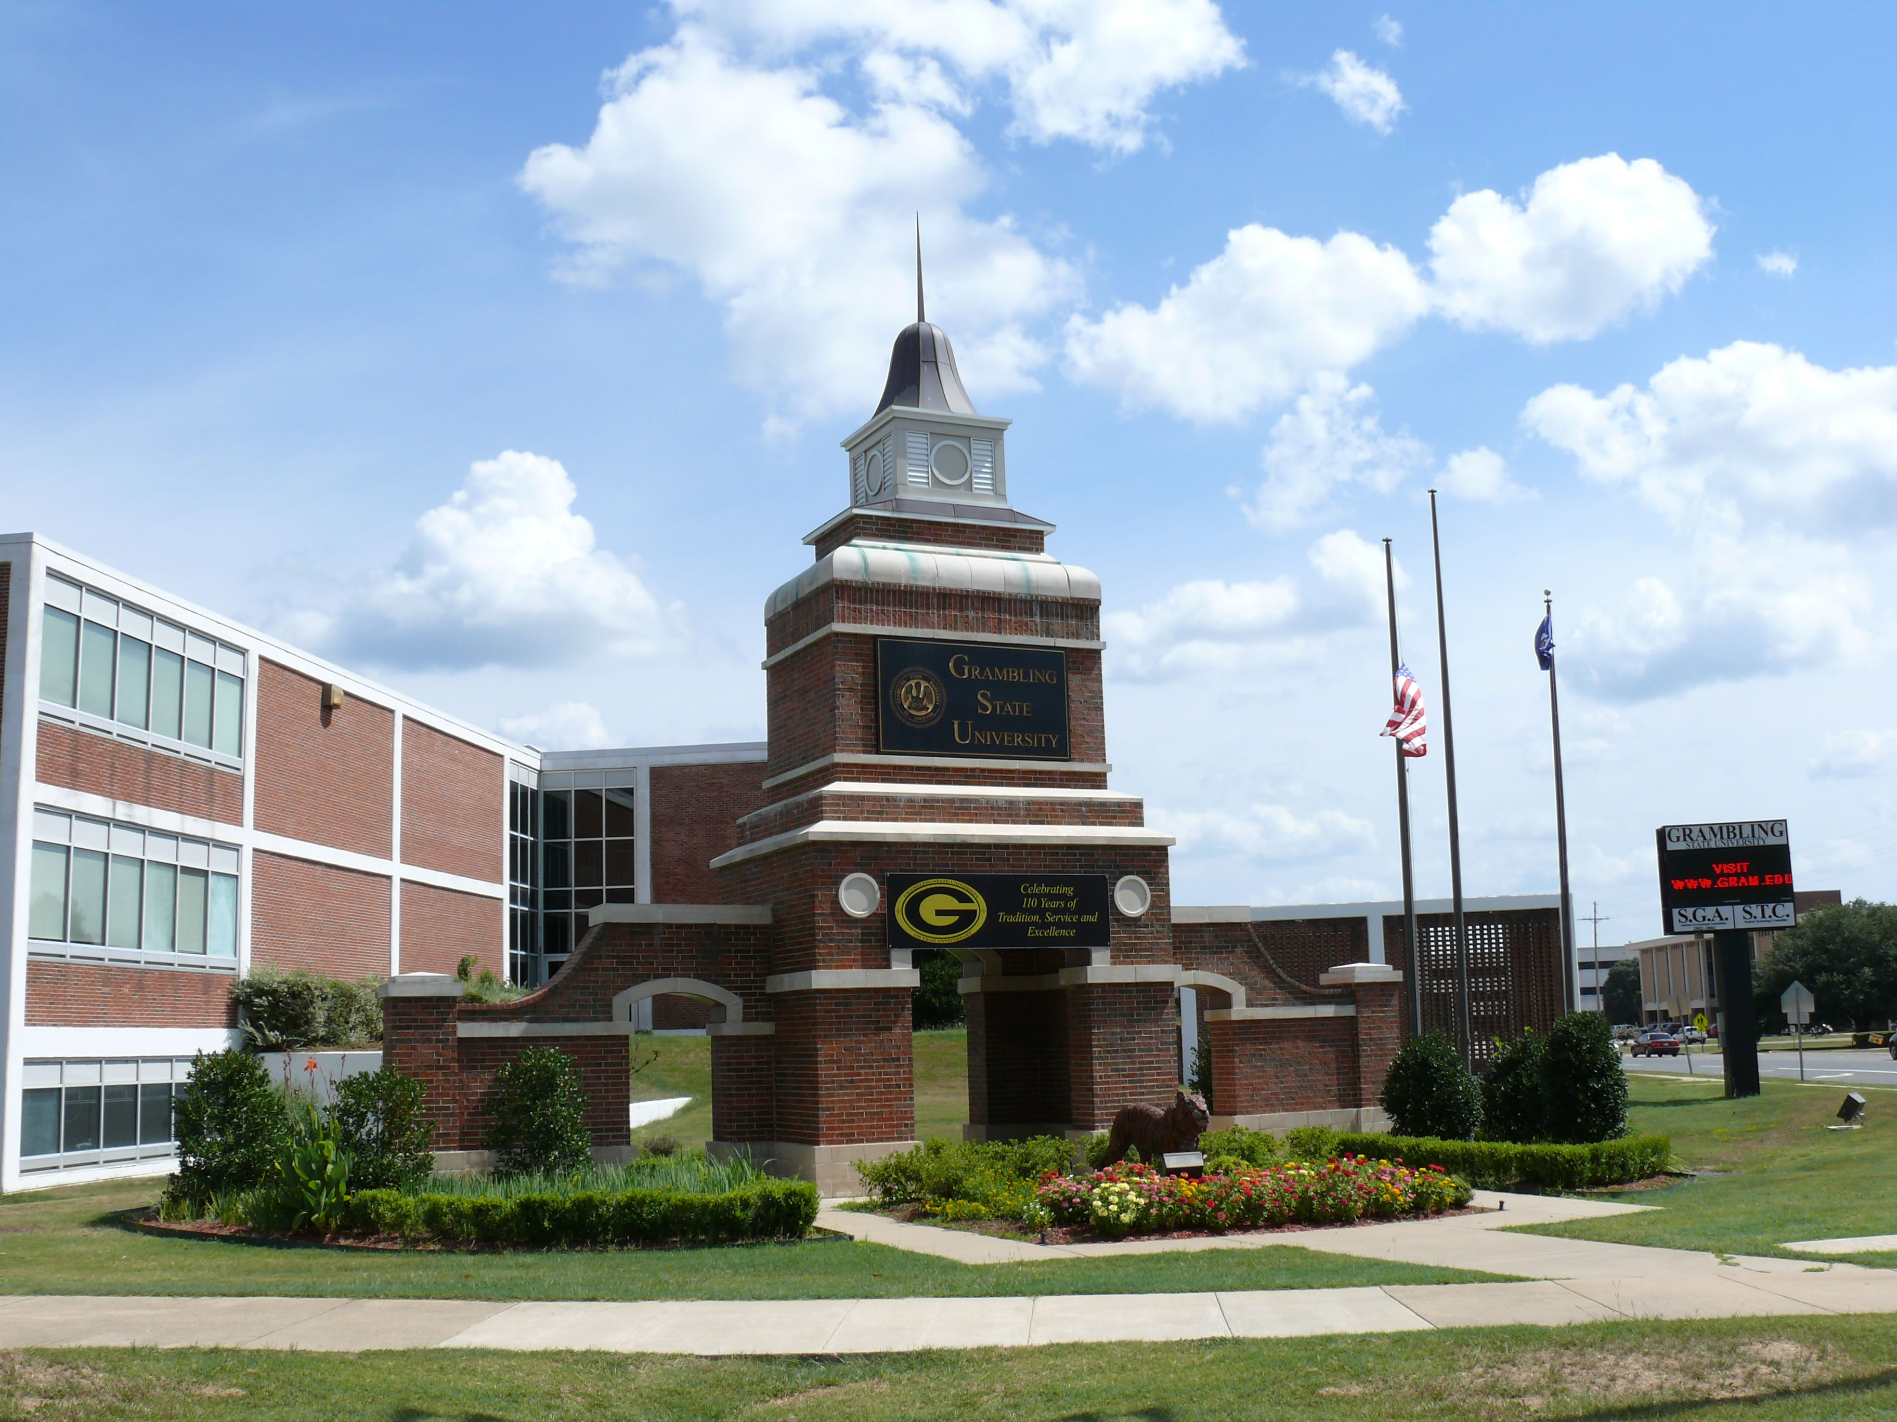

Mr. Richard J. Gallot, Jr., JD, President
P.O. Drawer 607
Grambling, LA 71245
(318)274-2117
Prez@gram.edu

Dr. Connie R. Walton
Provost & Vice President for Academic Affairs

Dr. Debbie Thomas, Dean
College of Education

Dr. Obadiah J.K. Simmons, Department Head/Director
Department of Kinesiology, Sport & Leisure Studies

December 31, 2023
TABLE OF CONTENTS
CONTENT PAGE
1.0 Eligibility Criteria 9
2.0 Mission, Vision, Values and Planning 12
3.0 Administration 17

4.0 Faculty 20

5.0 Students 27

6.0 Instructional Resources 31

7.0 Learning Outcomes 35

APPENDICES
Exhibit A | GSU's Accreditation status via SACS-COC (update)
Exhibit B | Louisiana Board of Regents Approved Deg (Programs search page)
Exhibit C | University of Louisiana System Board of Supervisors
Exhibit D | GSU Strategic Five-Year Plan
Exhibit E | GSU Organizational Chart.
Exhibit F | GSU Quality Enhancement Plan (QEP)
Exhibit G | LSP Syllabi

LIST OF TABLES

NO. PAGE

Table 1: Chronology of Activities/Events since 2012 8

Table 1.04: Full-Time Faculty Degrees Earned 11

Table 1:05: Competency & Credentials of Full-Time Faculty 11

Table 4.02 – LSP Faculty Information Technology Training 21

Table 4.07: Scholarly and Professional Development 23



LIST OF KEY DOCUMENTS, FOLDERS, LINKS & RELATED REPORTS

ITEM

Eligibility Criteria (Standard 1.0)
Exhibit 1.01a | Organizational chart of College of Education
Exhibit 1.01b | Organizational Chart for KSLS/LSP
Exhibit 1.01c | Degree Description from pp. 147 – 151 of the 2013 – 2015 General University Catalog
Exhibit 1.01d | Council on Accreditation Letter
Exhibit 1.02 | University’s SACS-COC Accreditation Status
Exhibit 1.03 | Faculty Teaching Loads
Exhibit 1.04 | Curriculum vitae of LSP faculty
Exhibit 1.06 | COAPRT Training received by LSP faculty verified by attendance

Mission, Vision, Values and Planning (Standard 2.0)
Exhibit 2.01.1 | KSLS Department mission, vision, and values statement
Exhibit 2.01.2a | GSU Strategic Five-Year Plan
Exhibit 2.01.2b | KSLS Five-Year Strategic Plan
Exhibit 2.01.2c | LSP Assessment Plan
Exhibit 2.02 | LSP curriculum updates in degree program
Exhibit 2.03a | Degree requirements in 2013 – 2015 General University Catalog
Exhibit 2.03b | Leisure Studies Academic Curriculum Sheet
Exhibit 2.03c | KSLS Departmental Minutes
Exhibit 2.04 | LSP COAPRT Annual Report submission
Exhibit 2.05.1a | GSU QEP Plan via SACS-COC
Exhibit 2.05.1b | University’s SACS-COC Accreditation Status
Exhibit 2.05.2 | LSP Policy Handbook
Exhibit 2.05.3 | Exit Survey for Graduate
Exhibit 2.05.4a | KSLS Departmental Minutes
Exhibit 2.05.4b | Annual Assessment Report 2016

Administration (Standard 3.0)
Exhibit 3.01.01 | GSU Faculty Handbook via Department Head duties
Exhibit 3.01.02 | GSU Budget for KSLS Department
Exhibit 3.01.03 | GSU HR Policy & Procedures Handbook (Faculty Handbook)
Exhibit 3.01.04 | GSU HR Policy & Procedures Handbook (Faculty Handbook)
Exhibit 3.03 | Policy on faculty workloads
Exhibit 3.04a | KSLS Departmental Minutes
Exhibit 3.04b | LSP Minutes
Exhibit 3.05a | Advisory Board Minutes
Exhibit 3.05b | Advisory Board
Exhibit 3.06 | LSP website regarding Statement on Degree Mills
Exhibit 3.07 | COAPRT Statement on KSLS/LSP website

Faculty (Standard 4.0)
Exhibit 4.02 | GSU Strategic Five-Year Plan
Exhibit 4.03a | HR Office employment (hiring) practices and policies
Exhibit 4.03b | Position Announcement
Exhibit 4.04a | Faculty Workload policy
Exhibit 4.04b | Faculty Teaching Loads
Exhibit 4.05 | Employee Policy Manual (Salaries - Pages 20 - 25)
Exhibit 4.06 | Faculty Teaching Loads
Exhibit 4.07 | Documentation of scholarly productivity of LSP faculty

Students (Standard 5.0)
Exhibit 5.02a | LSP Policy Manual
Exhibit 5.02b | Admission process - Catalog (GSU Page 20, College of Education Page 125)
Exhibit 5.02c | Advisement Flow Chart
Exhibit 5.03a | LSP Advisement Handbook
Exhibit 5.03b | GSU Advisement Evaluation Form
Exhibit 5.03.01a | Leisure Studies Academic Curriculum Sheet
Exhibit 5.03.01b | LSP Advisement Handbook
Exhibit 5.03.02a | Student Exit Survey
Exhibit 5.03.02b | Career Services Calendar of Events
Exhibit 5.03.02c | Career Services Newsletter
Exhibit 5.04 | Confidentiality Practices for student records (FERPA)

Instructional Resources (Standard 6.0)
Exhibit 6.05 | ADA Compliance and services for individuals with disabilities (Page 14, Page 48)
Exhibit 6.06 | ADA Compliance and services for individuals with disabilities (Page 14, Page 48)
Exhibit 6.07 | Resources provided by the A.C. Lewis Memorial Library

Learning Outcomes (Standard 7.0)
  Exhibit 7.04 | Student Internship Handbook
  Exhibit 7.04 | Student Internship Handbook
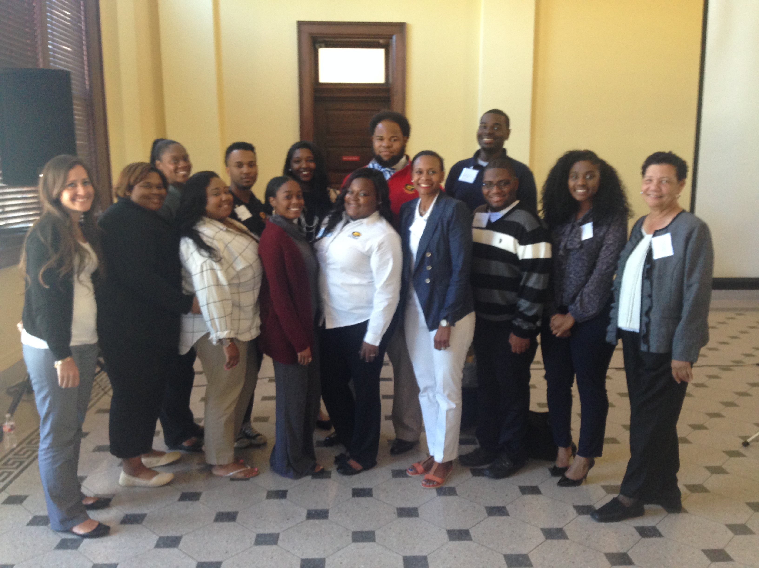

FOREWORD

The Department of Kinesiology, Sport & Leisure Studies (KSLS) at Grambling State University (GSU) has prepared and submitted this Self-Study Report in preparation of the impending Visit by Examiners with the Council on Accreditation of Parks, Recreation, Tourism and Related Professionals (COARPT) scheduled for the 2024 Spring Semester. GSU’s 2017 LSP Self-Study Report served as the guiding document for the preparation of the 2023 Self-Study Report under the direction of KSLS Department Head Dr. Obadiah J.K. Simmons, Jr. and assisted by Leisure Studies Program faculty and Leisure Studies Program majors. Preparation of the 2023 Self-Study Report began in 2022-23. LSP faculty members have been collecting required information in preparation of the self-study. It is also noted that the position of Coordinator of Leisure Studies is being handled on an interim basis by Dr. Simmons.

Notable events and personnel changes at the University since July 2017 include: changes in institutional academic divisional and college leadership; the advent of the COVID-19 pandemic (March 2020); the displacement and relocation; a required institutional operational reduction in the University’s Operating Budget; and, a required one (1)-year freeze in the University’s Operating Budget for 2023-24. Table 1 below identifies a chronology of key activities and/or events that have occurred since the 2017 COAPRT Reaffirmation Visit of the Leisure Studies Program.

Under its current structure, the KSLS Department has two (2) primary areas: 1) Kinesiology with concentrations in the areas of Health Promotion, Pedagogy, and Sport Management; and, 2) Leisure Studies with concentrations in the areas of General Recreation and Therapeutic Recreation. With the exception of Pedagogy, all other areas of concentration require the completion of a total of 120 semester credit hours inclusive of an internship. The concentration in Pedagogy requires the completion of 122 semester credit hours.

The (former) Recreation Program received its initial accreditation in 1986 and has maintained reaffirmation of the program—now Leisure Studies—since that time with the most recent reaffirmation received in 2017 (Council on Accreditation Letter). There is no specific area of concentration subjected to accreditation within the KSLS Department electing to focus accreditation activity over the entire Leisure Studies Program.

Table 1: Chronology of Activities/Events since 2017

Date(s) | Activity/Event | Commentary
May 2017 | Leisure Studies Program | LSP receives reaffirmation from COAPRT.
July 2018 | College of Education | Dr. Simmons named interim Dean.
August 2019 | College of Education | Dr. Debbie Thomas named new Dean.
March 2019 | LSP | Dr. Catalina Palacios hired as new LSP faculty member.
May 2019 | LSP | Dr. Rose Chew retires as LSP faculty member.
August 2019 | KSLS Department | Dr. Rodney Blackman hired as new LSP faculty member.
March 2020 | Institutional | COVID-19 pandemic alters institutional practices.
November 2020 | GSU-LSP | COAPRT reaffirms GSU LSP program.
January 2021 | LSP | Initial discussions regarding next COAPRT Self-Study.
July 2022 | LSP | Dr. Gilbert earns PhD (Oklahoma State University).
January 2022 | LSP | Ms. Yvonne Calvin retires as LSP faculty member.
November 2023 | Institutional Leadership | GSU President Richard Gallot named UL System President.
November 2023 | GSU-LSP | COAPRT notification of self-study report and Visit for 2024

1.0 – Eligibility Criteria

A unit will be considered for accreditation only when the following 1.0 series of standards are met. Eligibility criteria apply throughout the accreditation period. Thus, institutions should note that upon notification of a deficiency in the 1.0 series, the Council may withdraw accreditation at any time.

1.01 The academic unit and curriculum concerned with parks, recreation, tourism, and related professions shall have been in operation for three years and be clearly identifiable to the public.

Evidence of Compliance: The Department of Kinesiology, Sport and Leisure Studies (KSLS) is an academic unit located within the College of Education (now College of Educational, Organizational chart of College of Education. The Leisure Studies Program (LSP) is one of two major tracks within the KSLS Department and serves as the authorized academic unit to administer and manage the curriculum. The LSP curriculum has two concentrations: General Recreation and Therapeutic Recreation. Students from both concentrations are required to take all recreation core classes Leisure Studies Academic Curriculum Sheet. The LSP was established at Grambling State University in 1959 and was last accredited with the Council on Accreditation for Recreation, Park Resources and Leisure Services in 2012 (Appendix A insert here). The requirements for earning a degree in the Leisure Studies Program is listed in the GSU 2013 – 2015 General Catalog (Degree requirements in 2013 – 2015 General University Catalog) beginning on p. 149. The approved curriculum has been approved by the Louisiana Board of Regents’ List of approved degree programs (Appendix B insert here) at Grambling State University (GSU).

1.02 The institution shall be currently accredited by the appropriate regional accrediting association approved by the Council for Higher Education Accreditation (CHEA) or by the current national accrediting body.

Evidence of Compliance: GSU is fully accredited by the Commission on Colleges of the Southern Association for Colleges and Schools (University’s SACS-COC Accreditation Status). The University has maintained its accreditation since its initial accreditation in 1949. GSU’s most recent visit was in 2020 with their next SACS Reaffirmation Visit scheduled for 2030.

The College of Education houses the Department of Kinesiology, Sport and Leisure Studies is located--maintains accredited degree program by CAEP (i.e., the National Council for Accreditation of Teacher Education) and respective SPAs (Specialized Professional Associations). NCATE Accreditation has been continuous since early 1960s. Until 2009 Fall Semester, GSU has maintained 100% accreditation of all academic programs that have an accrediting agency.

1.03 A minimum of two full-time faculty members and a minimum of one additional full time equivalent faculty position (FTE), which may be comprised of multiple individuals, shall be assigned to and instruct in the program.

Evidence of Compliance: Currently, the department consists of three full-time members and one part-time faculty who teach courses within the Leisure Studies core curriculum. Full-time faculty also teach courses within each concentration. Teaching assignments of full-time departmental faculty members and adjunct faculty are recommended by the Leisure Studies Coordinator to the Department Head. LSP and other academic programs within the University have a teaching load determined by SACS Standards; that is, undergraduate faculty teach 12 credit hours per semester. Academic Policy as approved by the University of Louisiana System are outlined in the Grambling State University Faculty Handbook (see GSU HR Policy & Procedures Handbook (Faculty Handbook) The following link provides a complete record of department faculty teaching loads and assignments for the period of 2019 through 2021-22 (see Faculty Teaching Loads).

1.04 A minimum of two full time faculty members shall hold a degree of masters or higher, and a degree of bachelors or above in parks, recreation, tourism, and related professions.

Evidence of Compliance: Full-time Leisure Studies faculty members possessing either a terminal degree or Master's degree from regionally accredited institutions are identified in Table 1.04 (see below). Complete curriculum vitae of all Leisure Studies faculty members are also provide in Exhibit 1.04.
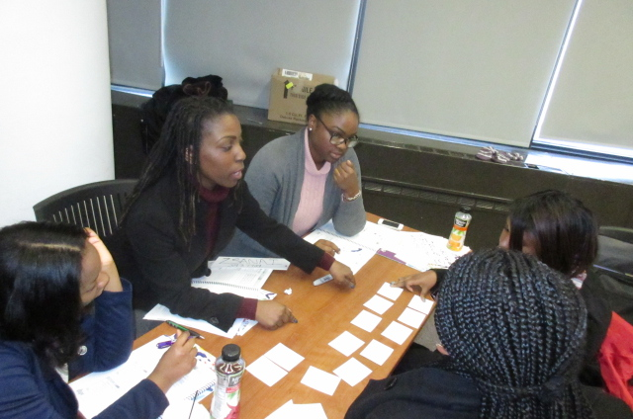

Table 1.04: Full-Time Faculty Degrees Earned
Faculty/Rank | Degree(s)/Yr | Area of Concentration | Institution
Rodney Blackman | Ph.D.  M.S./2008  B.A./1971 | Leisure Studies (Therapeutic Recreation)  Sociology | Southern University  Dillard University
Breleisha Gilbert | Ph.D./1982  M.S./1972  B.S./1966 | Recreation Administration  Secondary School Administration  Recreation Administration | Oklahoma State University  Lincoln University of MO  Grambling State University
*Theresa Gray-Jacobs | M.S./1983  B.S./1974 | Sports Administration  Health and Recreation | Grambling State University  Grambling State University
Catalina Palacios | Ph.D/  M.S./2013  B.S./2003 | Youth and Family Recreation  Recreation Leadership | Brigham Young University  Brigham Young University-Idaho
[*Note: Mrs. Theresa Gray-Jacobs currently serves as an Adjunct faculty member and is CTRS Certified.]
1.05 All individuals instructing in the programs shall have competence and credentials in the subject matter for which they are responsible.
Evidence of Compliance: While the list of credentials is identified below, information provided in Table 1.05 serves as evidence supporting Sub-standard 1.05. As part of our most recent NCATE Self-Study and Leisure Studies Academic Program Review, Table 1.05 also serves to validate the competence and credentials required to demonstrate mastery of the requisite subject matter in the Leisure Studies Program.

Table 1.05: Competency & Credentials of Full-Time Faculty
Faculty | Agency | Area of Certification or Specialized Training | Certificate No. (Exp Date)
Rodney Blackman |  |  | N/A
Breleisha Gilbert |  | Certified Therapeutic Recreation Specialist (CTRS) | To Be Determined
Theresa Gray-Jacobs |  | Certified Therapeutic Recreation Specialist | To Be Determined
Catalina Palacios |  | Certified Therapeutic Recreation Specialist (CTRS) | To Be Determined

1.06 Each program seeking accreditation shall employ at least one individual as a faculty member who has completed formal COAPRT training no less than five years prior to submission of the self-study.

Evidence of Compliance: A record of attendance at COAPRT Training attendance by faculty that serve the program is located in Appendix 2a – 2d. Current (and former) full-time faculty in the LSP have attended several COAPRT training sessions including: Mrs. Theresa Jacobs and Dr. Rose Chew at the 2014 NRPA Conference in Charlotte (NC); Mrs. Theresa Jacobs, Dr. Rose Chew, and Ms. Yvonne Calvin attended the 2015 NRPA Conference in Las Vegas (NV); and Ms. Yvonne Calvin attended the recent 2016 COAPRT training in St. Louis (MO). Attached are the continuing education units for the training sessions.

CEU Transcript of Training Sessions

2.0 – Mission, Vision, Values, and Planning

2.01 The academic unit shall have the following current written documents that are clearly demonstrated to be consistent with the institution and with the parks, recreation, tourism, and related professions:

2.01:01 Mission, vision, and values statements of the program shall be visible, operational, and present in the unit culture.

Evidence of Compliance:
Mission, vision, and values statements of Grambling State University
The mission of the University states that: Grambling State University is a comprehensive, historically-black, public institution that offers a broad spectrum of undergraduate and graduate programs of study. Through its undergraduate major courses of study, which are under girded by a traditional liberal arts program, and through its graduate school, which has a decidedly professional focus, the University embraces its founding principle of educational opportunity. With a commitment to the education of minorities in American society, the University seeks to reflect in all of its programs the diversity present in the world. The university advances the study and preservation of African American history, art and culture.

Grambling State University is a community of learners who strive for excellence in their pursuit of knowledge and who seek to contribute to their respective major academic disciplines. The University prepares its graduates to compete and succeed in careers related to its programs of study, to contribute to the advancement of knowledge, and to lead productive lives as informed citizens in a democratic society. The University provides its students a living and learning environment which nurtures their development for leadership in academics, athletics, campus governance, and in their future pursuits.

The University affords each student the opportunity to pursue any program of study provided that the student makes reasonable progress and demonstrates that progress in standard ways. Grambling fosters, in its students, a commitment to service and to the improvement in the quality of life for all persons. The University expects that all persons who matriculate and who are employed at Grambling will reflect through their study and work that the University is indeed a place where all persons are valued, “where everybody is somebody.”

The Vision of Grambling State University is: “To be one of the premiere universities in the world that embraces educational opportunity and diversity.”

The Core Values of Grambling State University are “Integrity, Student Success, Academic Excellence, Pride, Commitment, and Accountability.”

Mission and vision statements of the College of Educational, Professional, and Graduate Studies (College of Education)
Additionally, the mission of the College of Educational, Professional, and Graduate Studies states: The College of Education, the oldest college in the University, has been nationally accredited since 1964. The College of Education (COE) seeks to produce graduates who are competent and compassionate professionals. In preparing students for work in P-12 and higher education settings, the faculty and staff in the College of Education strive to produce graduates who value academic excellence, diversity, equity, and fairness.

The faculty members in the college endeavor to ensure that their students acquire the professional skills, dispositions, and knowledge-bases that reflect best practices in research, service, and teaching within the field of education.

The vision of the College of Educational, Professional, and Graduate Studies is: Producing knowledgeable, skilled, and compassionate educators and other school professionals in the place “Where Everybody is Somebody.”

Mission, Vision, and Values Statements of the Department of Kinesiology, Sport Management, and Leisure Studies

Mission of the Department of Kinesiology, Sport and Leisure Studies
The Department of KSLS embraces the mission of the College of Education and Grambling State University. The Department’s mission entails a commitment to academic excellence, quality assurance and accreditation of degree programs, as well as preparation of competent, skilled professionals in kinesiology and leisure studies at the undergraduate level, and sports administration at the graduate level.

2.01.02 The academic unit shall maintain an up-to-date strategic plan for the program. This plan must include a) current mission, vision and values; b) goals; c) measureable objectives; d) target dates for accomplishment of objectives; e) designation of primary person or organizational unit responsible for attainment of objectives; and f) a strategic plan status report.

Evidence of Compliance: The Department of Kinesiology, Sport, and Leisure Studies has an established five year strategic plan for the department. In addition, Grambling State University’s 5 year strategic plan is also included.

KSLS Department’s 5 Year Strategic Plan

GSU’s 5 Year Strategic Plan

LSP Assessment Plan

2.02 There shall be ongoing curricular development and improvement, including faculty ownership of the curriculum and meaningful input from stakeholders and constituent groups.

Evidence of Compliance: From 2008 to 2011, three Level Tests were administered to Leisure Studies majors designed to test their Specialized Academic Program (SPA) at the sophomore, junior and senior level. Two of the tests, Level Tests I & II, have since been eliminated and only Level III is currently being administered at the Senior Level. The reason for this change was due principally to the difficulty of administering a seamless test at all three levels to test students who matriculated in such varied ways. Going forward, only Level Test III is administered that consist of 100 Multiple Choice questions with 25 questions randomly selected from Level Test I and 25 randomly selected questions from Level Test II for inclusion on the “new” Level Test III.

In addition to the Level Test III, the LSP program has been proactive in updating needed changes on the curriculum sheets.

LSP curriculum updates in degree program

2.03 The academic unit shall have institutionally approved degree requirements for all programs being considered for accreditation.

Evidence of Compliance: Degree requirements for the B.S. degree in Leisure Studies in both General Recreation and Therapeutic Recreation concentrations are detailed in the 2013-2015 General Catalog for Grambling State University and on the Leisure Studies Curriculum Sheets. The LSP faculty participate in curricular development, update activities, advisory boards and other curricular activities. Changes are made in accordance with updates in Standards and Evaluative Criteria for Baccalaureate Programs in Recreation, Park, Recreation, Tourism and Leisure Services. By attending professional meetings in the subject field, LSP faculty stay abreast of COAPRT Updates and best practices in the discipline.

KSLS Departmental Minutes

2.04 The COAPRT accreditation decisions shall apply only to those degree requirements for which the institution or program seeks accreditation and do not extend to other offerings at the institution or within the program.

Evidence of Compliance: The Leisure Studies website indicates the core curriculum for Therapeutic Recreation and General Recreation are accredited by COAPRT. COAPRT Accreditation solely applies to the Leisure Studies Program and does not extend to additional concentrations, programs, degrees, minors, or certifications that do not fall under the accreditation standards.
LSP COAPRT Annual Report submission

2.05 The academic unit shall maintain an up-to-date assessment plan for the learning outcomes in Section 7.0, and if applicable, the 8.0 series standards.

Evidence of Compliance: The LSP Assessment Plan via the KSLS Departmental Unit Assessment Plan is contained in the link above. It should be noted here that this particular plan was based on the previous University Strategic Plan which was updated in 2015-16 prior to the change in University Leadership. As such, the LSP Unit Plan along with the KSLS Departmental Plan will undergo revision prior to the end of 2016-17

2.05.01 Evidence shall be provided demonstrating that the program’s assessment plan is compatible with expectations of the regional accrediting association and the institution.

Evidence of Compliance: The LSP has updated its learning outcomes and assessment plan periodically in accordance with the institutional policy. The program has made every effort to maintain an assessment plan, which is updated and carried out each academic year. An assessment report for the current year and predictions for the next year are given to the Department Head in an Annual End-of-Year Faculty Report.

The LSP program has made every effort to enhance the learning outcomes and assessment plan to stay in compliance with COAPRT standards. There are challenges with the assessment process (i.e. faculty turnover, limited training of adjunct faculty in assessment procedures and limited administrative resources to support data collection, analysis and reporting) the
department will need to improve our assessment system. During the fall of 2014, the department began updating the assessment plan which included taking the Level Test, majors must have earned a “C” grade or better in LSP course and have completed the LSP courses series for 200, 300, and 400 level courses.

The goal is to have the General Recreation and Therapeutic Recreation majors better prepared (competence and skills) at the point of graduation to take and pass certification examinations. Students are expected to sit for the exam at the next opportunity after graduation.

GSU QEP Plan via SACS-COC
University’s SACS-COC Accreditation Status

2.05.02 The program shall demonstrate that data generated through measurement tools that were designed to measure program learning outcomes are used solely for that purpose. Such data must not be used as secondary data for instructor evaluations or other non-related functions.

Evidence of Compliance: No part of the assessment plan is used to evaluate faculty performance or other functions unrelated to learning outcomes assessment. In the 2016 annual report, none of the measures are used for instructor evaluation.
LSP Policy Handbook
2.05.03 Evidence shall be provided that the metrics used for assessment are suitable and appropriate for their intended use.

Evidence of compliance: Core Curriculum Assessment – included in the 2013 assessment plan, each course utilized embedded assessment rubrics which have been used to evaluate course assignments, artifacts, portfolio, term papers, and research papers on student outcome achievement. The rubric was developed to specifically measure learning outcomes coming from each activities within a course. Each rubric was designed by a full-time faculty member in respect to the specific course outcomes.

The Senior Level Test is a Comprehensive Exit Examination, multiple-choice, designed by the faculty. The design was selected because standardized examinations taken by the students are multiple-choice with a four choice option. The goal is to have Leisure Studies majors become certified soon after graduation. The test has two comprehensive examinations from LSP courses taught at the 200, 300, and 400 levels. Developed from a Test Bank of faculty-made questions. The examination will continue to develop, as courses are reviewed.

The 2016 Assessment Plan includes direct measures and indirect measures. The direct measures include teacher made examinations, marketing plans, strategic and risk management plans projects, presentations, Internship Supervisor’s evaluation and Comprehensive Examination (i.e. Level Test). The Indirect measures include curriculum review, exit interview and field-based practicum and the senior Capstone project. A future improvement is LSP alumni questionnaires; however, GSU does distribute exit surveys for graduates.

2.05.04 Evidence shall be provided to demonstrate that the program uses learning outcomes data to inform decisions.

Evidence of Compliance: The Annual Assessment Report includes recommendations based on data collected from our learning outcomes. These data guide the faculty in making decisions on curricular updates, course content and revised learning outcomes.

Annual Assessment Report 2016

KSLS Departmental Minutes
2.05.05 The program annually posts the most current 7.0 series data and additional evidence reflecting program academic quality and student achievement on their program and/or departmental website. Such information shall be consistent with The Family Educational Rights and Privacy Act (FERPA) requirements.

Evidence of compliance: Grambling State University has consistently reported academic quality and student achievement on the Leisure Studies website since this standard was in place. The website and information on student and program achievement can be found here.

3.0 – Administration

3.01 Institutional policies and the organizational structure within which the program is housed shall afford sufficient opportunity for the program to succeed in its mission, vision, and values with respect to:

3.01:01 Responsibility and authority of the program administrator to make decisions related to resources allocated to that program.

Evidence of Compliance: The Department Head/Director is the head administrator over the Department of Kinesiology, Sport and Leisure Studies (KSLS). Dr. Obadiah Simmons, Jr., currently serves in this capacity. Upon the retirement of Dr. Willie Daniel as Department Head/Director, Dr. Simmons was initially appointed by former Interim President Dr. Cynthia Warrick as recommended by the Dean and Interim Provost and Vice President for Academic Affairs in August 2014. The interim tag was removed in January 2016 with Dr. Simmons selected as Head/Director by former President Dr. Willie Larkin as recommended by the Interim Provost and Vice President for Academic Affairs and the Dean of the College of Educational, Professional and Graduate Studies.

The Department Head/Director oversees all academic, administrative, and personnel concerns within the department. His role and responsibilities within Leisure Studies includes hiring personnel, retention and evaluation of current personnel, course scheduling, overseeing accreditation, and allocating budgets and administering finances.

GSU Faculty Handbook via Department Head Duties

3.01:02 Adequacy of financial resources.

Evidence of Compliance: The Leisure Studies Program’s financial resources stem from the allocation to the Department of Kinesiology, Sports, and Leisure Studies from GSU’s Operating Budget as shown below. The link below provides the funding levels for the department as a unit within the College of Education.

GSU Budget for KSLS Department

3.01:03 Implementation of personnel policies and procedures.

Evidence of Compliance: Information about employee policies and procedures is detailed throughout the Unclassified Personnel Handbook and Faculty Handbook. The policies and procedures are set in place by administration to ensure the faculty are supported and also maintain appropriate terms while working. The Faculty Handbook and the Unclassified Personnel Handbook can be reviewed at the following link:
GSU HR Policy & Procedures Handbook (Faculty Handbook)

Unclassified Personnel Handbook

3.01:04 Development and implementation of academic policies and procedures for the unit.

Evidence of Compliance: Academic policies and procedures are highlighted throughout the GSU Faculty Handbook and the GSU Unclassified Personnel Handbook, both were created by the administration at Grambling State University. Both handbooks give detailed policies to ensure the integrity of the academics and compliance with standards.

GSU HR Policy & Procedures Handbook (Faculty Handbook)

Unclassified Personnel Handbook

3.02 The program administrator of the academic unit shall hold a full-time appointment in his or her academic unit with the rank of associate or full professor with tenure, with appropriate academic credentials in the unit being considered for accreditation.

Evidence of Compliance: The Department Head/Director caries the rank of Associate Professor and is tenured in the KSLS Department. In this capacity, the Department Head also serves as Program Administration.

Faculty Credential Table
(See Table 1.04: Full-Time Faculty Degrees Earned – Page 12)

3.03 The program administrator of the academic unit shall have a workload assignment and compensation consistent with the prevailing practice within the instruction.

The program administrator has a workload assignment that is conducive to regular full-time faculty, consisting of 12 hours, per semester. Additional compensation is given for teaching an extra course, but an additional course is rarely, if ever given.

Policy on Faculty Workloads

3.04 There shall be formal participation of faculty in setting policies within the academic unit.

Evidence of Compliance: The LSP faculty meet regularly (one or two times monthly) throughout the academic year under the leadership of the Department Chairperson and maintain minutes. The faculty and chairperson discuss matters consistent with University policies, and policies relative to the LSP Program. Matters considered in these meeting include but are not limited to, curriculum development, graduation requirements, strategic planning, resource allocation, marketing, advising policies and procedures, course scheduling, assessment planning and reporting, community relations, and outreach, faculty recruitment, and alumni affairs.

The LSP Coordinator convenes meetings once a week with the LSP faculty and maintains minutes. Issues discussed are but not limited to are , strengths and weakness of the program, trends and issues in the field that may impact the program, curriculum development, opportunities for improvement, assessment, planning and evaluation procedures.

KSLS Departmental Minutes
LSP Minutes
3.05 Consistent consultation with practitioners shall affirm or influence the curriculum.
Suggested Evidence of Compliance: Minutes of interactions and meetings, and/or correspondence, with practitioners and documentation of how that input was used in curriculum development and improvement.

Evidence of Compliance: LSP faculty are consistently engaged with practitioners. The following methods are examples of compliance to this standard and the outreach LSP faculty have with Leisure Practitioners.
- Advisory Board: Many practitioners are on the LSP advisory board. During these advisory board meetings, the practitioners and LSP faculty discuss adjustments needed in the LSP curriculum or within the program in general. The practitioners are also able to call/visit at any time to offer suggestions.
- Internship Site-Visits: Each semester the LSP Internship Coordinator visits interns who are within one hour of the university. This gives the LSP Internship Coordinator and the practitioner (i.e. internship site supervisor) an opportunity to discuss the positive and the needed changes within the Leisure Studies Program.
- Internship Phone Calls: The LSP Internship Coordinator regularly contacts practitioners in the field and discusses items that can improve the program.
- Guest Practitioner Speakers: Practitioners are invited to the LSP to speak to students in courses and as special guests for lectures. Practitioners are able to interact directly with students and grasp the overall structure of the LSP and evaluate where strengths and weaknesses lie.

Throughout these different interactions, a tremendous amount of feedback has been received. Practitioners consistently praise the hands-on experience that our LSP majors receive. They are impressed with the core curriculum and feel it addresses a general grasp of the profession. One major improvement the LSP implemented was to bring in more guest and keynote speakers. This improvement is currently being addressed and will continue to be addressed in the future as LSP faculty schedule more guests to come.
Advisory Board Members
Advisory Board Minutes

3.06 The program has a practice of informing the public about the harm of degree mills and accreditation mills.

Evidence of Compliance: The following statement appears on the LSP’s webpage:

Important Information Regarding Degree Mills Please watch this important video (http://youtu.be/a1voHNMQDrk) regarding degree and accreditation mills. According to CHEA, "Degree mills and accreditation mills mislead and harm. In the United States, degrees and certificates from mills may not be acknowledged by other institutions when students seek to transfer or go to graduate school. Employers may not acknowledge degrees and certificates from degree mills when providing tuition assistance for continuing education. “Accreditation” from an accreditation mill can mislead students and the public about the quality of an institution. In the presence of degree mills and accreditation mills, students may spend a good deal of money and receive neither an education nor a useable credential." Read more on CHEA's website located at http://www.chea.org/degreemills/.

Evidence of Compliance: A public warning about the harm of degree mills and accreditation is located at www.gram.edu/academics/majors/education/kinesiology/leisure on the Grambling State University Leisure Studies website.

3.07 The program has a practice of informing the public about their COAPRT accredited programs.

Evidence of Compliance: Grambling State University’s Leisure Studies Program is accredited by the Council on Accreditation of Parks, Recreation, Tourism and Related Professions (COAPRT). This information is found on the KSLS Departmental website here.

4.0 - Faculty

4.01 Professional development opportunities for academic unit faculty shall be sufficient to enable the program to accomplish its mission and operate in a manner consistent with its values.

Evidence of Compliance: GSU is very supportive of faculty professional development. GSU financially supports professional development activities of full-time faculty members who are eligible to participate in a faculty development program that entitles the faculty funding for: terminal degrees, conferences, workshops, seminars, scholarly projects and sabbaticals. Decisions of financial allocations to support professional development activities are determined and controlled by faculty members through the University Title III program and faculty Professional Development Committee. Additionally, KSLS Departmental funding via the University’s Operating Budget supports LSP faculty professional development activities, when available, on an as needed basis (i.e. BOR/ULS meeting, SACS Meeting, etc.)

4.02 Faculty development activities shall impact program quality, consistent with the missions of the institution and the academic unit.

Evidence of Compliance: The LSP faculty are continually encouraged to seek professional development experiences in the discipline of practice. It is the responsibility of the LSP to honor the encouragement. Although funds for the professional development (university-wide) were not at the overall level expected, the university support was equitable and representative across disciplines.

Faculty Development, Accreditation and Reaffirmation Program (FDARP), a Title III Funded Activity, is linked to the University’s Strategic Five-Year Strategic Plan. It provides for faculty development opportunities that address the improvement of instruction, assist faculty with grant development, encourages interdisciplinary collaborations and provides for more faculty development opportunities with emphasis on research.

Additionally, FDARP provides professional development opportunities that include:

- Support of faculty travel to strengthen academics. Funds are available to support faculty attendance to conferences, meetings, workshops, and symposiums to secure information, training, or materials that will strengthen identified academic areas in the department, college/school and/or university;
- Support of faculty to obtain the doctorate degree in their subject field;
- Support to host faculty workshops; and,
- Support to infuse technology in the classroom such as Smart Boards, equipment checkouts, laptops, for instruction and student presentations.

Instructional support through training is also available for LSP (and all) faculty. Table 4.02 below notes specific training that has taken place involving KSLS/LSP faculty

Table 4.02 – LSP Faculty Information Technology Training
Name(Last, First) | Dates(s) | Location | No. | Title
Blackman, Rodney
Gilbert, Breleisha
Palacios, Catalina
Simmons, Jr., OJK

4.03 The program shall utilize strategic hiring practices intended to result in a faculty that varies in education, training, institutions attended, gender, ethnicity, race, age, and other elements of diversity.

Evidence of Compliance: The department utilizes institutional recruitment and hiring practices when searching for hiring vacancies intended to attract a diverse pool of applicants. Per the Employee Policy Manual:

HR Office employment (hiring) practices and policies
Position Announcement

4.04 The policy used to determine academic unit faculty workloads shall be consistent with that applied to other academic units.

Evidence of Compliance: The University uses SACS standards to assign faculty workloads (teaching loads). With regards to the undergraduate degree program in Leisure Studies, all full-time faculty have a workload (teaching load) equal to 12 credit hours per semester. Faculty have the option to accept additional assignments including course overloads and/or duties for supplementary compensation. Compensation is based on an established pay grade according to faculty rank and noted on pages 25 – 29 of the 2009 GSU Faculty Handbook. The workload (teaching load) process and extra service amounts—also noted in the GSU Faculty Handbook—are administered consistently between units across campus throughout the University.
Faculty Workload policy
Faculty Teaching Loads

4.05 Salaries, promotion and tenure privileges, university services, sabbatical leaves, leave of absences, workload assignments, and financial support for faculty shall be sufficient to enable the program to accomplish its mission and operate in a manner consistent with its values.
Suggested Evidence of Compliance: A copy of pertinent policies or specific URL locations, evidence of policy adherence, and an evaluation of the adequacy of those resources in terms of the mission and values of the academic unit.

Evidence of Compliance: University policies governing promotion, tenure, leaves, workloads (teaching loads) and financial support are applied uniformly throughout the University. Governance is through GSU Faculty Handbook. To determine faculty salaries, the University uses SREB and CUPA based on disciplines. Applicable forms cited can be located on the University’s web page.

Employee Policy Manual (Salaries - Pages 20 - 25)

4.06 Full-time faculty members with appointments to the parks, recreation, tourism, and related professions program shall instruct at least 60 percent of the required courses within the curriculum.

Evidence of Compliance: Faculty in the Leisure Studies Program teach 60% of courses in the core curriculum as evidenced by teaching load forms for all Instructors-of- Record. Copies of the LSP faculty Teaching Load Forms for the period beginning with 2013-14, 2014-15 and 2015-16 are available below.
Faculty Teaching Loads
4.07 Scholarship activities of discovery, integration, and/or application by academic unit faculty serving the curriculum shall impact program quality, consistent with the missions of the institution and the academic unit.

Evidence of Compliance: Faculty in the Leisure Studies Program are fully engaged in professional development and scholarly activity to the extent of available institutional resources. Below provides a glimpse of the activity of Leisure Studies Program faculty through 2015-16.

Table 4.07: Scholarly and Professional Development

Dr. Rodney Blackman | Scholarly and Professional Development  Professional Memberships:  - Louisiana Recreation and Park Association  - National Recreation and Park Association  - Life Member of Delta Sigma Theta  - Phi Epsilon Kappa (PEK) Honors Fraternity  Presentations:  - LRPA Conference, Presentation: “Don’t Forget About Me,” New Iberia, LA, April 2014  - LRPA Conference, Presentation: “The Internship Experience,” Shreveport, LA, April 2013  - Shreveport Park and Recreation, Presentation: “Inclusive Recreation,” Shreveport, LA, March 2012  - LAHPERD Conference, Presentation: “Inclusive Recreation,” Baton Rouge, November 2013  Conference Attendance:  - Gulf Coast Therapeutic Recreation Conference, Hattiesburg, MS, April 8, 2016  - LRPA Conference, Baton Rouge, LA, April 2016  - National Intramural-Recreational Sport Association Conference, Jackson, MS, February 25-27, 2016  - NRPA Conference, St. Louis, MS, 2016  - LRPA Conference, Lake Charles, LA, April 2015  - National Council for Therapeutic Recreation Certification (NCTRC) Webinar, Overview of NCTRC Requirements and standards for national exam, October 2015  - NRPA Conference, Las Vegas, NV, 2015  - LRPA Conference, New Iberia, LA, April 2014  - NRPA Conference, Charlotte, NC, 2014  - LRPA Conference, Shreveport, LA, April 2013  - LAHPERD Conference, November, 2013  - NRPA Conference, Houston, TX, 2013  - LRPA Conference, Grambling, LA, April 2012  - NRPA Conference, Anaheim, CA, October 16-18, 2012  Workshop Attendance:  - A Quest for Licensure, GSU, October 16, 2014  Certification:  - CTRS Certification, Expiration: November 2017
Dr. Breleisha Gilbert | Scholarly and Professional Development  Professional Memberships:  - Louisiana Recreation and Park Association  - National Recreation and Park Association  - Life Member of Delta Sigma Theta  Research Published:  Chew, R and Shelly Butler, (2015). The Influence of the African American Church on Recreation and Leisure.  Presentations:  Quartermann, Harris, & Chew. African American Students Participation of Value of Basic Physical Education Activity Programs at Historically Black Colleges and Universities.  Conference Attendance:  - Texas State Missionary Baptist Convention, Conference Planning Committee, 2016  - LRPA Conference, Baton Rouge, LA, April 2016  - LAHPERD Conference, 2016  - LAHPERD Conference, 2015  - National Association of African American Studies, Session Moderator, 2015  - NRPA Conference, Las Vegas, NV, 2015  - NRPA Conference, Charlotte, NC, 2014  - LAHPERD Conference, 2014  - LRPA Conference, Shreveport, LA, April 2013  - LAHPERD Conference, November, 2013  - NRPA Conference, Houston, TX, 2013  - LRPA Conference, Grambling, LA, April 2012  - NRPA Conference, Anaheim, CA, October 16-18, 2012  - LAHPERD Conference, 2012  Workshop Attendance:  - Workshop Participant, SPAR, Title: Inclusive Recreation: Programs and Service, 2015  - Classroom Crisis, GSU  - Best Practices for Effective On-line Instructions, GSU  - Canvas Training Instructions, GSU, 2016  Certifications:  - Alcohol/Tobacco, 2017  - Human Growth and Development, Texas Teaching  - Nutrition and Your Health, Texas Teaching  - Building Health and Wellness, Texas Teaching  - Human Sexuality, Texas Teaching
Theresa Gray-Jacobs, M.S., C.T.R.S. | Scholarly and Professional Development  Research Published:  Russell, M., Widmer, M., Lundberg, N., & Ward, P. (2015). Adaptation of an Adolescent Coping Assessment for Therapeutic Recreation and Outdoor Adventure Settings. Therapeutic Recreation Journal, 49(1). Retrieved from http://js.sagamorepub.com/trj/article/view/5287  Conference Attendance:  - Therapeutic Recreation Symposium for the Southwest, Dallas, TX, November 10-12, 2016  - Gulf Coast Therapeutic Recreation Conference, Hattiesburg, MS, April 8, 2016  - National Intramural-Recreational Sport Association Conference, Jackson, MS, February 25-27, 2016  - National Council for Therapeutic Recreation Certification (NCTRC) Webinar, Overview of NCTRC Requirements and standards for national exam, October 2015  Workshop Attendance:  - A Quest for Licensure, GSU, October 16, 2014  - Best Practices for Effective On-line Instruction, Faculty Professional Development Workshop, Grambling State University (GSU), October 15, 2015  - Task Stream Training Session, COEGPS, GSU, October 22, 2015  Certification:  - CTRS Certification, Expiration: June 2017

The University continues to support faculty professional development opportunities and encourage all full time faculty to engage in scholarship. The University Title III grant supports the following: 1) faculty travel, 2) faculty skilled enhancement workshops, 3) a faculty computer laboratory, 4) short-term equipment loaner initiative, 5) faculty support for obtaining the doctorate in critical-academic areas and 6) retention of consultants with special expertise. Through the grant, faculty (university-wide) have been able to travel for professional development as linked to skills and competencies needed for program accreditation and reaffirmation.

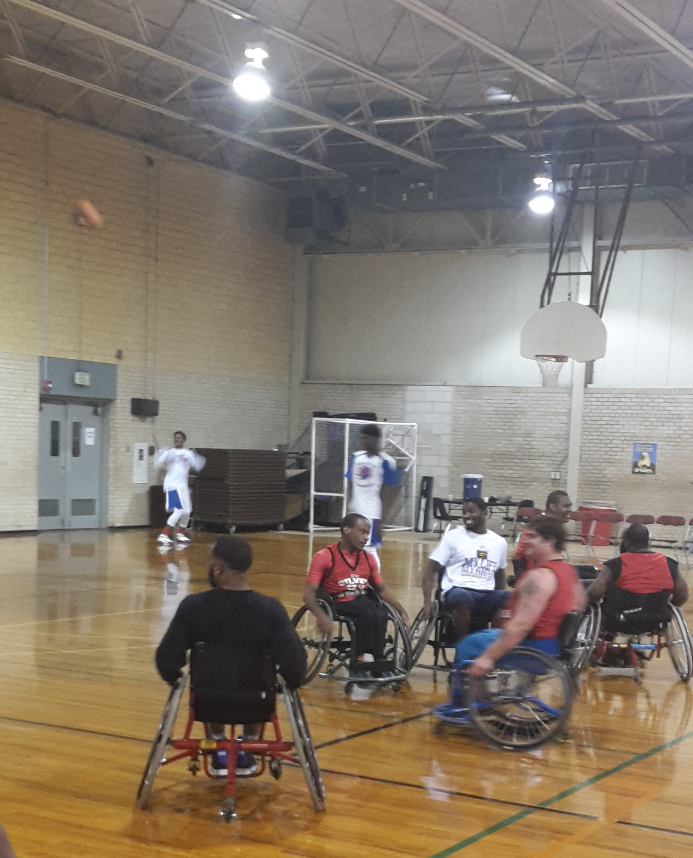

5.0 – Students

5.01 There shall be formal and ongoing processes designed to generate, maintain, and consider student input relative to those aspects of the academic unit affecting their professional preparation.

Evidence of Compliance: The Leisure Studies Program is collecting (or should we say collects) information from graduating seniors in their Exit Survey administered through the Office of Career Services. This survey is administered by the Office of Career Services. The online survey is available after entering the Office of Career Services website under the Software Support links in the left-hand column. Information from the exit survey solicits feedback from the students’ overall undergraduate experience, especially within the classroom, internship, and interactions with faculty. In addition to the exit questionnaire, the faculty feel more student involvement can and should be rendered. Therefore, the following changes will be put into place starting in 2017. Student representatives will have the opportunity to come to staff meetings monthly and are encouraged to share concerns and also participate in the discussion. In addition, more questionnaires will be given to students to analyze their academic experiences and to evaluate where faculty and staff can improve.

Input from students is also received by way of dialogues with members of the undergraduate clubs namely the KSLS Majors Club along with members of Phi Epsilon Kappa Professional Fraternity. LSP majors have an opportunity to converse with Club Advisors who typically share any and all concerns, issues or challenges encountered by students during KSLS Departmental Meetings. Students also have the opportunity to provide input on any item or concern through call meetings, social media via the KSLS Facebook page or scheduling a meeting with any faculty member and/or the department head.
Student Exit Survey
5.02 Written policies and procedures shall exist for admission, retention, and dismissal of students from the academic unit.

Evidence of Compliance: Policies relative to admission, retention and dismissal of students from the Leisure Studies Program typically mirror those required for all students majoring in a degree program from the College of Education insert here from NCATE Hyperlinks.

LSP Policy Manual

Admission process - Catalog (GSU Page 20, College of Education Page 125)

Advisement Flow Chart

5.03 Student advising systems shall be effective, accessible to students, continually improved through evaluation, and include:

Evidence of Compliance: The LSP faculty are responsible for advising majors assigned to them according to areas of concentration. A LSP Advisement Handbook was developed with Advisors input to provide Advisors with information and act as a guide to Advisors to make a positive impact on the matriculation of the KSLS Student. Each Advisor is required to maintain an updated (by semester) list of advisees. This list is available upon request of the department head via the GSU Help Desk operated by the Information Technology Center (ITC). Advisors are required to reconcile their list of advisees each semester in light of the arrival of new students, students changing their majors, transfer students arriving each semester, and related items that impact retention (i.e. academic, economic, etc.). GSU operates a revolving admissions process that enables new students to begin their studies at the beginning of each semester or summer session.

The Advisors Handbook contains several forms of utmost importance to the Advisor. These forms include an:

- Admissions Criteria for Louisiana High School Graduates;
- Undergraduate Advisement Flowchart to include Leisure Studies Program Advisors Advisee Assignments;
- Senior Comprehensive Application Process;
- Internship Application Process;
- Advisors Evaluation Form;
- Undergraduate Curriculum Sheets;
- Advisee Check-List;
- Academic Advising Contract;
- Protocol- COE and Degree Program Admission; and,
- Additional Forms that include the KSLS and Leisure Studies Course Substitution Forms, Request for Permission to Audit Course, Major/ Minor Declaration Form, and a detailed Semester Advisee Check-List.

LSP utilizes an Advisement Evaluation Form modified from the GSU Advisement Evaluation Form. Developing the LSP Advisement Evaluation Form was a recommendation of the COA Onsite Visiting Team a(in 2011) for the LSP Advisement Evaluation Form and Academic Advisement Forms. To be considered complete, forms require signatures of the Academic Advisor and Advisee. After completion of the advisement process, the Advisement Forms are filed in the Advisee’s folder and locked in a file in the advisor's office. Any breach of a signed Advisement Form listing the Schedule of Classes for any semester or summer school session of enrollment is the consequence of the advisee. Any change in the Schedule of Classes for any semester or summer session must be approved by the academic advisor “before the change is made”.

Additionally, a course identified as ED 201 (Advisee Report) has been designed to enhance the advisement system within the College of Education. Although this is a zero (0) credit hour course, LSP majors along with all majors in the College of Education are required to complete 4 units and is included in their degree program. Students enroll in a specific section offered according to the area of concentration in their degree program. All faculty in the KSLS Department are assigned a specific section of ED 201: Advisee Report according to the area of concentration that is described in the 2013–2015 General Catalog, SP majors meet periodically throughout the semester to monitor their progress toward degree, reviewing their degree plan making adjustments where appropriate, and pre-registering for the subsequent semester when period for pre-registration begins each semester.

5.03.01 Academic advising. Suggested Evidence of Compliance: Degree planning documents, policies, and a description of procedures.

Evidence of Compliance: The KSLS Department developed a comprehensive advisement system in 2013 and illustrated in the KSLS Undergraduate Advisement Flow Chart. In its basic form, the flow chart includes the primary organization of the KSLS Department with specific duties for all faculty members engaged in the advisement process. For students majoring in the Leisure Studies track (General Recreation and/or Therapeutic Recreation), advisement is under the guidance of the Coordinator of Leisure Studies with advisement duties for all LSP faculty as depicted on Slide 1. This pattern of advisement is followed until students reach different stages in their degree program; that is, as a student’s classification changes, their designated advisor may also change. This flow of advisement continues leading-up to preparation for a student’s internship or student-teaching experience depending on their specific area of concentration within the degree program.

The KSLS Undergraduate Advisement Flow Chart is reviewed annually with required modifications incorporated as recommended by faculty members through the respective Program Coordinators.
Student Advisory Handbook
Leisure Studies Academic Curriculum Sheet

5.03.02 Professional and career advising. Suggested Evidence of Compliance: Professional/career portfolios, resumes, employment documents, participation in seminars, and plans for acquisition of professional credentials.

Evidence of Compliance: Student professionalism and career success are top priorities with the LSP faculty. The following are examples of the evidence to demonstrate:
- Resume and Cover Letter: Students are prepared before their internship to develop a resume and cover letter. Students are first taught how to make a resume and cover letter by the LSP internship coordinator. The student then brings the first draft of their resume and cover letter to the Career Services Office. Career Services gives the students additional tips and then also corrections. After the student makes adjustments to their resume and cover letter after their visit to the Career Services, the student then meets with the LSP Internship Coordinator one-on-one to finish a final draft. This process helps students apply for internships, but is also essential for finding jobs after graduation.

- Internship Portfolios: Each student is required to put together an internship portfolio. This includes their professional work as an intern, including their weekly journals, capstone project, and weekly reports of experience. Students are instructed that their portfolio can be used as a resource for a future job interview or as a reference when working in the field.

- Professional Conferences: Students are encouraged to be involved in professional organizations. The following are examples of student involvement in professional organizations:

  - 2014: 13 students attended the National Conference for Therapeutic Recreation.
  - 2014: Eight people attended the local LRPA conference.
  - 2015: Five students attended the state LRPA conference.
  - 2015: Five students attended the stat LAPHERD conference.
  - 2016: Eight students attended the NIRSA Conference
  - 2016: Eight students attended the Gulf Coast Therapeutic Recreation.
  - 2016: A student attended the Therapeutic Recreation Symposium for the Southwest and received a scholarship for her service within the field.

- Social Media (Facebook): Most LSP students use social media, including Facebook. In 2015, the LSP began a Facebook page for students and alumni. Through Facebook, students and alumni are able to connect and therefore, increase networks. In addition, the LSP internship coordinator posts job opportunities on the Facebook page. Facebook has shown to be a great avenue to reach out to more students and alumni and increase visibility in the profession.

- Professional Credentialing: Students are encouraged throughout their undergraduate studies and after their graduation to obtain sit for national exams and acquire their credentials in their field.

In addition to services provided to Leisure Studies Program majors by faculty advisors, the University’s Office of Career Services provides an array of services to “all” students irrespective of major (www.gram.edu/student-life/services/career-center). With an obvious slant toward upperclassmen, staff from the Office of Career Services interface with a number of academic departments regarding the services available along with providing support for items such as resume building, etiquette and interviewing skills just to name a few.

Career Services Calendar of Events

Career Services Newsletter
Student Exit Survey

5.04 Student records shall be maintained in compliance with accepted confidentiality practices.

Evidence of Compliance: See Grambling State University’s FERPA statement below:

Confidentiality Practices for student records (FERPA)

5.05 There shall be ongoing student involvement in professional organizations, activities of those organizations, and in professional service.

Evidence of Compliance: Leisure Studies’ students are involved with several professional organizations and have been in attendance at several conferences. Below are some of the conferences attended by LSP students:
2014: Thirteen students attended the national conference for Therapeutic Recreation.
2014: Eight people attended the local LRPA conference.
2015: Five students attended the state LRPA conference.
2015: Five students attended the stat LAPHERD conference.
2016: Eight students attended the NIRSA Conference
2016: Eight students attended the Gulf Coast Therapeutic Recreation.
2016: A student attended the Therapeutic Recreation Southwest Conference and received a scholarship for her service within the field.

In addition to attending conferences, the majors are encouraged to join the Louisiana Recreation and Park Association (LRPA). Many students since 2012 have been recipients of the LRPA scholarship for their academic abilities and community service.

LSP students also have two organizations they can join. The Kinesiology, Sport, and Leisure Studies (KSLS) Club is opened to all students who wish to be involved. The KSLS Club participates in service opportunities throughout each year, including sponsoring parades, volunteering with local community recreation programs, etc. The second club LSP students can join is the Phi Epsilon Kappa (PEK). This is an honor club and requires a certain GPA and is oriented to community service.

6.0 Instructional Resources

6.01 Administrative support services shall be sufficient to enable the program to accomplish its mission and operate in a manner consistent with its values.

Evidence of Compliance: The Kinesiology, Sport Management, and Leisure Studies (KSLS) Department has access to administrative support from various entities. The KSLS Department has an Administrative Assistant who directly assists the Department Head and Leisure Studies faculty with clerical and office support. The Administrative Assistant assigns/monitors all students assigned to the KSLS Department for their College Work-Study assignment inclusive of assigning these students to assist and/or support faculty as may be requested. The College of Education also provides academic support to departments in the college via an Administrative Aide or a Laboratory Technicians upon approval of the Dean. Additionally, Leisure Studies faculty utilize staff from the Departments of Information Technology Center (ITC) and Distance Learning (DL) for any technological issues and training including training the Learning Management Systems LMS).

Leisure Studies faculty received new computers in 2016 and are provided laptops and projectors as needed from the Office of Academic Affairs. Two classrooms (Rooms 164 and 165) located in the Fredrick C. Hobdy Assembly Center are equipped with smartboards and the others require laptop/projectors to be set-up for class instruction. Grambling State University is also moving to a new LMS via Canvass in 2017 demonstrating their desire to provide up-to-date classroom technology that appears to be more user friendly for both faculty and students.

6.02 There shall be properly located and equipped faculty offices of sufficient quality to adequately address privacy and confidentiality issues, and that are of a number and size comparable to other programs housed in the academic unit and consistent with institutional policy.

Evidence of Compliance: The KSLS department is housed in the Assembly Center at Grambling State University. The LSP faculty each have an office adequate and equal to other disciplines in the university. The office space is adequate to store student information, textbooks, etc. In addition, these offices are sufficient in size to effectively work and to maintain confidentiality with classroom information and when addressing students’ overall privacy. Furthermore, the KSLS department also maintains an equipment room with supplies for classroom activities.

6.03 There shall be adequate conference rooms for faculty use, study areas for students, and meeting space for student organizations.

Evidence of Compliance: LSP students and faculty have access to the KSLS Departmental Conference Room, eight classrooms, a computer laboratory along with a dance studio. The establishment of an Exercise Physiology Laboratory is in progress for student instruction, practice, research, and study. Meeting spaces for student organizations and announcements of activities is facilitated through Student Affairs. Additional spaces for study is provided in the student lounge area located in the Favrot Student Union and in the Fredrick C. Hobdy Assembly Center located in the Mary A. Hobdy Foyer on the main corridor of the Second Level.

6.04 There shall be classrooms, laboratory and teaching areas, and appropriate content specific instructional areas for the academic unit.

Evidence of Compliance: The Fred C. Assembly Center, which has Wi-Fi capacity, has sufficient instructional resources to facilitate the program. Noted previously, the Assembly Center has eight well equipped class rooms. Two of the rooms are equipped with a Smart Board. There is an Exercise Physiology Laboratory that is currently being updated with specialized instructional equipment from Title III funds, an Academic Enhancement Resource Center via computer laboratory. Each classroom has heavy duty desk and chairs. The Mary A. Hobdy Foyer is spacious enough to accommodate multipurpose movement-oriented activities, lectures and classes.

In instances where a student with special needs will be attending a course, the Instructor-of-Record will receive notification from the University’s Student Counseling Center regarding needs of the student. The student is instructed to identify her/himself to the Instructor-of-Record for plans to be developed to address the needs.

The Assembly Center meets all ADA requirements to include lavatories, elevators, Braille markings and parking. Planned modernization, renovation and restoration of select outdoor spaces at Grambling State University will provide additional opportunities for students majoring in both the General Recreation and Therapeutic Recreation programs to enroll in additional courses specifically geared toward Leisure Studies programming and enhance the overall quality of instruction in the KSLS Department. In terms of off-campus opportunities, the LSP also has access to the Methodist Children’s Home Outdoor Sanctuary that includes rope courses, equestrian therapy, hiking trails, gardening, etc. Other venues available to students enrolled in the LSP include the Ruston Park and Recreation Association (RPAR) and the Shreveport Park and Recreation Association (SPAR).

6.05 Sufficient resources shall be present to properly implement the curriculum of the parks, recreation, tourism, and related professions academic unit, including access to special services for individuals with disabilities.

Evidence of Compliance: The Fredrick C. Hobdy Assembly Center is equipped with sufficient technology to implement the basic curriculum. The classrooms include up-to-date laptop computers, smartboards with audio and video conference capabilities and the building has excellent Wi-Fi services. The computer Lab, located on the first floor of the assembly center, is available for classroom usage.

The Office of Disability Services, located in the GSU Student Counseling Wellness and Resource Center is to ensure access for students with documented disabilities be able to contribute to the development of self-advocacy. We encourage students to take control of their own learning and to discuss the means for arranging types of appropriate support. The center serves as an advocate for students in determining appropriate consideration.

ADA Compliance and services for individuals with disabilities (Page 14, Page 48)

6.06 All instructional areas, faculty offices, and other educational facilities shall comply with the requirements of the Americans with Disabilities Act (ADA) and the amendments to the Act.

Evidence of Compliance: The Fredrick C. Hobdy Assembly Center was opened in 2007, where the Department of Kinesiology Sport, and Leisure Studies Recreation. Room 148 serves as the Main Office for the department and houses offices for the Coordinator of Kinesiology along with the Coordinator of Leisure Studies. Immediately upon entering the main office, hard copies of all undergraduate and graduate curriculum sheets are available for GSU students and the general public. All official departmental documents (i.e. curriculum sheets, student files etc.) are maintained in a secure file cabinets; a designated locked room is also home to secured student’s records. The faculty corridor serves as home to all faculty officers in Suite 173 (A-U). The building is in compliance with the City of Grambling, State and federal building codes and the ADA guidelines.

6.07 Library resources and access shall be sufficient to enable the program to accomplish its mission and operate in a manner consistent with its values.
Suggested Evidence of Compliance: Documentation of the adequacy of library resources (financial, materials, reference, staffing, etc.) and services and an evaluation of the adequacy of library resources, in terms of the mission and values of the unit.

Evidence of Compliance: Grambling State University has been serviced by the A.C. Lewis Memorial Library which is the main library centrally located on the campus. This two-story structure, initially constructed in 1961 and updated in 2000 and 2002, has adequate library resources and electronic databases to support the LSP. The LSP annually has an opportunity to place request to update the library collection with new books and related resources consistent with the LS discipline. After fall 2016 request, the program was granted a book purchase budget of $1,500.00. It should be noted here that all academic departments are provided an annual book allocation. Specifically, the KSLS Department has received hard-copies and electronic copies of select journals related to recreation, park, and tourism on a regular basis.

Library Collection of Park, Recreation, and Tourism Books and Journals
6.08 Computing technology and computing support services available to faculty, staff, and students of the parks, recreation, tourism, and related professions academic unit shall be sufficient to enable the program to accomplish its mission and operate in a manner consistent with its values.
Evidence of Compliance: Grambling State University (GSU) has many options for Information Technology. Technology support and services are considered a major strength in the delivery of educational program offerings at GSU. LSP faculty have a desktop computer and printer, as well as access to other state of the art equipment and technologies, including Smart Boards, laptops, projectors, copy/scanner machines, scantron machine for exams, etc. Students have a computer technology fee assessed each semester that supports student computer equipment and laboratories. The largest computer laboratory is located in Jacob T. Steward, with approximately 100 computers, specifically for student use. This computer center remains open throughout the week until midnight, with different hours of operation on weekend. In addition, the Kinesiology, Sport Management, and Leisure Studies Department has a separate computer laboratory specifically for our majors housed in the Assembly Center Room 176. This computer laboratory is used for classes to meet in when necessary and for individual use for students.
7.0 Learning Outcomes

7.01 Students graduating from the program shall demonstrate the following entry-level knowledge: a) the nature and scope of the relevant park, recreation, tourism or related professions and their associated industries; b) techniques and processes used by professionals and workers in these industries; and c) the foundation of the profession in history, science and philosophy.

Evidence of compliance: The Leisure Studies program has evident of meeting standard 7.01 according to the attached COAPRT 7 Series Templates

Template - REC 201- Outdoor Recreation
Template - REC 225 - Fieldbase Practicum
Template - REC 301 Program Planning in Recreation
Template - REC 327 Design and Maintenance of Recreation and Sport Facilities
Template - REC 350 LeadershipGroup Dynamics in Recreation and Sport.
Template - REC 380 Management of Leisure Services
Template - REC 408 Research and Computer Use in Recreation
Template - REC 410 - Legal Liabilities in Recreation and Sport
Template - REC 416 Internship in Recreation
Template - REC 417 Level Test III
Template - TREC 302 - Disabling Conditions in TREC



