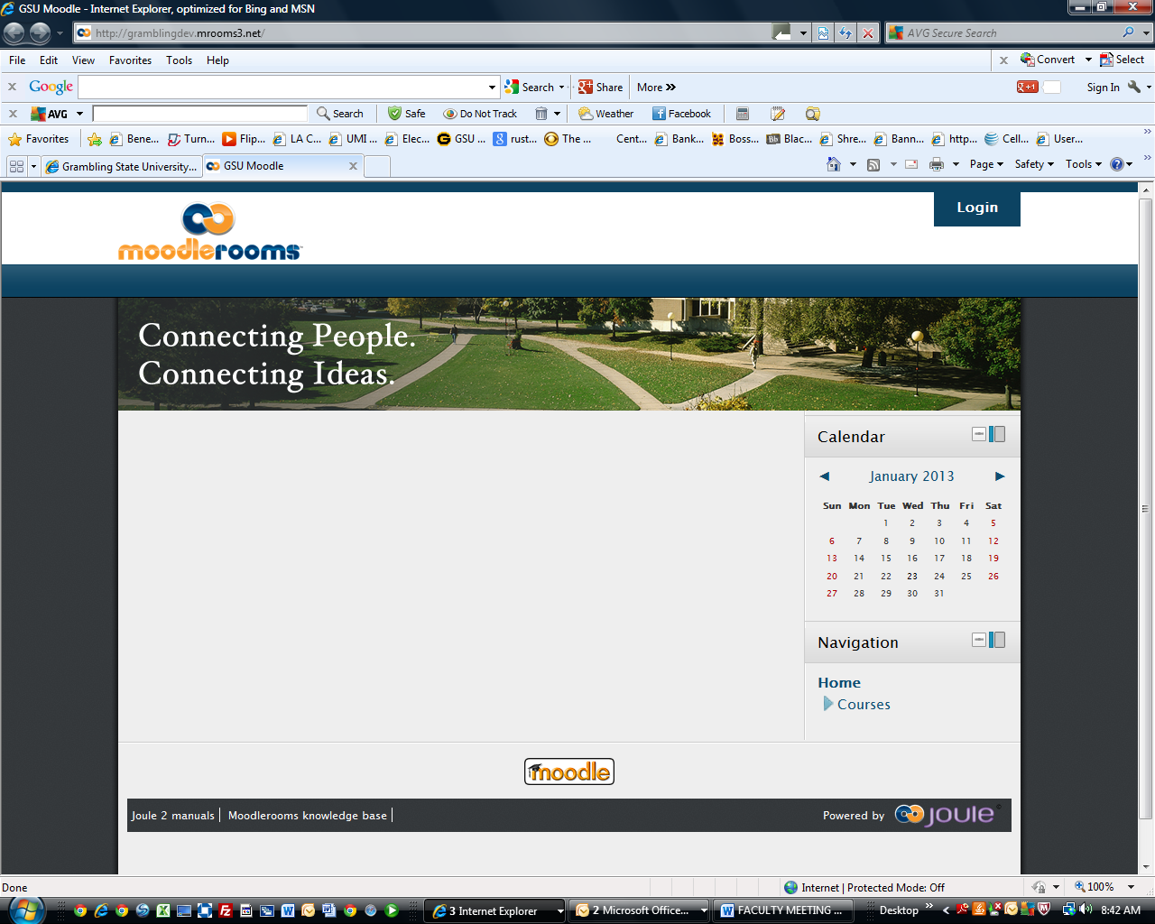

COMING SUMMER 2013!!!!!!!
MOODLE UPGRADES TO VERSION 2.3.

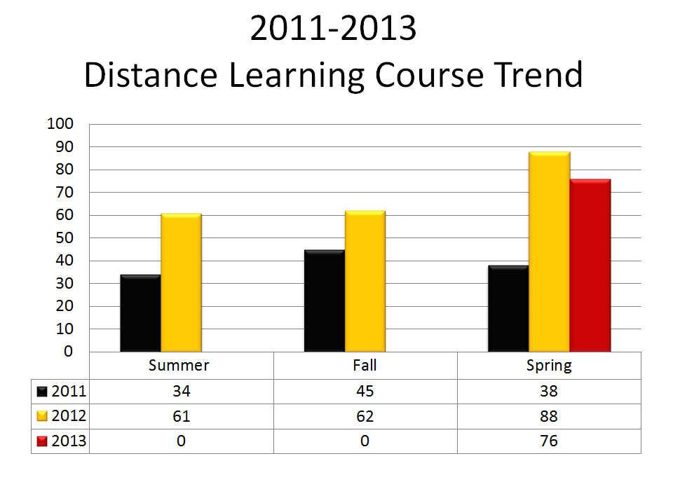
__________________________________________________________

Faculty eLearning Training Workshops

The Office of Distance Learning (ODL), in collaboration with the Faculty & Staff Professional Development and Reaffirmation Program (FSPDRP), will offer the following workshops per semester:






Location: Fred C. Hobdy Assembly Center
Room: Faculty Professional Development Lab (176)

To review a complete listing of the calendar and register for workshops:

- Login to Banner Web
- Click on Distance Learning User
- Click on Distance Learning Registration
- Complete the registration form

The ODL appreciates your cooperation and continued support.

* Please note: All software will be used to enhance classroom instruction and integration into Moodle Course Management Systems.

If you have any questions, please contact:

Eldrie B. Hamilton :318.274.6321 ~ : hamiltoneb@gram.edu
La Tina S. Johnson :318.274.6411 ~ : johnsonl@gram.edu
Jacques P. Prudhomme :318.274.2192 ~ : prudhomme@gram.edu

