**SmarterID Instructions for Students**

Schools may provide this information to your students in course syllabi, orientation courses, etc. Feel free to edit as you consider appropriate. There are two phases for using SmarterID: Authentication and Verification. Instructions for students in each phase are below.

**-------------------------------------------------------------------------------**

**Information about SmarterID**

This course requires you to authenticate at multiple times during the course using a tool called SmarterID. The first time you use SmarterID at this school you will be asked to provide an image of your government issued ID using a cell phone, camera or scanner. This image will be compared to a database of thousands of valid IDs to ensure that your ID is valid. During this initial authentication you will also be instructed to look at your webcam so that a baseline photo is collected. Once you have finished this step, the enrollment process will be completed and you will not be required to authenticate using your ID again in SmarterID.

After this initial authentication, you then may be prompted at multiple, random times during the course to verify your identity as the enrolled student. To do so, look directly at your webcam and follow the on-screen instructions to look in a random direction. The verification will only take about 15 seconds.

**A webcam is required** as you are taking courses that verify student identity using SmarterID. Webcams are inexpensive ($15 or less) and can be purchased at stores selling computing equipment. Minimum resolution is 640 x 480 with recommended resolution at 1280 x 720.

**A government issued photo ID is required**. For the initial authentication, be sure and have your government issued photo ID available in hand. Acceptable forms of identification include US and international driver’s licenses, nondriver identification cards, photo voter identification cards, passports, and military identification cards. **School issued photo ID cards are NOT acceptable.** After completing the validation of your ID, the SmarterID enrollment process is complete and you will not be asked to do it again.

**Instructions for Initial Authentication Using SmarterID**

1. SmarterID is a solution that authenticates your identity using facial recognition technology. Early in your experience as a student at this school you will be prompted to enroll in SmarterID
2. To begin, click the **“Get started”** button. *Note: you will* ***not*** *have to do this for every course, only the very first course.*

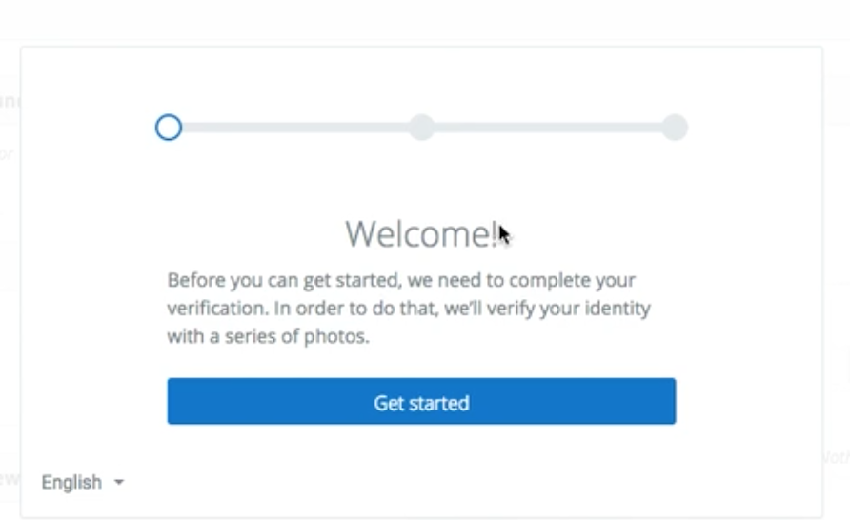

1. Next, answer the question on the screen “Have a smartphone”? If you do, click “Yes”; if you do not, click “No”.

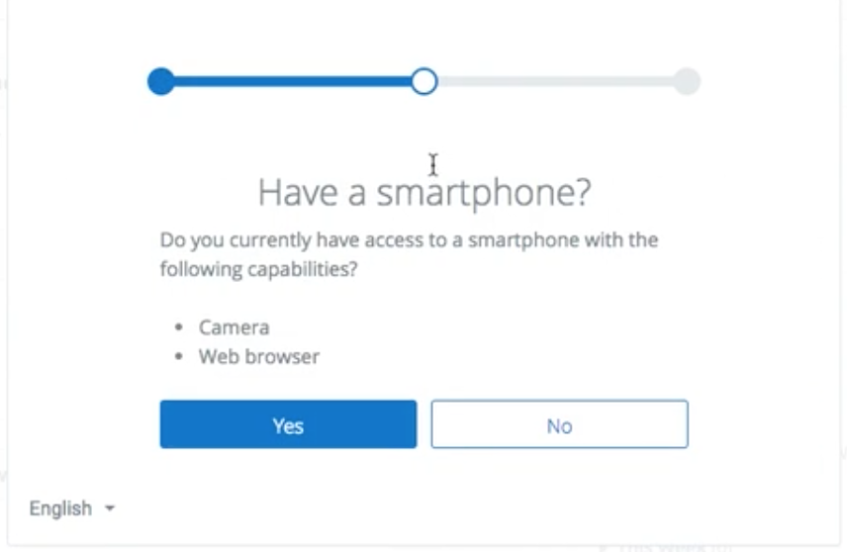

* 1. If you clicked “yes’, follow instructions on your screen. Enter your cell phone number, and click “Text me the link”. You’ll be prompted to take the Identification photos using your cell phone.

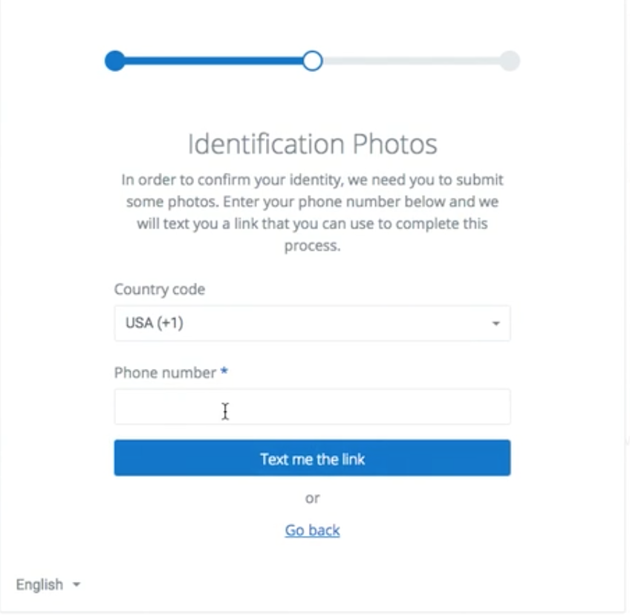

* 1. If you clicked “No”, you will be prompted to scan and upload the required Identification photos.

1. Whether you do complete via the cell phone method or the scan and upload method, you will be prompted to enroll using 3 photos.
2. **Front of your government-issued ID**

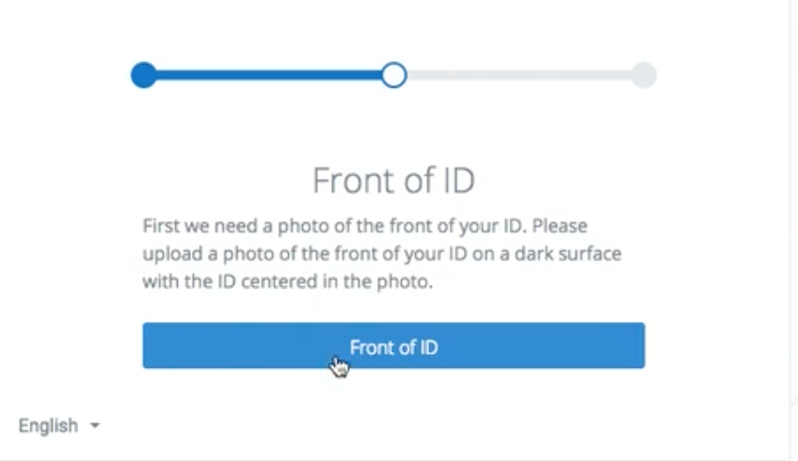

After clicking Front of ID, take/select the photo you wish to use and click “Use this photo”. *Note: Ensure that the photo is centered and of high quality with good lighting.*

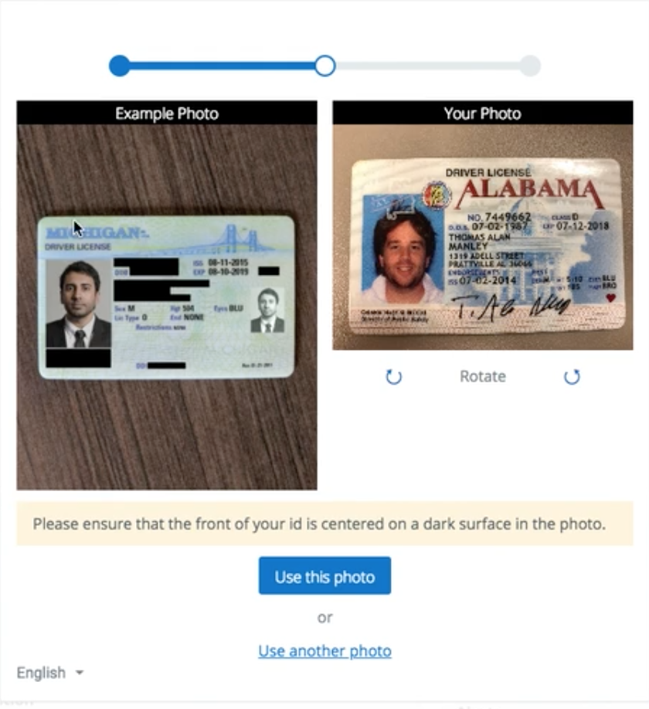

1. **Back of government-issued ID**

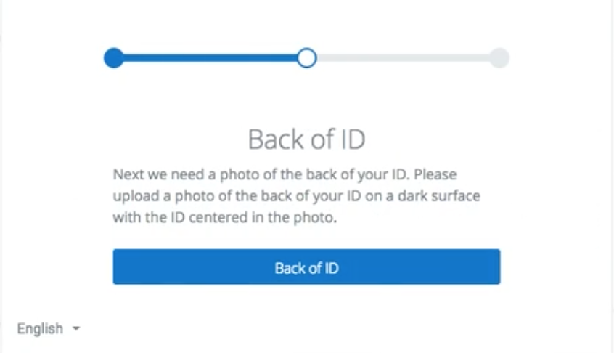

After clicking Back of ID, take/select the photo you wish to use and click “Use this photo”. *Note: Ensure that the photo is centered and of high quality with good lighting.*

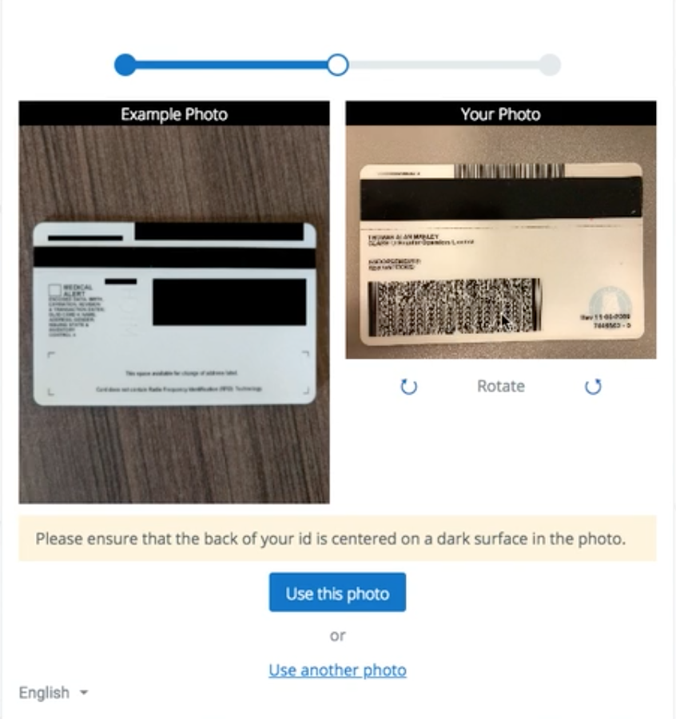

1. **Picture of your face**

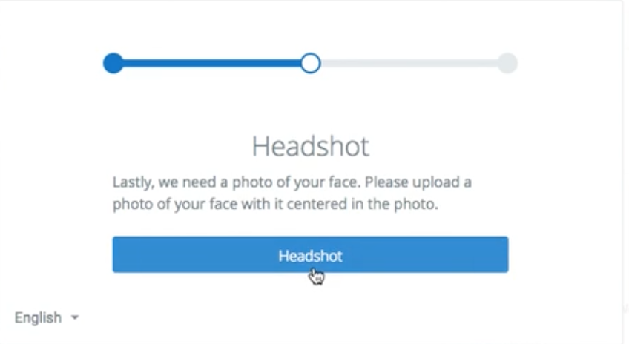

After clicking Headshot, take/select the photo you wish to use and click “Use this photo”. *Note: Ensure that the photo is centered and of high quality with good lighting.*

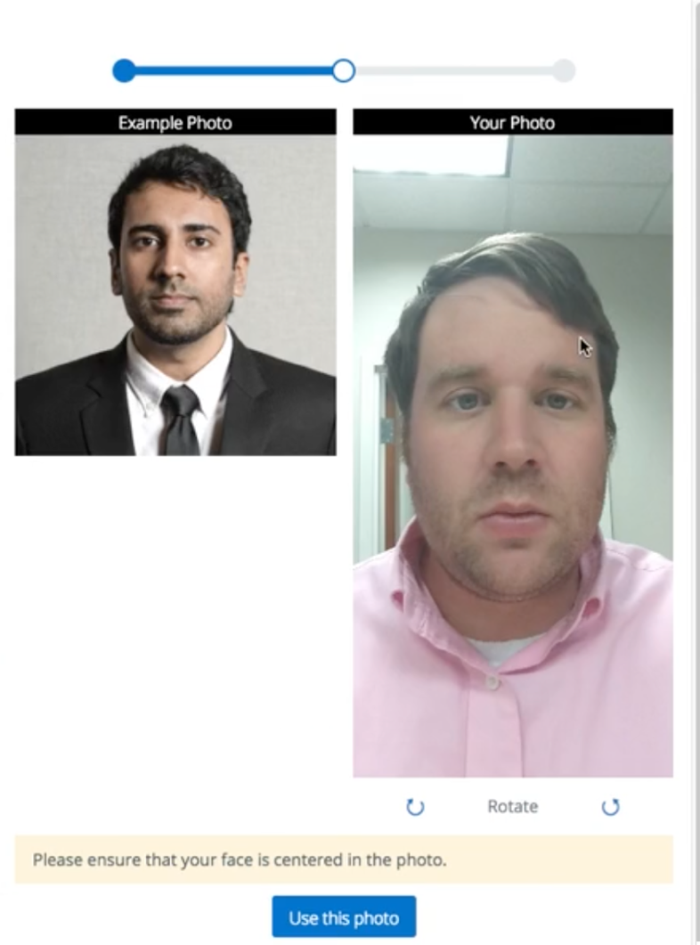

1. The system then validates the authenticity of the ID and ensures the face on the ID matches the picture of the headshot. Upon validation, continue to your course. *Note: this process typically takes 30 seconds.*

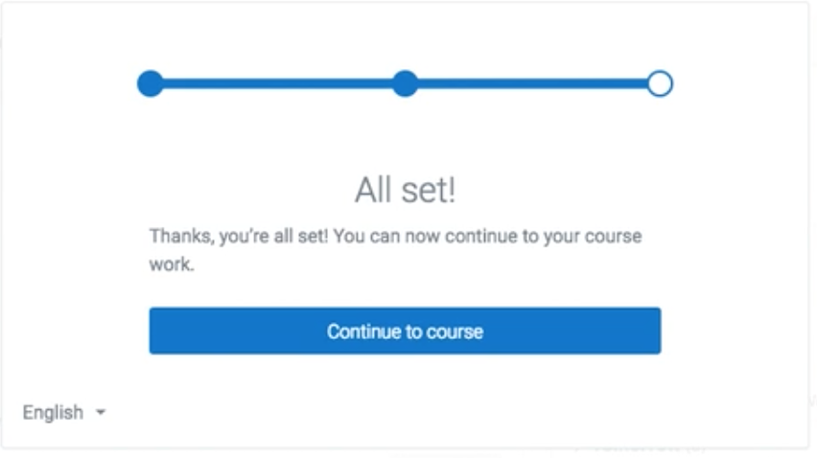

1. If you have difficulty with this process, you may contact the SmarterID support team using the support icon in the top, right side of the screen, or email [support@smarterid.com](mailto:support@smarterid.com).

**Instructions for Verification During the Course Using SmarterID**

1. At random points while inside your courses, you will be asked to verify your identity. Click “Continue” to enable your webcam in order to verify.

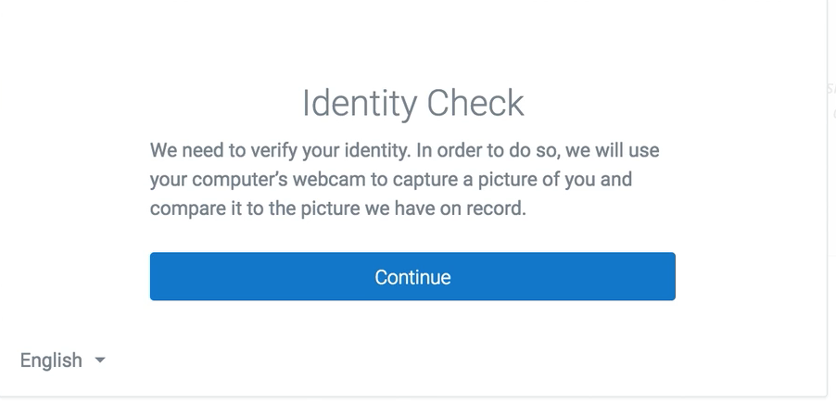

1. After clicking continue, follow instructions and position your face into the view of the webcam, your webcam will turn on so that you see yourself. This may take a few seconds.

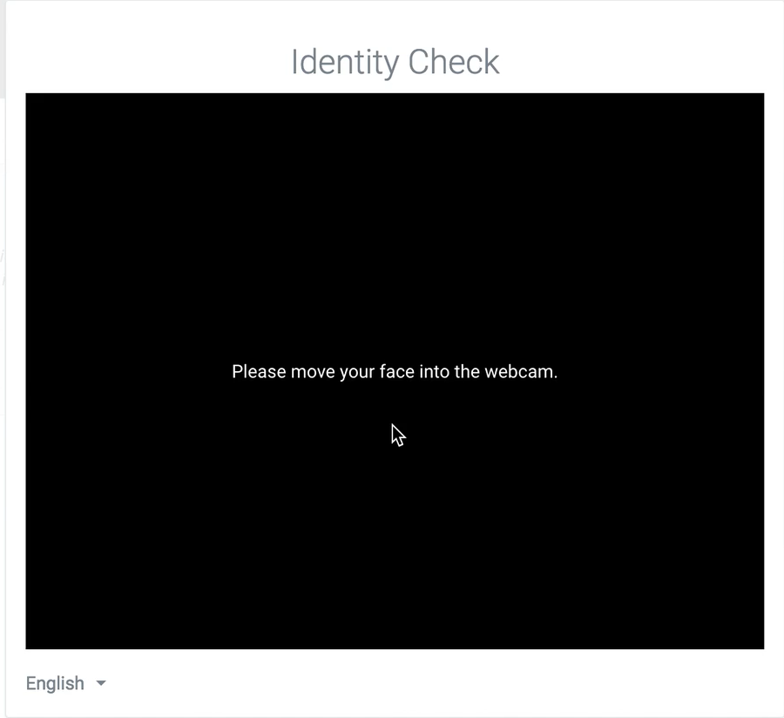

1. To authenticate your identity, follow instructions and turn your head toward the direction of the arrow so that the arrow moves into the target (see image). Note: Don’t turn your head hard and fast; simply incline your head slightly toward the direction indicated as if you are using your nose to guide the arrow into the target.

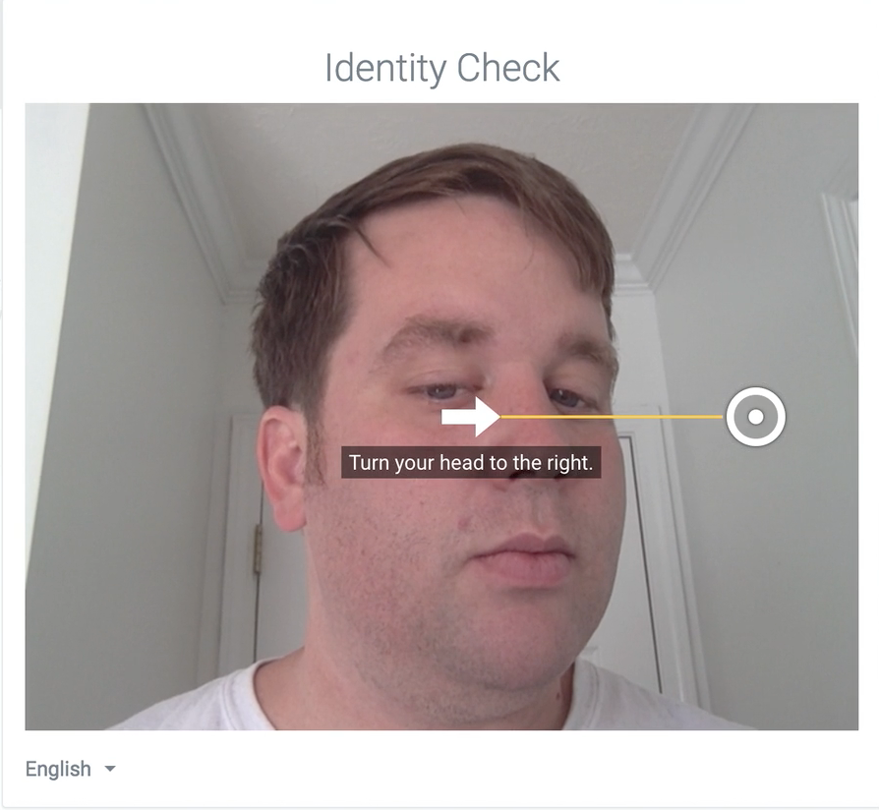

1. When the arrow meets the target, you will see a green check. Note: You will be asked to complete this step 2 or 3 times per authentication.

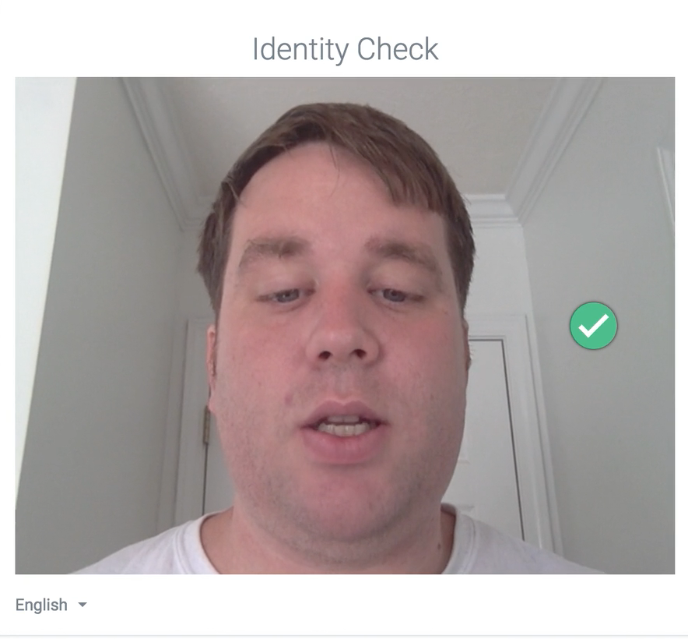

1. Upon completion, you may continue with your coursework.
2. If you have difficulty with this process you may contact the SmarterID support team using the support icon in the top, right side of the screen or email [support@smarterid.com](mailto:support@smarterid.com).