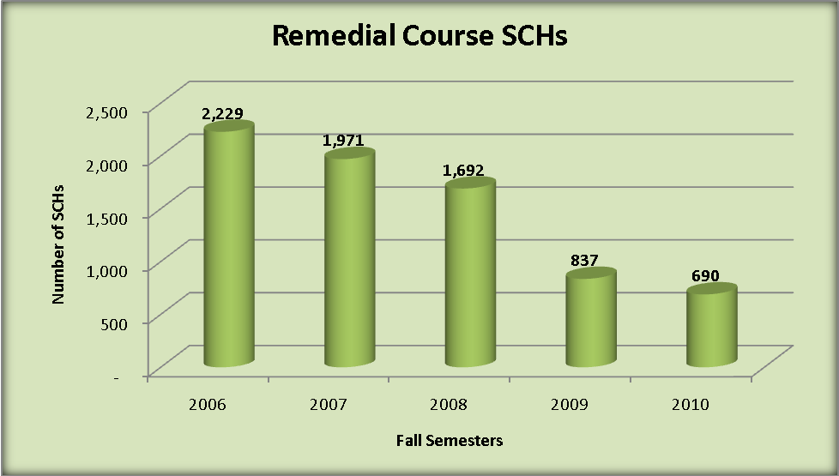

Trend in Remedial Course Offerings per Student Credit Hours (SCHs)
Fall Semester | Developmental Courses |  | Lower Level Courses |  | Upper Level Courses |  | Total Undergraduate SCHs
Fall Semester | No | % | No | % | No | % | Total Undergraduate SCHs
2006 | 2,229 | 3.5% | 36,589 | 56.8% | 25,556 | 39.7% | 64,374
2007 | 1,971 | 3.0% | 37,849 | 57.1% | 26,443 | 39.9% | 66,263
2008 | 1,692 | 2.5% | 39,096 | 57.3% | 27,397 | 40.2% | 68,185
2009 | 837 | 1.3% | 33,966 | 54.3% | 27,763 | 44.4% | 62,566
2010 | 690 | 1.1% | 31,152 | 51.8% | 28,336 | 47.1% | 60,178

