GRAMBLING STATE UNIVERSITY

ACADEMIC ADVISING MANUAL

August 2009
TABLE OF CONTENT

Grambling State University’s Definition of Advising ……………….. 4

Grambling State University’s Goals of Academic Advising ……………….. 5

Introduction ……………….. 6

Characteristics of Advisors ……………….. 6

Advisor Roles/Responsibilities ……………….. 6

Advisee Roles/Responsibilities ……………….. 7

Grambling State University’s Academic Advising Model ……………….. 7

Procedure for Assigning Advisees to Advisors ……………….. 8

Advising of Student-Athletes ……………….. 11

Procedure for Changing Advisors ……………….. 12

Change of Major ……………….. 12

Enrollment in Developmental Courses ……………….. 13
Academic Advising Plan ……………….. 13

Curriculum Sheets ……………….. 14

Academic Advising Contract ……………….. 15

Record Sheet ……………….. 17

Alternate PIN ……………….. 17

Course Substitutions ……………….. 17

Banner Web ……………….. 18

Registration Holds ……………….. 18

Satisfactory Academic Progress/Financial Aid ……………….. 19

Admission Requirements for Professional Programs
(Social Work, Nursing, and Education) ……………….. 20

Transfer Credits ……………….. 23

Advanced Placement Program Credit ……………….. 23

College Level Examination Program Credit ……………….. 24

Credit By Departmental Examination ……………….. 24

Credit For Military Service ……………….. 24

Auditing Courses ……………….. 24

Inter-Institutional Cooperative Program (ICP) ……………….. 25

Undergraduate Taking Graduate Credit Course ……………….. 27

Academic Probation ……………….. 27

Academic Suspension ……………….. 27

Academic Renewal ……………….. 28

Rising Junior Examination ……………….. 28

Graduation Requirements ……………….. 28

Double Majors ……………….. 32

Requirements for second undergraduate degree ……………….. 32

Minors ……………….. 32

Associate Degrees ……………….. 32

Support Services ……………….. 32

Academic Advising Evaluation ……………….. 33

Grambling State University’s
Definition of Advising

Academic advising is a developmental process in which students are assisted and guided in clarifying their life/career goals and in developing educational plans for realizing those goals. It is a decision-making process that is ongoing, multi-faceted, and the responsibility of both student and advisor.

Grambling State University’s Goals of Academic Advising
- Assist students in developing an educational plan that helps them achieve their life/career goals (e.g., chosen program(s) of study).
- Assist students in monitoring and evaluating their progress toward established goals.
- Assist students in obtaining services from other campus and/or community agencies when necessary.
- Facilitate and coordinate student communication with campus and community stakeholders through effective networking.

Introduction

Grambling State University (GSU) recognizes the important role advising plays in the academic success of students as well as in their growth and development as future leaders. As a result this manual was designed as a resource for the “Advisor”. All full-time faculty at GSU serve as advisors. The university offers Advisement Training for all new faculty and at specified times offers workshops for “seasoned faculty” that focus on issues related to advising. GSU strives to maintain an advisor/advisee ratio of 1 to 30. Several strategies can be used to deal with overloads, such as course load reductions (e.g., a maximum of 3 credit hours per year for 30 additional students); faculty assistance from other departments with low enrollments; student-peer advising; departmental/college group advising; and utilizing paraprofessionals for advising.

Characteristics of Advisors

Advisors must possess special traits in support of the advisement process. These traits include listening and communication skills as well as knowledge of academic policies. The following items are desired characteristics of advisors.
- Knowledge of academic policies and procedures
- Committed to serving as an Advisor
- Concerned and caring attitude
- Effective communication skills and active listening skills
- Adherence to high ethical and professional standards
- Demonstrate student-centered behavior

Advisor Roles/Responsibilities

The responsibilities of an advisor are not limited to assisting the student with selection of courses. The advisor must consider the “whole” person and encourage the student to think about “life after Grambling”. The following items are advisor roles and responsibilities.

- Help students define and develop educational and career goals
- Assist students in planning a program consistent with their abilities, interests and resources
- Assist students in monitoring progress toward educational/career goals
- Discuss linkages and relationships between instructional program, career and further educational pursuits, where appropriate
- Inform students of the nature of the advisor/student relationship
- Obtain written administrative approval prior to making
course substitutions
- Refer students to other sources when educational, attitudinal, attendance, financial, employment, or other personal issues require the service of other professionals
- Schedule and meet with each advisee at least twice in a semester
- Interpret and provide rationale for academic policies, procedures, and requirements

Advisee Roles/Responsibilities

The advisee plays a critical role in the success of the Advisement Process. Advisors should make advisees aware of their responsibilities. Advisors are not required to “hunt” students down or force them to follow recommendations. The following items are advisee responsibilities.

- Meet with advisor at least twice in a semester
- Adhere to academic advising contract
- Demonstrate ownership in the advising process by obtaining knowledge about requirements and policies
- Consult with advisor before taking courses off-site or on-line courses
- Select major before the end of sophomore year
- Complete rising junior exam at the completion of 45 credit hours
- Maintain an updated curriculum sheet on file
- Consult with advisor about deficient grades
- Exhibit responsible behavior by; being an active listener, providing contact data to advisor, keeping scheduled appointments, and by being receptive to professional guidance
- Read & abide by rules and regulations listed in the catalog

Grambling State University’s Academic Advising Model

The Academic Advisement Model that GSU uses is a Split Model. Students who have selected a major are advised by their major department. Students who have not selected a major are advised by the Office of Academic Support and Special Programs. Students with ACT scores of 21 or higher may be co-advised by the major department and the Honors College, since the Honors College is an optional educational experience.

GSU Advising Model

Procedure for Assigning Advisees to Advisors

Each unit uses the following procedure for assigning advisees to advisors. This process is done prior to the arrival of the incoming freshman on campus. The name of the advisor and contact information are provided to the student prior to his/her arrival on campus.

- Each unit will identify an individual (Coordinator of Advising) who will have the responsibility of assigning incoming students to an advisor. Note: In small departments (50 majors or less) the department head may serve as the Coordinator of Advising.
- The Admissions Office will provide each Dean with a list of incoming students who have declared a major in their respective area. This list will be distributed at least three weeks prior to the start of each semester. (Updates to the list will be provided as needed).
- The Coordinator of Advising will assign advisees to advisors. During this process strict attention will be paid to the University’s established maximum advisor/advisee ratio. One of the following methods will be used by degree programs.
  - Last Names: Each Advisor is assigned Advisees based upon the first letter of the last name of the student. For example, Advisor #1 is assigned advisees who have last names that begin with A-D. Advisor #2 is assigned advisees who have last names that begin with E-H, etc.
  - Rotating: Using the list of incoming freshmen and transfer students that is provided by Admissions, each advisor is assigned an advisee. The first student on the list is assigned to Advisor #1, the next student is assigned to Advisor #2, and the student that follows is assigned to Advisor #3. This process is repeated until all students on the list have been assigned an advisee. (This process is more suited for the smaller departments).
- Dual Advisors have specific duties that relate to the advisement process. The Honors College advises the Advisee relative to Honor College activities. The academic department advises the student relative to degree program activities/matters.

- Students who are dual-advised will be made aware of the function/purpose of each Advisor by both Advisors.

- The Coordinator of Advising will generate a list that identifies the Advisor for each Advisee and share this information with the department head.

- The department head will enter advisor/advisee information into Banner.

- The Coordinator of Advising will give each advisor a list of advisees who have been assigned to him/her.

- The Coordinator or Department Head will contact incoming students making them aware of the name of their advisor and the office room number and telephone number for this individual three weeks prior to the start of the semester.

- After the fourteenth class day each Advisor will submit a list of the names of the students that were actually advised for that current semester (advisement could have taken place during early registration) to the Coordinator of Advising.

- The Coordinator of Advising will compare the list of advisees to students that were actually advised in an effort to determine if some students are not utilizing their advisors during the advisement process. The results of this comparison will be submitted to the Department Head and Dean.

- In the event that it becomes necessary to assign a new advisor to a student, the Coordinator of Advising will be contacted by the assigned advisor and/or department head. Once a new advisor is assigned, this information will be given to the department head and entered into Banner.

DIAGRAM OF PROCEDURE FOR ASSIGNING ADVISEES TO ADVISORS

Advising of Student Athletes

NCAA & Grambling State University Academic Eligibility Guidelines

To remain eligible for intercollegiate athletics, student-athletes must meet Grambling State University, Southwestern Athletic Conference and NCAA academic standards. These requirements are listed below.

- After Two Semesters – 24 credit hours must be earned. Eighteen of these hours must be earned during the Fall and Spring semesters. The student must have at least a 1.8 cumulative GPA.
- After Four Semesters – 40% of the courses required in the degree program must be completed. The student must have at least a 1.9 cumulative GPA.
- After Six Semesters – 60% of the courses required in the degree program must be completed. The student must have at least a 2.0 cumulative GPA.
- After Eight Semesters – 80% of the courses required in the degree program must be completed. The student must have at least a 2.0 cumulative GPA.
- To be eligible for competition a student-athlete must have earned/passed 6 credit hours during the previous semester.
- The student-athlete must maintain a full-time load each semester with the exception of athletes who are candidates for graduation and require less than a full-time load to complete major curriculum requirements.

For additional academic eligibility status requirements, please contact the Athletic Compliance Office at X6279.

Advising of Student Athletes during First Year

Athletes should be advised to enroll in a minimum of 15 credit hours (excluding the Summer Session) in an effort to ensure that full-time status is maintained. The athlete should provide a copy of the pre-approved class schedule to the Academic Enhancement Coordinator, who will pay special attention to NCAA/GSU Academic Eligibility Regulations.

Procedure for Changing Advisors

Under rare circumstances it may become necessary for a student or advisor to make a request that a new advisor be assigned. To facilitate this change in advisor the student or the advisor must make this request in writing to the department head. The reason for the change must be clearly stated. Within one week of receiving the written request the department head will refer the request to the Coordinator of Advising. The Coordinator of Advising will assign a new advisor or deny the request

Change of Major

A student changing his/her major must complete a “Major/Minor Declaration” Form. This form requires the student to obtain the signatures of the Dean and Department Head of their current major as well as the signatures of the Dean and Department Head of the new intended major. Once all signatures have been obtained the completed form must be taken to the Registrar’s Office for processing.

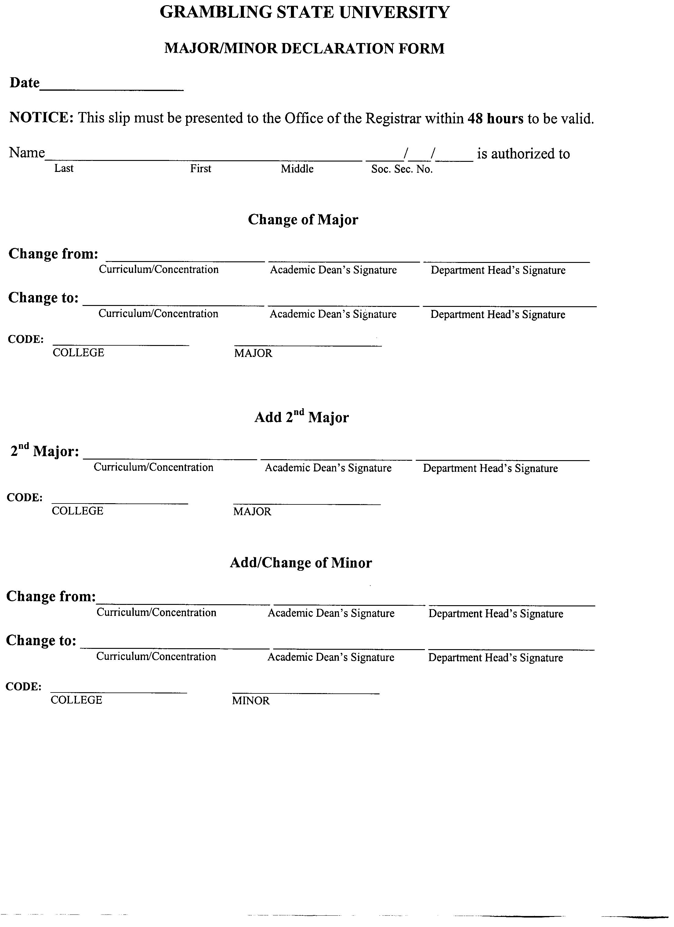

Enrollment in Developmental Courses

All entering students with ACT scores/equivalent SAT scores below 15 in the English subject area of the exam are to be enrolled in Basic English 093. Students who earn below a 19 on the mathematics component of the ACT exam will be given the mathematics placement exam. Those students who earn a certain minimum score (will be announced) on the mathematics placement exam will not be required to enroll in developmental mathematics. Those students not meeting the minimum score requirement on the placement exam must be enrolled in Basic Math 099.

Academic Advisement Plan

Each student will have an Academic Advisement Plan which will consist of the following elements:

- A curriculum Sheet
- Academic Advisement Contracts

An Academic Plan shall be maintained by the advisor for each advisee. Students shall be given copies of the curriculum sheet and the academic advisement contract each semester.

Curriculum Sheets

Each degree program has a curriculum sheet that outlines the courses that should be taken by academic year. The curriculum sheet also has space available for grades to be entered for each course taken, along with a space for the semester the course was taken. Most curriculum sheets also have an area devoted to course substitutions.

Grades that were earned for courses taken during a semester should be entered onto the curriculum sheet by the advisor or student (verified by the advisor at that time) at the beginning of the next semester. This updated curriculum sheet will allow both the student and advisor to easily see what remains to be taken in an effort to fulfill graduation course requirements. An updated copy of the curriculum sheet will be placed in the student’s folder, which is maintained in the department.

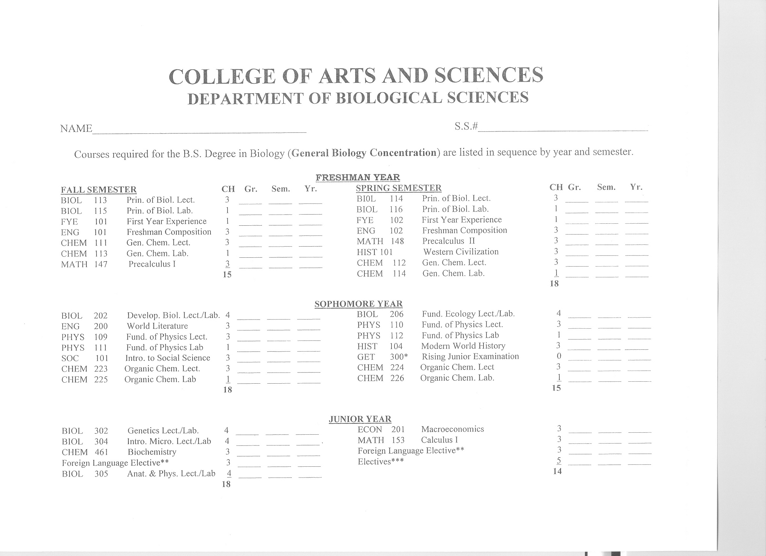
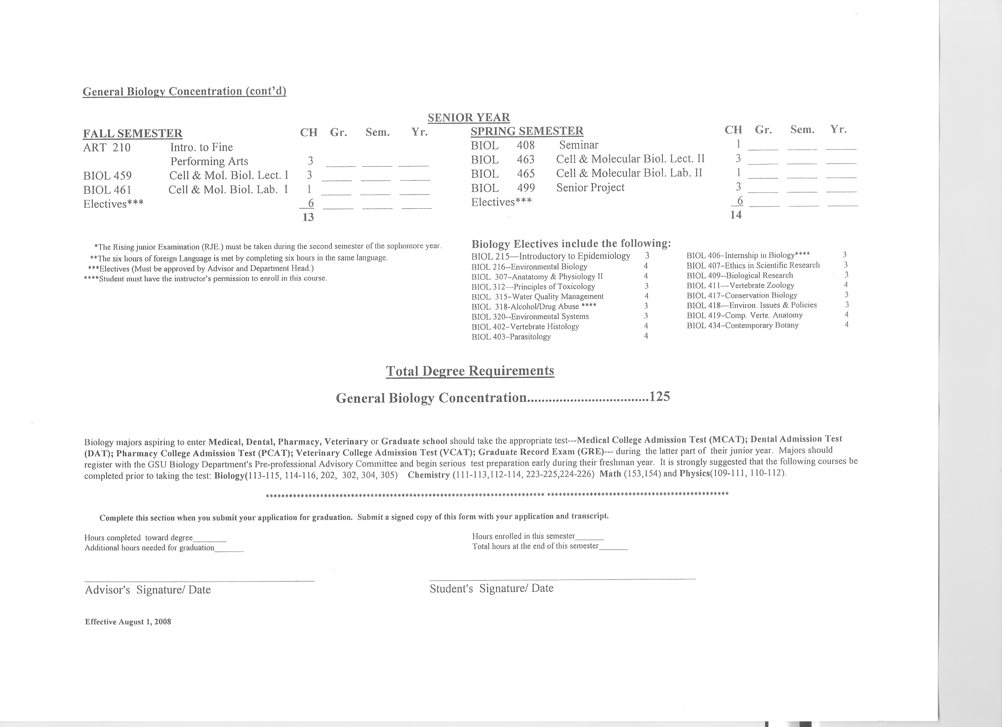

Academic Advising Contracts

The Academic Advising Contract is a critical document. The student and the advisor will complete a contract prior to the beginning of the student registering for a given semester. This contract can serve as a legal document verifying what has been agreed upon between the advisee and the advisor. A dated original copy that contains the signature of the advisor and advisee must be kept in the student’s folder that is housed in the department. The contract contains contact information about the student, his/her course schedule for the semester and a notes section. The notes section of this document allows comments to be written by the advisor that are related to the advisement process. For example, a notation should be made in this section indicating a student refuses to take a course after being advised to do so. Once the contract is signed and dated by both the advisee and the advisor the student should receive a copy of the contract, along with an alternate pin number, which will allow the student to enter classes into Banner Web.

GSU ACADEMIC ADVISING CONTRACT

SEMESTER | YEAR

Name: |  | ID #:
Local  Address: |  | Permanent  Address:
Telephone #: |  | Telephone #:
Classification: |  | Major:
The student and the advisor should maintain a copy of this contract.
CRN  (Optional) | SUBJECT  COURSE | COURSE  TITLE | CREDIT  HOURS
Total Credit Hours:
Advisor Notes:
_______________________________ ________________________________
Student Signature Date Faculty Advisor Signature Date
Amendments to Contract: Any amendments to this contract must be signed by the student & the advisor.
I,________________________, shall inform my advisor on any change to my course
schedule within 24 hours of the change.

Bottom of Form

Record Sheet

The Record Sheet will be used to record the date and time, and subject of all meetings between the advisor and the student. The advisor must indicate on the Record Sheet any action that the student has been advised to undertake.

Advisor/Advisee Record Sheet

Advisee Name | Date | Time | Subject/Action | Advisee Signature
John Smith | 6/29/05 | 3-4 p.m. | Career options/Apply for internship with IBM
Jane Doe | 6/29/05 | 4-4:30 p.m. | Course enrollment
Henry Tate | 6/29/05 | 4:30-5 p.m. | Course enrollment

Alternate PIN

An Alternate PIN number is generated each semester for all students. This number changes each semester. It is given to the student after he/she has been advised and the academic advising contract has been completed. The advisor can access this PIN number by using Banner Web and entering the Faculty & Advisors menu. The alternate pin allows the student to enter his/her classes directly into Banner web from his/her student account. The student may also make adjustments to his/her schedule.

If an advisor chooses to allow the student to enter his or her own classes, the advisor must have met with the student, discussed/agreed upon course selections, and signed the academic contract. The Alternate PIN should not be given to a student who has not been advised by his/her designated advisor.

Course Substitutions

The advisor makes recommendations for course substitutions to the department head. Recommendations should be made as soon as possible. They must be made prior to a student taking a course. Substitutions are appropriate when the courses have similar content (80% or more of the content is the same). If the department head agrees with a recommendation, the recommendation is submitted to the Dean for his/her approval. Recommendations for course substitutions should be approved prior to registration and should not be entered on the curriculum sheet until the Dean has approved the request.

Banner Web

Prior to using Banner Web, an advisor must have an account. A Banner Web account request form can be obtained from Grambling’s web page. Once the Information Technology Center receives the request, the advisor will be assigned a user ID and a PIN number.

From the Faculty & Advisors menu, the advisor can access Banner Web from Grambling’s web page (www.gram.edu). Once on Banner Web, the advisor is allowed to do registration add/drops, view/print a student’s transcript, view a student’s grades and access the course catalog.

BANNER FACULTY & ADVISOR MENU

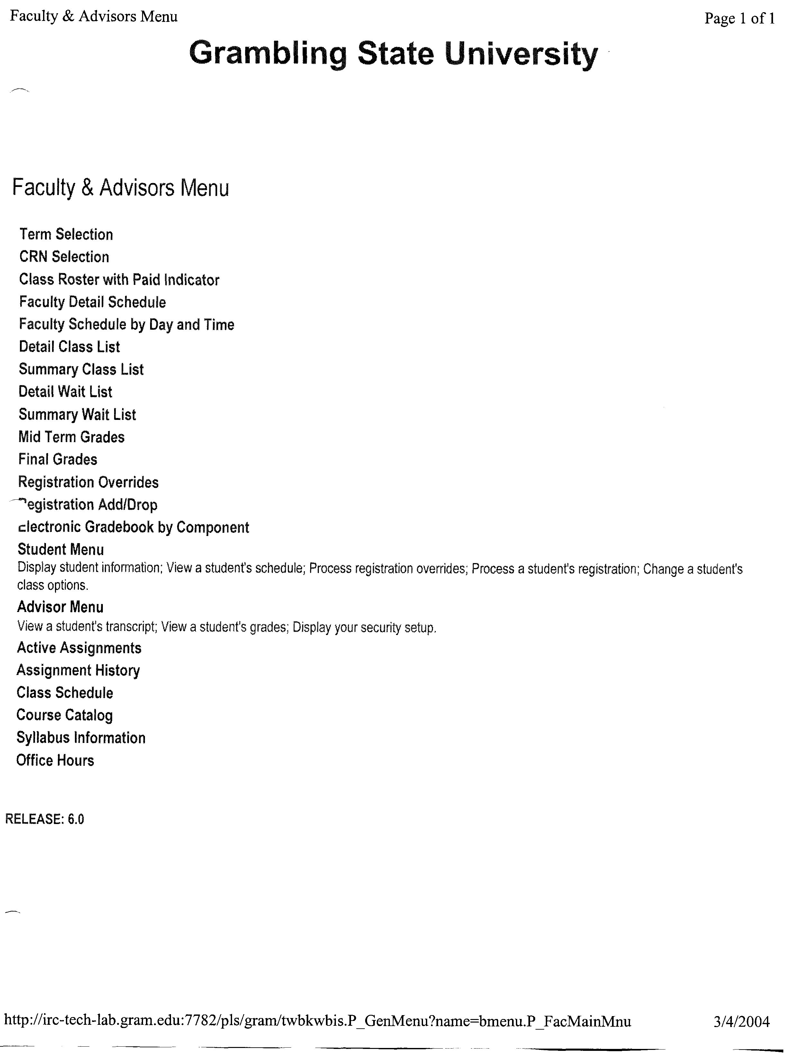

Registration Holds

A student’s record may have several holds that may impede the registration process. When attempting to enter classes into Banner, the system will indicate that there is a “hold”. Banner can be used to give the details of the hold.

- Students with immunization holds should be directed to the Foster Johnson Health Center, ext. 4251.
- Students with Delinquent Account Holds should be directed to Accounting.
- Students with an Academic Hold should be directed to the Dean of the College/School of that student’s major program.
- Students with a Judicial Hold should be directed to the Director of Judicial Affairs at ext. 3169.

Satisfactory Academic Progress/Financial Aid

Students are required to pass a specified number of hours with a minimum required grade point average during an academic year for continued eligibility for Federal Financial Aid. The academic year is composed of the Fall and Spring semesters and, excluding holidays and scheduled breaks, is approximately thirty weeks in duration

Students | Total hours attempted | Min% earned | Min. Cumulative GPA
Undergraduate (Baccalaureate) | 1-29 hrs  30-59 hrs | 50%  50% | 1.50  1.75
Undergraduate (Baccalaureate) | 60-188 hrs  Max hours with >188 hours | 67% | 2.0
Undergraduate  (associate) | 1-29 hrs  30-59 hrs  60-102 hrs  Max hours with >102 hrs | 50%  50%  67% | 1.50  1.75  2.0%
Undergraduate (undecided major) | 1-29 hrs  30-59 hrs | 50%  50% | 1.50  1.75
Undergraduate (undecided major) | 60-188 hrs  60-188 hours max hours with >188 | 67% | 2.0

Incomplete (I) grades are counted as failing (F) grades until the course has been completed. Repeated courses are included in the cumulative hours pursued and all grades earned in courses taken are used in the calculation of the cumulative grade point average.

Students receiving financial aid and whose attempted number of hours are 150% or greater than the total number of hours required for the major will be notified by the Office of Financial Aid. The department head in the student’s major area must complete a Satisfactory Academic Progress Form for those students.

Admission Requirements for Professional Programs (School of Social Work, School of Nursing, and College of Education)

School of Social Work

Freshmen majoring in Social Work whose composite score is 16 or higher, sophomores, juniors and seniors are advised by the program’s faculty. To socialize freshmen into the social work culture, the School of Social Work reaches out to these students through the Social Work Student Organization, the annual orientation, and through other sponsored functions.

There are 43 hours in the professional foundation, which begins when a student has earned 64 credit hours. Courses in the professional foundation are sequenced and span four semesters. These courses can not be taken out of sequence. If a student does not enter the professional foundation after completing 64 hours, that student will be out of sequence and will not be allowed to enter the professional foundation until the following year. This will result in the student remaining at the university an additional year. All students who have declared Social Work as a major must have a social work faculty as their advisor upon completion of the fourth semester or 64 credit hours.

For admission into Social Work a student must have a GPA of at least a 2.3 and should have completed the courses that are outlined in the curriculum for the freshman and sophomore years. Once admitted, a student cannot enter the practicum in field education with a GPA below a 2.0.

School of Nursing

General Information
- Applicants seeking admission to the pre-nursing component must meet the same requirements as all students admitted to Grambling State University.
- Students who have been unsuccessful (i.e. received grades of D, or F) in a pre-requisite science lecture or laboratory course two times will not be eligible for admission to the professional nursing component.

Course Substitutions
- Nursing 201- No substitutions will be allowed for this required pre-nursing course.
- Students must have credit in all required laboratory courses.

Louisiana State Board of Nursing requires any student who answers yes to any of the following questions to submit information required by the Board directly to LSBN by the student for review and action sixty (60) days prior to anticipated enrollment in a clinical nursing course.

The following questions must be answered honestly and truthfully:

- Have you had, or do you now have pending, any disciplinary actions against you by a licensing or certifying board in any state?
- Have you ever been arrested, charged with, convicted of, pled guilty or no contest to, or adjudged a juvenile delinquent, for any criminal offense in any state? (Even though an arrest, conviction or plea has been pardoned, expunged, dismissed, or your civil rights have been restored, you must answer “yes”. You may answer “no” if the juvenile offense has been expunged.)
- Within the last five (5) years, have you habitually used or been diagnosed as addicted to drugs or alcohol?
- Do you have any physical or mental impairment which may affect your ability to practice safely as a registered nurse?

Application to the Professional Component
1. Admission requirements and materials include:
- Eligible for or current enrollment at Grambling State University
- A notarized admissions application postmarked by April 1st for Fall admission or October 1st for Spring admission
- Official transcripts from all colleges and universities attended received in School of Nursing Office by April 1st for Fall Admission or October 1st for Spring
- Completion of all pre-nursing courses with a grade of “C” or above (The last grade earned will be the grade utilized)
- A 2.75 minimum adjusted grade point average in required courses (48 hours) in the pre-nursing component of the nursing curriculum (The last grade earned will be the grade utilized)
- A 2.75 for minimum adjusted grade point average in required science courses and mathematics course (23 hours) in the pre-nursing component of the nursing curriculum (The last grade earned will be the grade utilized)
- Two failures (D or F) in any required science course will disqualify a student from admission
- An admission application will not be reviewed if it is incomplete or received after the application deadline or if all required information is not received by deadline dates.
- Applicants will be notified of their admission status after all requested credentials and materials have been received and reviewed by School of Nursing Admissions and Academic Standards Committee. Student enrollment may be limited in proportion to faculty load and/or clinical facilities available.
- A student who has been denied admission to the professional program for any reason must RE-APPLY EACH SEMESTER to be reconsidered for enrollment.
- Applicant Ranking: All Applicants are reminded that completion of pre-nursing course requirements does not automatically assure admission to the professional nursing component. When the number of qualified applicants exceeds the number of openings in the professional component, a point system will be utilized to select students for admission.

The current curricula, educational plans, offerings, and requirements may be altered from time to time to carry out the purposes and objectives of the university. The provisions of the university catalog do not constitute an offer for a contract which may be accepted by students through registration and enrollment in the University, The University reserves the right to change any provision, offering, or requirement at any time within the student’s period of study at the University. The University further reserves the right (1) to involve students in experimentation designed to improve the curriculum and (2) to require a student to withdraw from the University for cause at any time.

College of Education

All students declaring Education as their major enter the College of Education via the CARE Center. Elementary/Early Childhood Majors and Special Education Majors are assigned an Advisor by the Head of Curriculum and Instruction. Secondary Education Majors are dual advised by an Advisor in the content area and an appropriate representative in the College of Education. Kinesiology (Pedagogy)/Recreation majors are advised by the Department of Kinesiology, Sport and Leisure Studies.

Admission requirements to the College of Education are outlined below:

- A completed Application for Admission, evidence of a 2.0 GPA and ACT/SAT scores are to be submitted to the NCATE/Certification Supervisor by the Advisor.

2. Upon request of the information specified in item 1, along with evidence of the completion of Core courses, the student’s application portfolio will be evaluated for admission to the College of Education.

3. Transfer Students
3.1 Students must complete appropriate application form that has been secured in the Office of Admissions.
  - Students must have a 2.0 GPA on all grades earned.
  - Students must bring a copy of their transcripts from previous institutions attended.
  - Students transferring in with 30 hours or more will not be required to take FYE 101/102 - Freshman Seminar.

Transfer Credits

Transfer credits earned at another university can be accepted by GSU if that institution is regionally accredited. Students transferring in with 30 hours or more are not required to take FYE 101 and 102 - Freshman Seminar I and II.

The Louisiana Board of Regents has an Articulation System that facilitates transfer of credit among Louisiana universities. To access this Articulation Agreement and to determine which course at another Louisiana University is equivalent to a GSU course please log onto www.regents.state.la.us/pdfs/Academic/Articulation%202009-2010/Master%20Matrix%20Master.pdf .

Advanced Placement Program Credit

Grambling State University does not offer Advance Placement Exams but does accept passing scores. Beginning students may be awarded college credit in some subjects as a result of the scores earned on Advance Placement Exams. Annually during the month of May, Advanced Placement Examinations are provided to students (not provided by GSU) who are enrolled in Advanced Placement Programs. See the table below for a summary of the exams, the credit awarded by GSU, and the minimum required examination scores.

AP Examination | Minimum  Score | Credit  Hours | GSU Courses
Art History | 4 | 3 | Art 215, 216
Biology | 4 | 4 | Biol 113, 115
Calculus AB | 4 | 3 | Math 131 or 147
Calculus BC | 4 | 3 | Math 153
Chemistry | 4 | 4 | Chem 105, 107
Computer Science A | 4 | 3 | CS 107
Computer Science AB | 4 | 3 | CS 110
Economics Macro | 4 | 3 | Econ 201
Economics Micro | 4 | 3 | Econ 202
English Language and Composition | 4 | 3 | Eng 101
English Literature and Composition | 4 | 3 | Eng 200
Environmental  Science | 4 | 3 | Science 101
French Language | 4 | 3 | French 101
Physics B | 4 | 4 | Phys 109,111
Physics C: Mechanics | 4 | 4 | Phys 153, 153L
Physics C: Electricity and Magnetism | 4 | 4 | Phys 154, 154L
Psychology | 4 | 3 | Psy 200
Spanish Language | 4 | 3 | Spanish 101
Studio Art Drawing | 4 | 3 | Art 101
U.S. History | 4 | 3 | Hist 201,202

College Level Examination Program (CLEP) Credit

A student at GSU may gain credit in a number of subjects by scoring on a Subject Examination at or above the level recommended by the College Level Examination Program. The examinations are available on campus at the Center for Academic Assessment. Registration must be completed three weeks prior to a test date. Applications are available in the Center for Academic Assessment.

Scores are provided by the Educational Testing Service with the exception of the essay for English composition which is scored by Grambling State University’s English Department. Students are graded on a pass/fail basis and must earn the minimum scores indicated for a passing grade. The grade is not computed in the student’s cumulative grade point average nor does it replace an earned letter grade. Students may not attempt credit by examination more than once for a given course. Credit by means of Subject CLEP Examinations is limited to 30 semester hours.

Credit by Departmental Examination

Several departments have departmental examinations that students who believe they have already master specific content that is equivalent to a course may take. The student must contact the department for approval to take the exam and must enroll in that course during the registration period. A student who fails a departmental exam may not take it again.

Credit For Military Service

Veterans with a minimum of one year of military service may receive credit for six semester hours of health and physical activity courses. The veteran must submit official copies of service records to the Registrar’s Office during the first semester of attendance.

Auditing Courses

A student may audit a class for personal enrichment. No college credit is earned for audited courses and the same fee that is charged for taking the course for credit is assessed. A student may not take more than the maximum allowable hours in a semester. The maximum allowable hours includes the audited hours.

A student may not audit more than 4 credit hours (only one course) in any semester. A course audited cannot be used to fulfill graduation requirements. A student may, however, take a course for credit that was previously audited at a later date.

The procedure for registering for an “audited” course is as follows.

- Student must meet admission requirements.
- Student must receive written approval from the department in which the course is offered.
- Student must take “approval document” to the Registrar’s Office.
- Student must pay the audit fee along with fees for courses taken for credit.

Inter-Institutional Cooperative Program (ICP)

Grambling State University and Louisiana Tech University operate a cooperative program that is designed to facilitate free exchange of students between the two universities. Both GSU and LA Tech University have courses that cannot be taken via ICP. The Registrar’s office has a list of these courses. Listed below is the procedure that a student who wants to take a course via ICP must complete.

- An application for courses to be taken via ICP must be obtained from GSU’s Registrar’s Office.
- The Department Head and Dean of the Student’s major must approve the courses selected and sign the ICP application.
- The signed application should be returned to the Registrar’s Office.
- An ICP student will be charged tuition based on a full-time load (regardless of the actual course load).
- GSU students planning to graduate in the Spring or Summer Sessions should not enroll in courses via ICP that are needed to fulfill graduation requirements. The end of the semester for GSU and the end of the quarter for LaTech do not coincide.

ICP Application

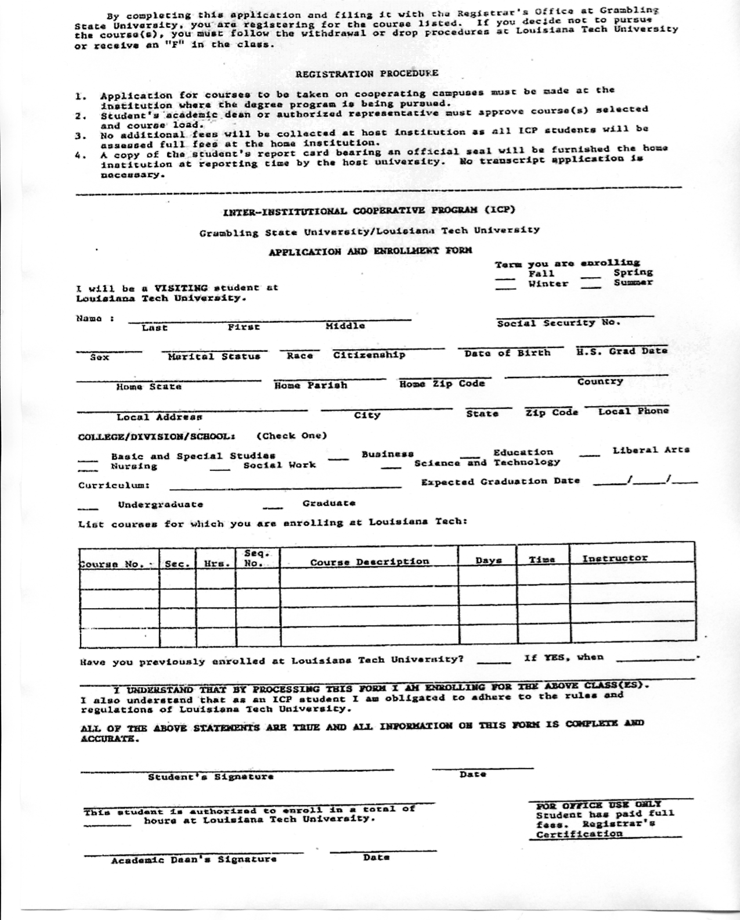

Undergraduate Taking Graduate Credit Course

Students classified as seniors who need 30 or less credit hours to complete baccalaureate degree requirements and have a grade point average of at least 3.20 may register for a graduate course. Approval must be obtained from the student’s department head, the college dean, the Dean of the Graduate School, and the head of the department offering the graduate course.

Academic Probation

A student is placed on academic probation when his/her cumulative average is at least ten quality points below a 2.0 average. Assuming that each semester after being placed on probation that the grades earned are at least 2.0, the student will remain on probation until a cumulative grade point average of 2.0 is achieved.

The following course load restrictions are placed on a student who is on probation.
- Student having a cumulative GPA of 1.5 or higher is limited to taking at most 15 semester hours during the Fall or Spring semester.
- Student having a cumulative GPA below1.5 is limited to taking 12 semester hours during the Fall or Spring semester.

Academic Suspension

A student on academic probation is suspended from GSU at the end of any semester (including summer session) in which a grade point average of at least a 2.0 is not obtained. A first-time freshman who was admitted in good standing will not be suspended prior to the completion of two semesters of study.

Students who have been suspended during a spring semester may attend summer school without appeal. If the cumulative GPA is raised to at least a 2.0 the suspension is removed. If the cumulative GPA is not raised to at least a 2.0 the suspension remains in effect for the fall semester.

A student has the right to appeal a suspension when extenuating circumstances impacted the academic performance. Appeals must be made in writing to the academic dean of the student’s major. Supporting documentation must be included with the written appeal.

Second or Subsequent Suspension

Students who have been suspended from the University a subsequent time at the end of the spring semester may attend summer school without appeal. Student must make an appeal for admission to any other semester. While on suspension the student must remain out of GSU or any other University within the University of Louisiana system for one calendar year.

Readmission of Former GSU Students
A student who has not attend the university for one regular semester (for any reason including academic suspension) must reapply for admission and meet the same requirements as a newly admitted transfer student must meet.

Academic Renewal

Undergraduate students who have not been enrolled in any university for at least three calendar years prior to enrolling at GSU at the time of application for admission may file for academic renewal in the Registrar’s Office. If Academic Renewal is granted no courses taken prior to enrolling at GSU may be used for graduation purposes or used to calculate the grade point average. These courses will however remain on the transcript.

Note: Academic renewal can only be granted once!

Rising Junior Examination

The Academic Profile is used as the “Rising Junior Examination”. The test focuses on the academic skills developed through the general education courses. It does this by testing college-level reading, college-level writing, critical thinking, and mathematics within the context of the humanities, social sciences, and natural sciences.

Sophomores who have earned at least 45 semester hours of credit including the general education requirements should enroll in GET 300. A student must pass the exam as one requirement for graduation.

The Rising Junior Examination is administered each semester. The official dates are published.

Results of the examination are provided to academic deans, who in turn, will provide copies to departments. The departments will notify students of their results. If a student fails any skill dimension (s), the department should encourage the student to take advantage of intervention services. After intervention, the student must retake the dimension (s) that he or she failed.

Graduation Requirements

A student eligible for graduation must meet the following requirements.

- File an application in the Dean’s Office at the time of registration during the last semester in which the candidate is expected to complete degree requirements.
- Complete one of the undergraduate curricula.
- Have at least a 2.0 adjusted grade point average (Some degree programs require a higher adjusted GPA).
- Earn a passing score on the Rising Junior Exam.
- Earn the last thirty semester hours in residence (Exceptions to this regulation may be made at the Dean’s discretion).
- Clear all financial obligations.
- Be present for commencement exercises (The academic dean can approve an absence).

APPLICATION FOR UNDERGRADUATE DEGREE 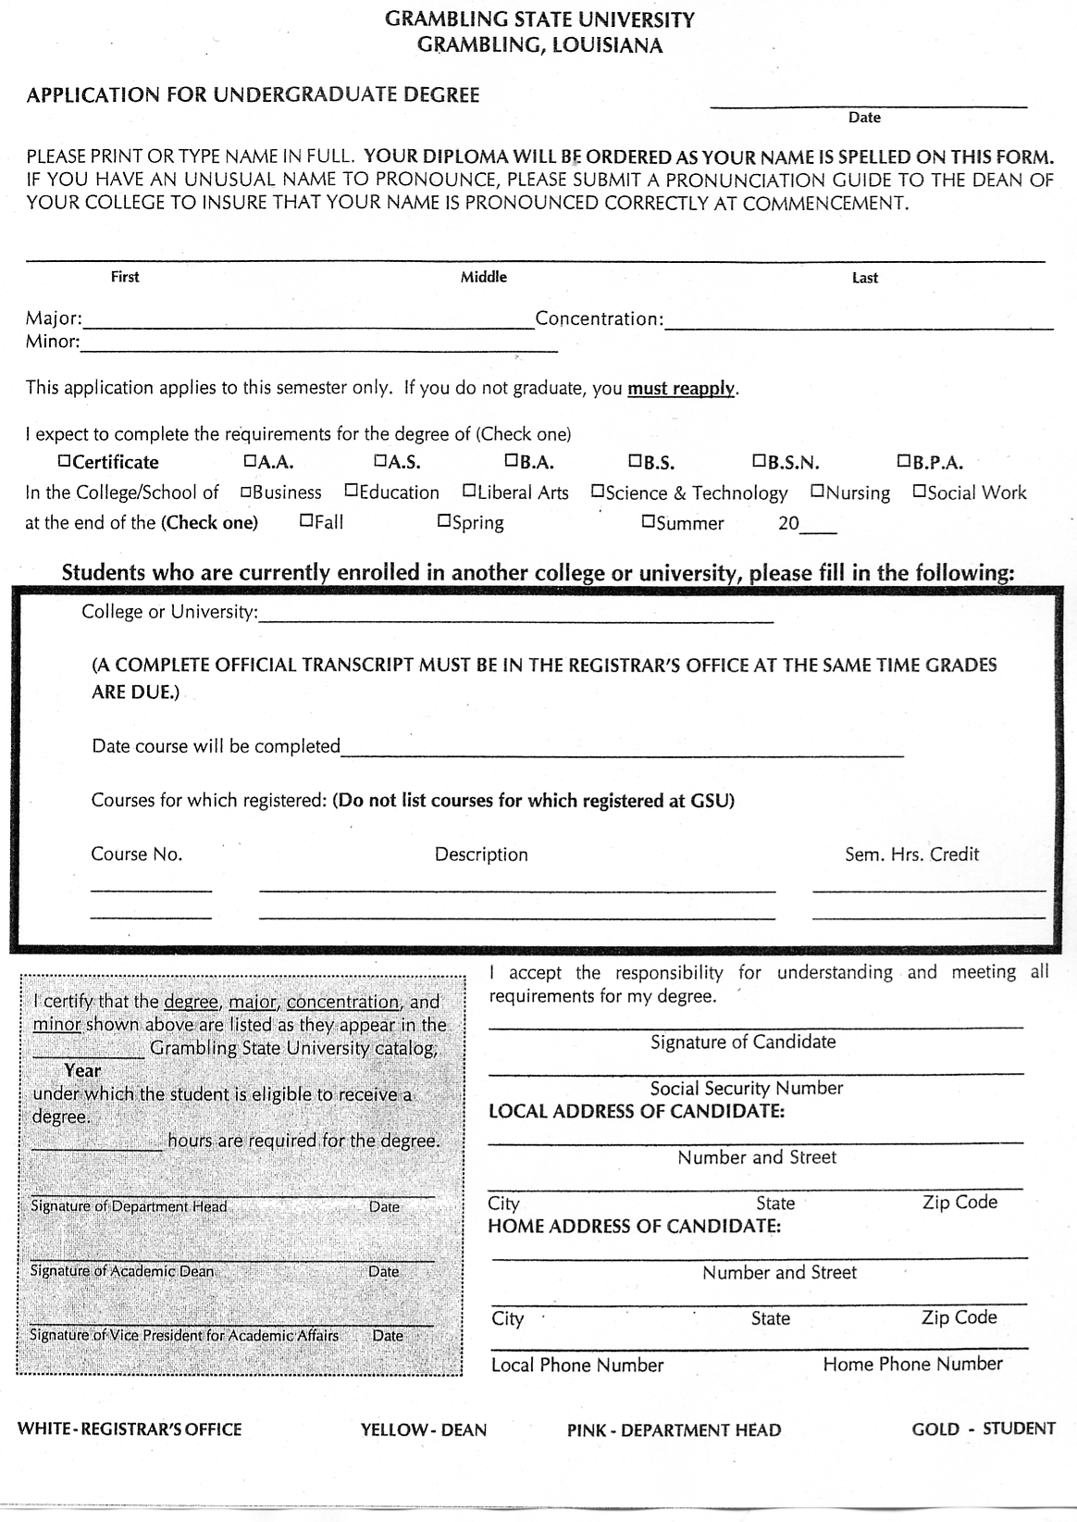

GRADUATION CERTIFICATION FORM

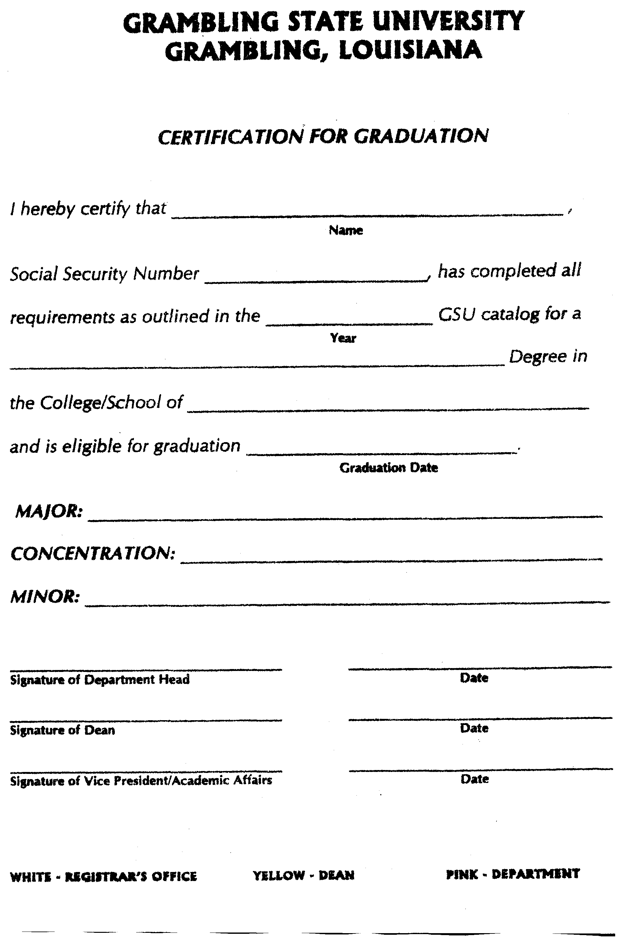

Double Majors

Students declaring a double major must be advised by both “major” departments. An Advisor will be assigned by both areas and each area will maintain an academic folder for the student.

Requirements for a second undergraduate degree

A student earning a second bachelor degree must earn at least an additional thirty semester hours beyond the first degree and must satisfy all requirements for the second degree.

Minors

Students declaring minors must be advised by the area in which the minor is housed and must complete the Major/minor Declaration Form. The minor will appear on the transcript upon graduation if the minor has been indicated on the graduation application and proper documentation is attached. The department head of the area in which the minor is housed must write a memo indicating that the student has completed or is completing the requirements for a minor. The courses completed toward the minor must be listed in this memo. A copy of this memo must be attached to the graduation application as well as the graduation certification form.

Associate Degrees

A student may not receive an associate degree in a major after receiving a higher degree in that area. Students pursing associate degrees cannot earn a minor.

Support Services

- Student Intervention & Resource Center- This unit offers counseling services to students and faculty. This unit also coordinates ADA services for students. The Coordinator of this service can be reached at 274-3762. The Student Intervention & Resource Center is located in the West-wing of the Foster-Johnson Health Center. (274-3338 or 274-3277)

- Foster Johnson Health Center- This unit offers medical services to students. It is located on the south side of campus between the University Police building and the Intramural Center. (274-2351)

- Office of Retention-This unit offers services that are designed to increase academic performance and ultimately retention. The Office of Retention is located in Grambling Hall, room 218. (274-6390 or 274-6225)

Academic Advising Evaluation

The academic advising evaluation form is one way of assessing advising. Advisees will evaluate their advisors towards the end of the fall semester. The results will be distributed to the Deans, who will in turn, distribute them to the advisors, via the department heads. An Academic Advising Annual Evaluation Form is included below.

