**Constitution Day Lecture**

**Featuring**

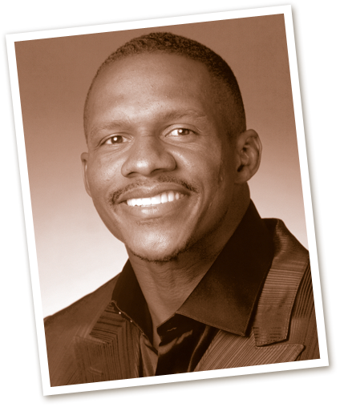

**Joe Horn**

*Retired American Football Wide Receiver, Four-timer NFL Pro Bowler, Kansas City Chiefs Fifth Round Draft Pick (NFL -1996) Atlanta Falcons, New Orleans Saints Hall of Famer;*

*Entrepreneur, Philanthropist, Distinguished Community Service Volunteer*

***Theme: Life, Liberty, Freedom, Prosperity***

**Tuesday, September 17, 2013**

**11:00 A.M.**

**T. H. Harris Auditorium**

**Grambling State University**

**Grambling, Louisiana**

**Grambling State University ~ Enhancing the Academic Profile**

For additional information contact: Dr. Rory L. Bedford, Director

Office of Service-Learning ~ 318-274-2547 ~ bedfordr@gram.edu