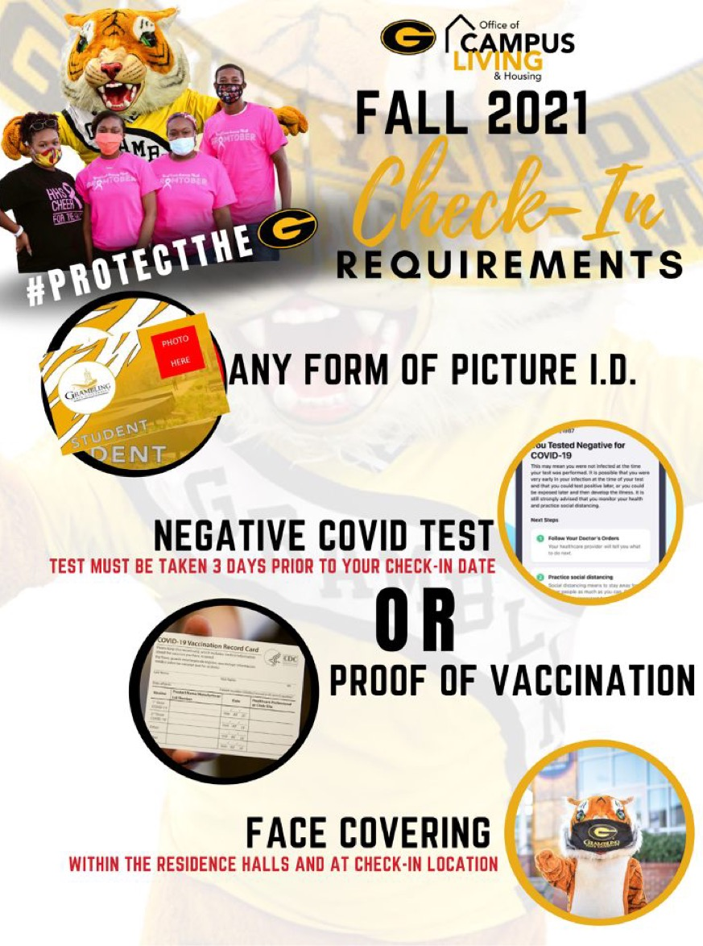Office of   
**CAMPUS   
LIVING   
& HOUSING**

**#PROTECTTHEG**

**FALL 2021  
*CHECK-IN*   
Requirements**

* ANY FORM OF PICTURE ID
* NEGATIVE COVID TEST  
  TEST MUST BE TAKEN 3 DAYS PRIOR TO YOUR CHECK-IN DATE

**OR**

* PROOF OF VACCINATION
* FACE COVERING  
  WITHIN THE RESIDENTS HALLS AND AT CHECK-IN LOCATIONS