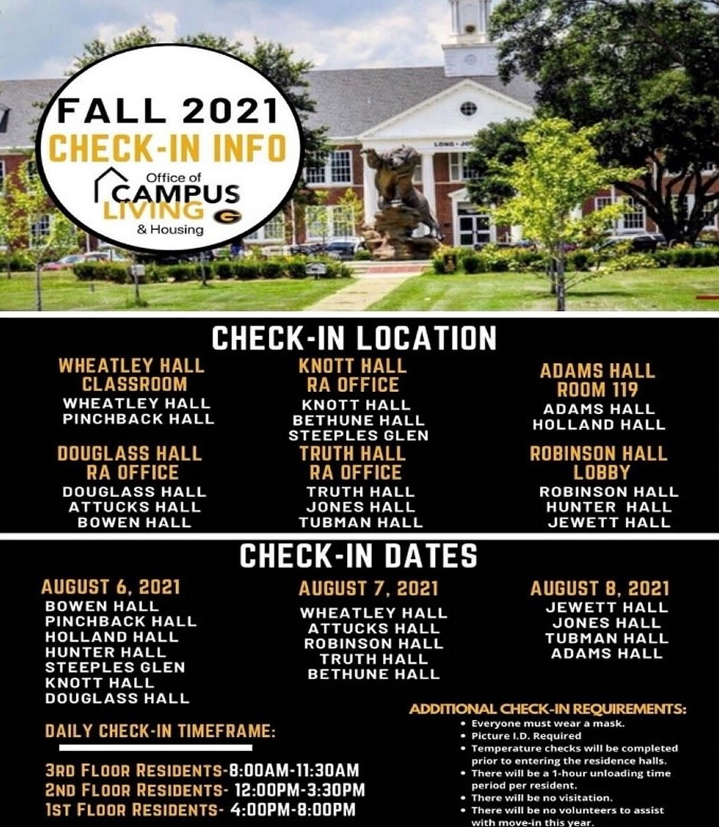**FALL 2021  
CHECK-IN INFO**  
Office of   
**CAMPUS   
LIVING   
& HOUSING**

**CHECK-IN LOCATION**

|  |  |  |
| --- | --- | --- |
| **WHEATLEY HALL CLASSROOM**  WHEATLEY HALL  PINCHBACK HALL | **KNOTT HALL  RA OFFICE**  KNOTT HALL  BETHUNE HALL  STEEPLES GLEN | **ADAMS HALL ROOM 119**  ADAMS HALL  HOLLAND HALL |
| **DOUGLASS HALL**  **RA OFFICE**  DOUGLASS HALL  ATTUCKS HALL  BOWEN HALL | **TRUTH HALL**  **RA OFFICE**  TRUTH HALL  JONES HALL  TUBMAN HALL | **ROBINSON HALL**  **LOBBY**  ROBINSON HALL  HUNTER HALL  JEWETT HALL |

**CHECK-IN DATES**

|  |  |  |
| --- | --- | --- |
| **AUGUST 6. 2021**  BOWEN HALL  PINCHBACK HALL  HOLLAND HALL  HUNTER HALL  STEEPLES GLEN  KNOTT HALL  DOUGLASS HALL | **AUGUST 7. 2021**  WHEATLEY HALL  ATTUCKS HALL  ROBINSON HALL  TRUTH HALL  BETHUNE HALL | **AUGUST 8, 2021**  JEWETT HALL  JONES HALL  TUBMAN HALL  ADAMS HALL |

|  |  |
| --- | --- |
| DAILY CHECK-IN TIMEFRAME:  3RD FLOOR RESIDENTS-8:00AM-11:30AM  2ND FLOOR RESIDENTS- 12:00PM-3:30PM  1ST FLOOR RESIDENTS- 4:00PM-8:00PM | ADDITIONAL CHECK-IN REQUIREMENTS:   * Everyone must wear a mask. * Picture ID. Required * Temperature checks will be completed prior to entering the residence halls. * There will be a 1-hour unloading time period per resident. * There will be no visitation. * There will be no volunteers to assist with move-in this year. |