**GENERAL INFORMATION**

* All university parking areas are designated or reserved. Refer to the map on the reverse side for zone designations.
* All parked vehicles must display Grambling State University parking permits appropriate for designated parking area.
* Students indebted to the University due to traffic fines will not receive a transcript to validate credit for academic work already completed, nor will they be permitted to re-enroll in school until the debt is cleared.
* The vehicle registrant will be responsible for all tickets issued to his/her vehicle, including violations incurred by member(s) of his/her family and other drivers.
* The operator of an unregistered vehicle is responsible for all tickets issued to that vehicle regardless of ownership.
* Vehicles found to be presenting a hazard to campus in any manner, destroying or defacing university property or bringing discredit to the university, will be towed off campus without notification and at the owner's expense.
* **On campus students are not allowed to drive to class. Students are to park at their respective dormitories during class time.**

**ENFORCEMENT HOURS**

* Parking regulations are enforced from 7:00 a.m. to 5:30 p.m., Monday thru Friday in all parking areas. In addition, handicap parking, parking in a no parking zone and blocking dumpster regulations are enforced 24 hours a day, 7 days a week in all parking areas.
* In addition to the University’s traffic and parking regulations, city ordinances and state laws relating to motor vehicles are also enforced on campus.
* Unauthorized vehicles parking in reserved spaces and/or designated areas will be ticketed, towed, and/or both.
* A vehicle receiving three (3) or more such citations is subject to be towed or immobilized by the university.

**FACULTY/STAFF/STUDENT PARKING**

A visitor is defined as a person who is not directly affiliated with the University and who needs to park an unregistered vehicle on campus. Visitors are required to secure a temporary Visitor's Pass before parking on campus. Visitor permits are available through the University Police Traffic Division upon request. Designated visitor parking spaces will be available.

**VEHICLE REGISTRATION**

* All registrants must show proof of insurance and a valid driver’s license.
* Faculty/staff are not permitted to register a vehicle for any student except their own children.
* Vehicles are registered for one year beginning August 31st of each year. Fees are as follows:

**PARKING PERMIT FEES**

Faculty/staff:

Fall - $30.00

Spring - $22.00

Summer Sessions I & II – $11.00

Resident/Commuter Students:

Fall - $14.00

Spring - $11.00

Summer Sessions I & II - $7.00

Summer session (each) $ 15

**PERMIT PURCHASE LOCATION**

Long-Jones Hall

Cashiers’ Window

100 Founders Street

Grambling, LA 71245

(318) 274-2671

**When a student’s housing status changes from one semester to another, you are required to inform the Traffic Department**

**RULES AND REGULATIONS**

**PERMIT DISPLAY**

* The parking permit is non-transferable.
* The permit must be displayed on the lower back window.
* Once a registration permit is issued for a vehicle, it is the responsibility of the person registering the vehicle to place on left side of the back window immediately on issuance.
* The vehicle is not officially registered until the permit is displayed.
* A permit placed on a vehicle for which it is not intended is considered fraud.

**PARKING POLICIES**

* The absence of a "no parking sign" does not institute that parking is allowed.
* Parking regulations are in effect at all times from the beginning of the first day of class each semester and all summer sessions.
* Service drives/loading zones are designated by signs and/or a yellow curb; these locations are closed to parking at all times except to authorized University vehicles and commercial vehicles making deliveries.
* Parking at fire hydrants or red curbs is prohibited at all times. Vehicles parked by red curbs will be towed and impounded.
* During the hours of regulation parking, registered vehicles may park only in assigned lots.
* Operating or parking an unregistered vehicle on campus will result in the issuance of a citation.
* Only students or employees who have obtained a handicap automobile license plate or state issued decal from the State of Louisiana will be eligible to park in a handicap space.
* A student enrolled at GSU Lab School who has a valid driver's license will be issued a decal to park at the high school parking lots.

**PAYMENT OF FINES**

Fines may be paid in cash, check, money orders or credit cards at the Cashiers Window located in Long-Jones Hall, between the hours of 8:30 a.m. and 4:00 p.m. Monday through Friday. Return check fee is $25. Unpaid fines result in a hold being placed on a student’s account, prohibiting registration, graduation or requesting transcripts.

**DECAL PLACEMENT**

Please place decal on the rearview mirror.

(See sample below)

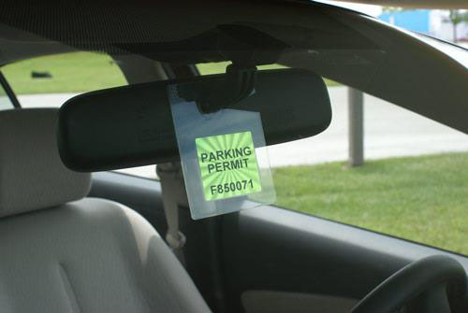

**FINES**

Parking in handicap (2nd Offense) $500

Parking in handicap (1st Offense) $275

Running stop sign $125

Violation of directional parking $125

Littering $125 Loud music $125

No passing zone/double yellow $75 Reckless operation $75 Parking in Faculty/Staff $50

Parking in no parking zone $50 Parking on lawn $50

Parking in visitor zone $50

Failure to yield for pedestrian in crosswalk $50

Obstruction of driveway $50

President/Vice President zone $50 Failure to obey officer $50 U-Turn $50

Operating vehicle on sidewalk $50

Driving on one way street $50

Driving around/through barricade $50 Blocking traffic $50

Parking in fire zone/subject to immediate tow $50

No Permit $50

Expired Permit $35

Loading Zone…………………….……………..$50

Improper Display of Permit. . . . . . . . . . . . . . . . .$15

Speeding ticket(s) – Please contact the Department of Traffic and Parking for amount of fine at (318) 274-2222.

**APPEALS**

University citations may be appealed through the Traffic Appeals Committee. Appeals must be in writing and submitted to the Traffic Office within (7) business days from the issuance of the citation. Failure to file an appeal within seven days may result in the loss of the right to appeal until after the citation has been paid.

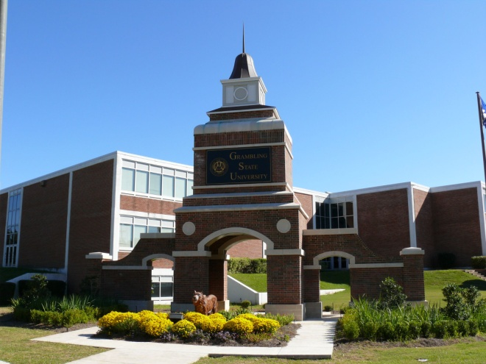

**REGULATIONS GOVERNING**

**MOTOR VEHICLE PARKING**

***READ THIS PAMPHLET CAREFULLY BEFORE OPERATING OR PARKING A VEHICLE ON THE CAMPUS OF GSU.***

**August 2020**

**Department of University Police**

**Traffic and Parking Division**

**Grambling State University**

**(318) 274-2222**